**Directives are of 2 type**

Attribute Directives sit on element just like attributes

Eg

<img src="img_girl.jpg"> src is an attribute

<img src="img_girl.jpg" width="500" height="600"> height width is an attribute

<p style="color:red;">This is a red paragraph.</p> Style is an attribute

Structural directives modify the structure of the dom like if *ngIf condition isnot fulfilled the element will not be added to the DOM where as attribute directives do not make any these kind of changes

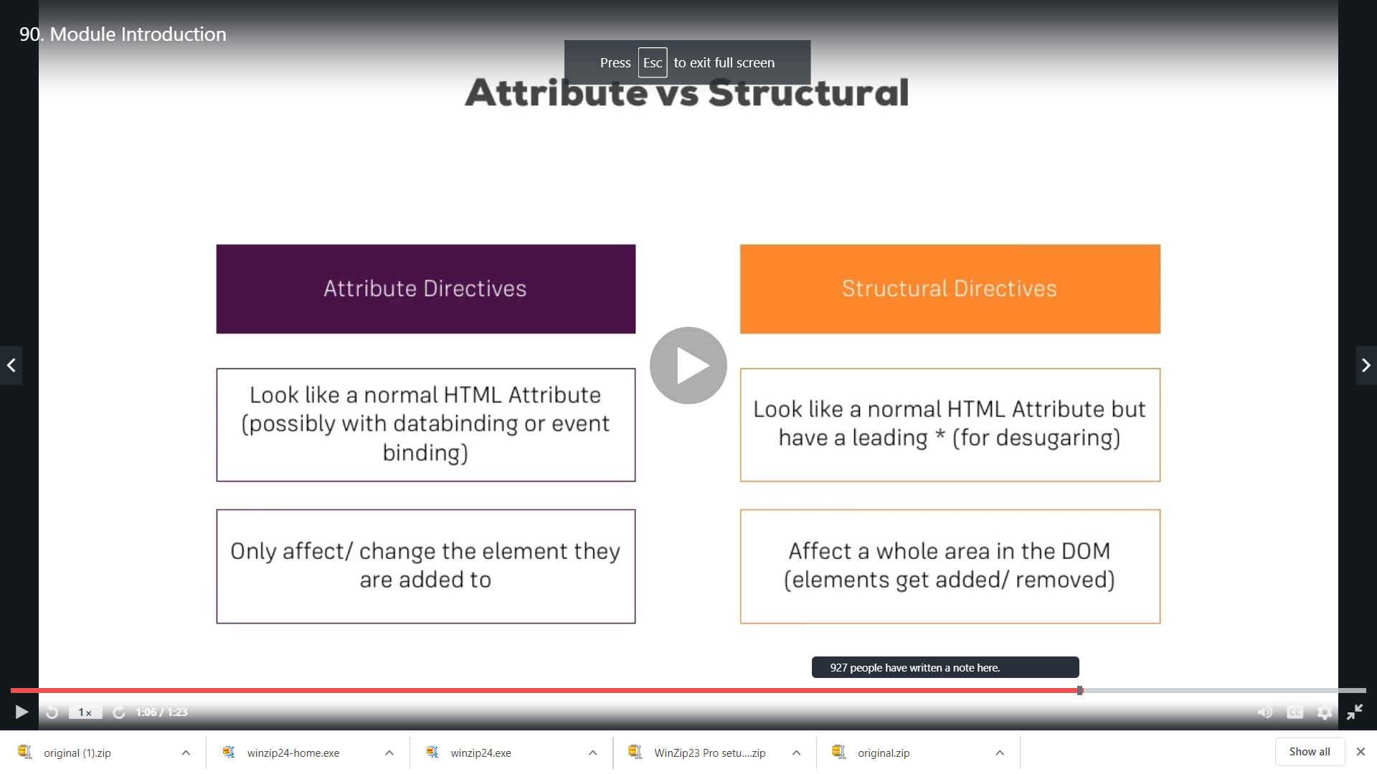

We unzipped the oridginal.zip and extracted the project “directive-start”in our ID and created a new component directive-practice

Now we have a very basic implementation here when we click the button only odd should be shown

**Ngfor and ngIf are structural directives**

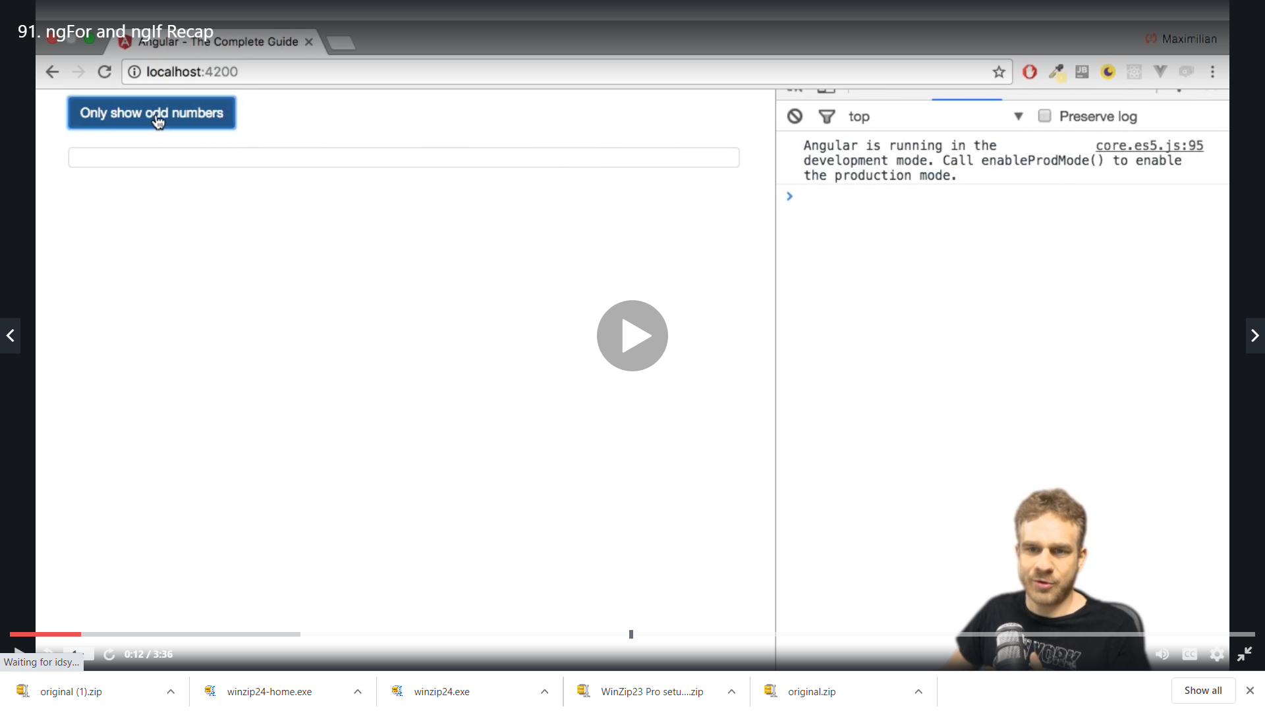

We have

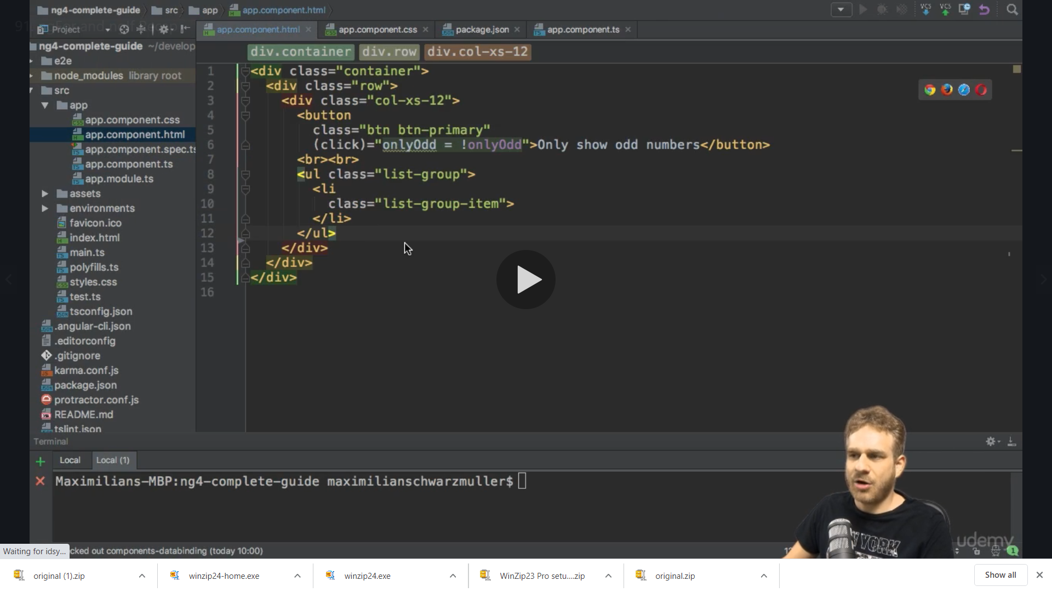

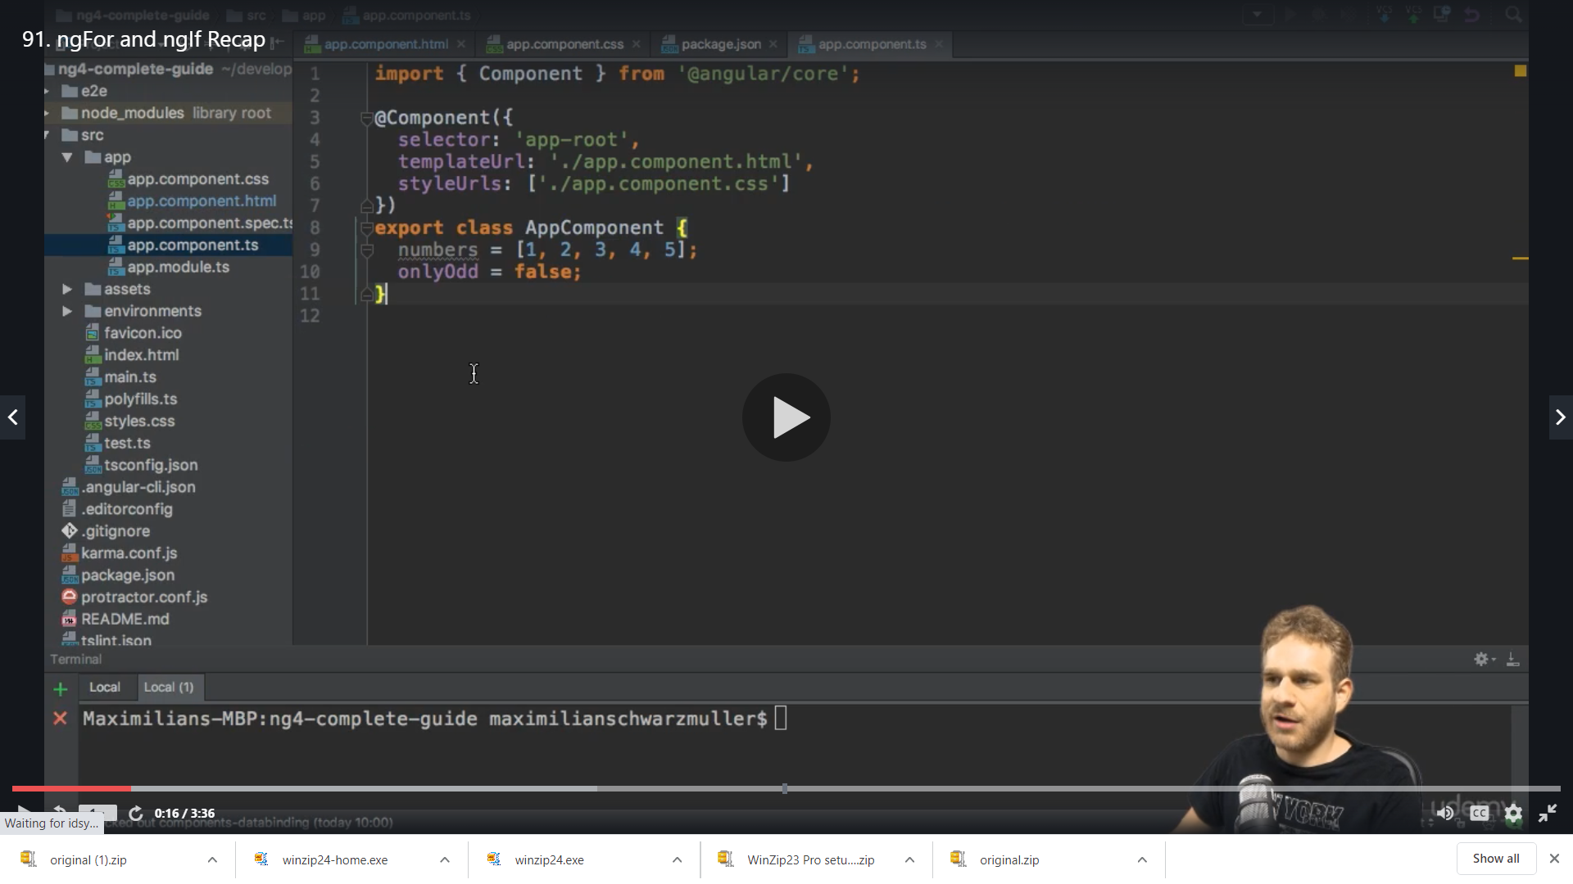

But we are not using it yet

So now we use *ngFor here to output the numbers

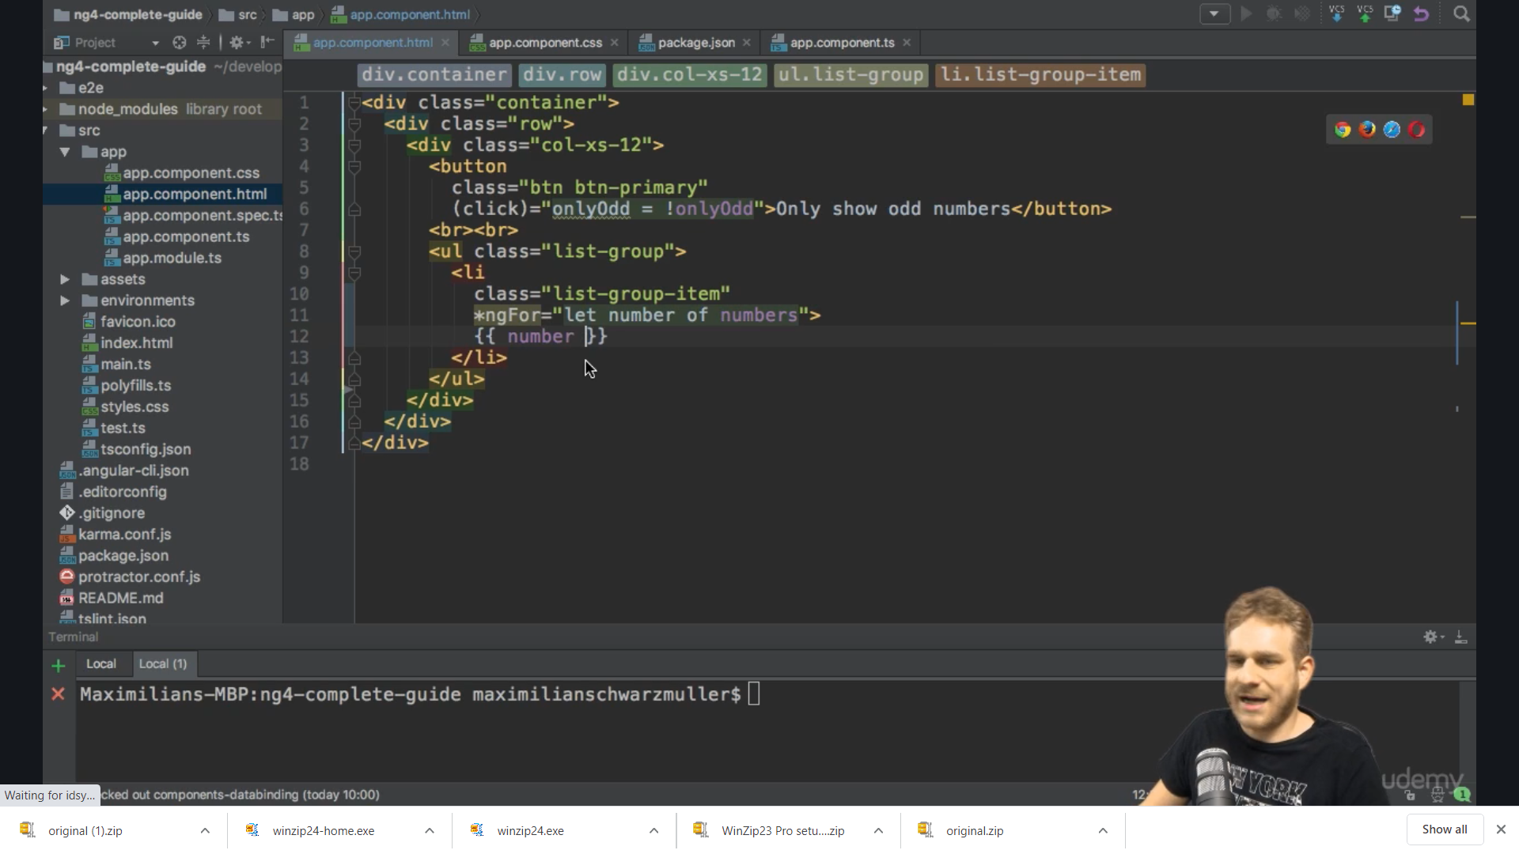

We get

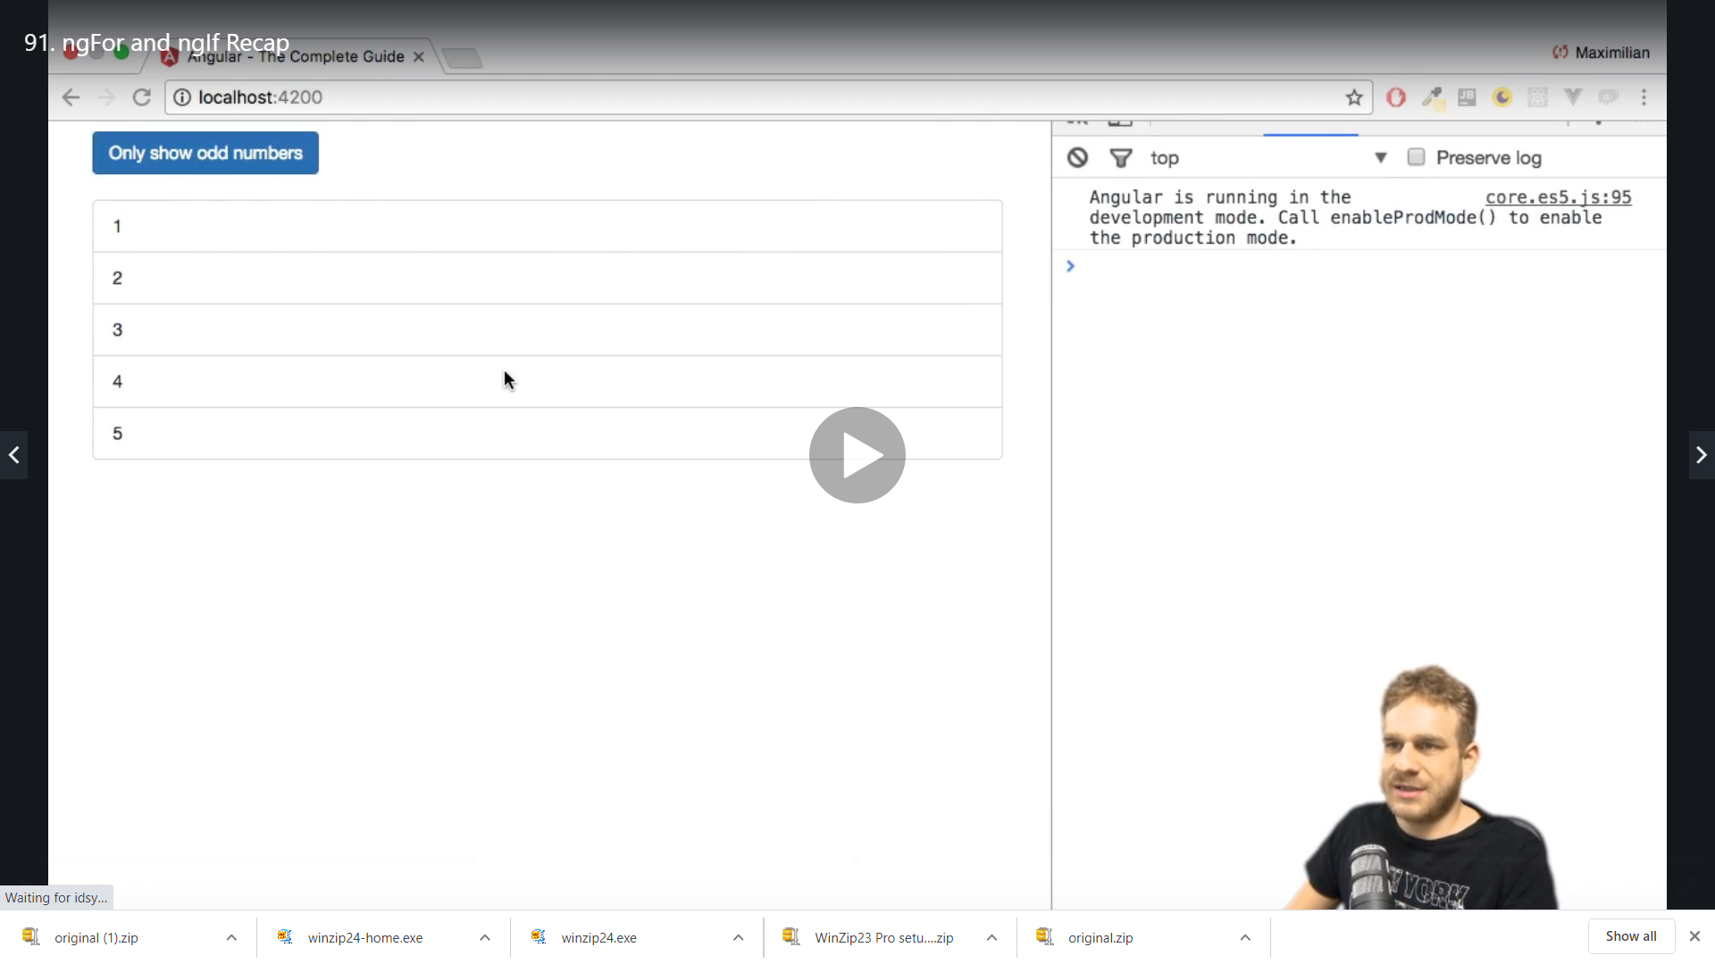

The button still does not do anything with the odd we have configured on the click so we can use it with the help of a condition *ngIf to display only even

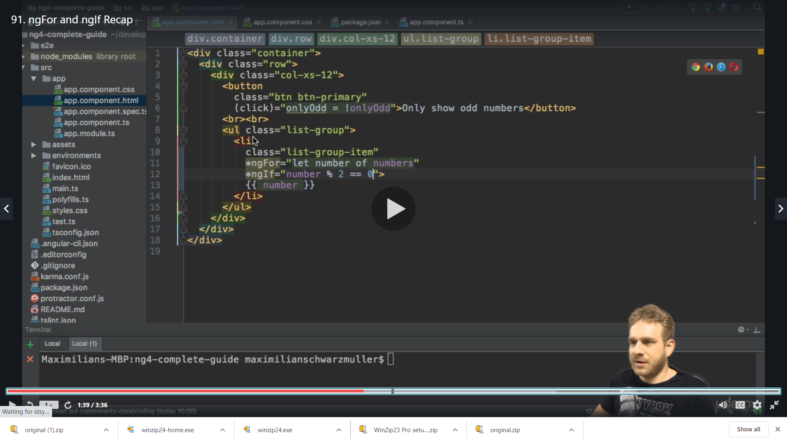

We get error

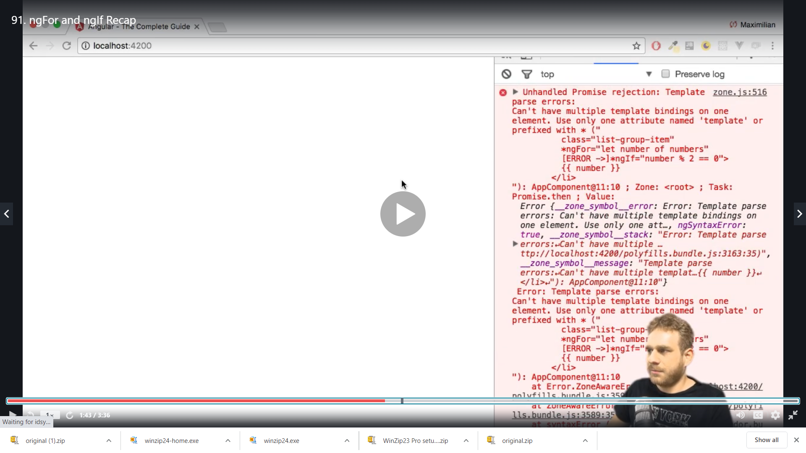

Because we cant have more than 1 structural directive on Same element so it does not work we revert

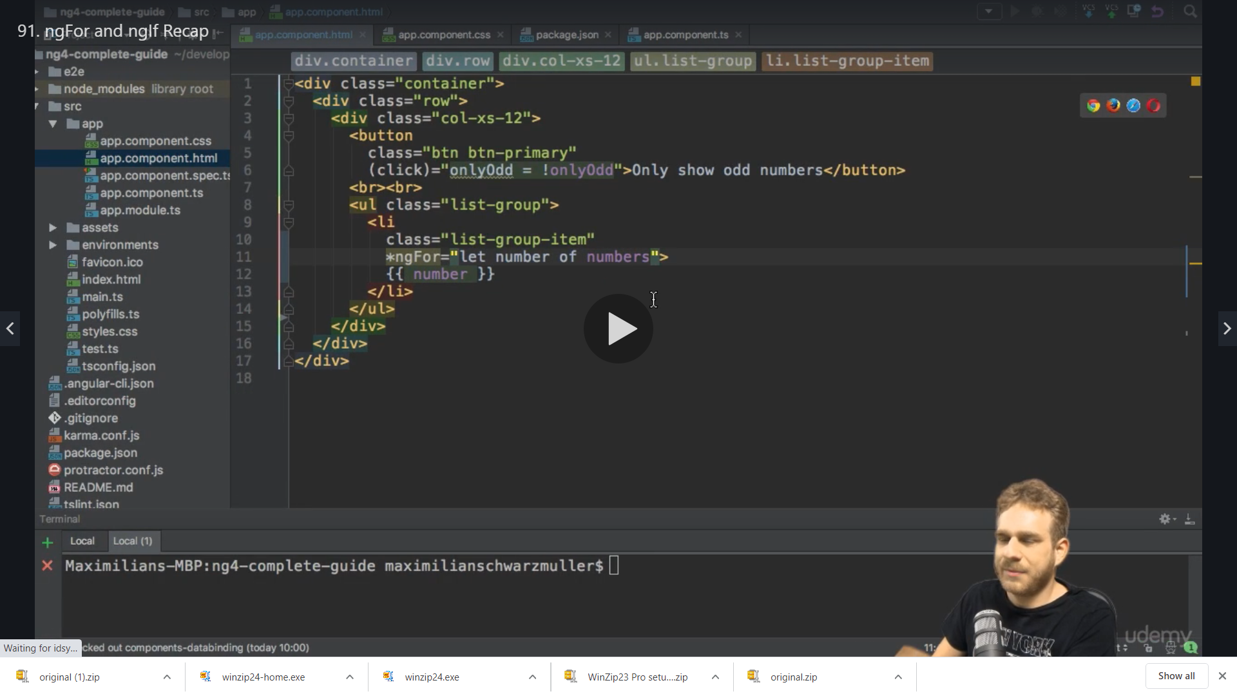

So we change in ts we add odd and even numbers (In pipes section we will learn how to dynamically filter an array )

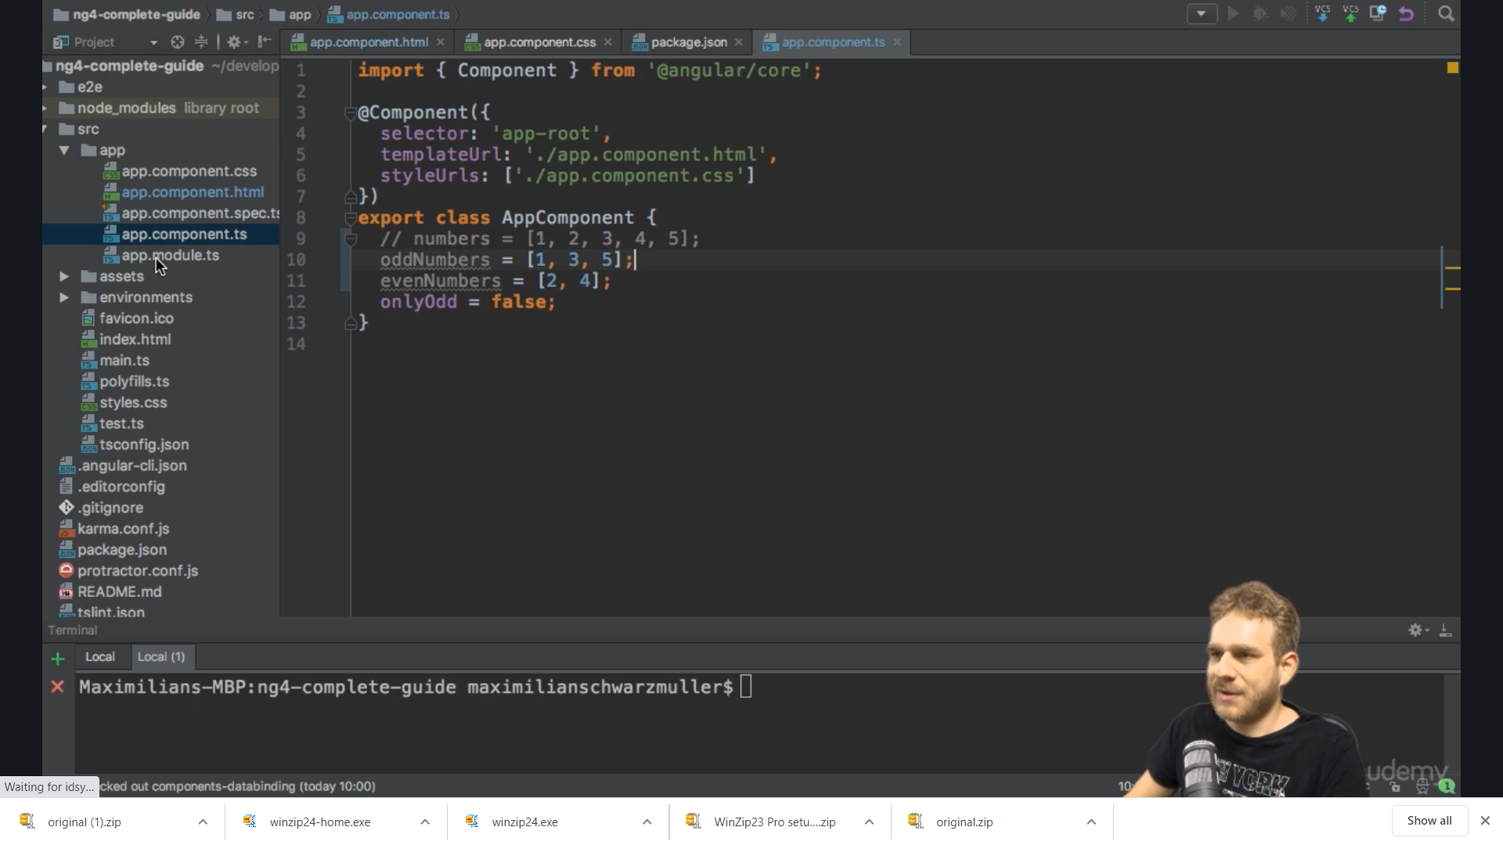

So now we change our loop for even and odd ( ss contains odd and even in the {{}})

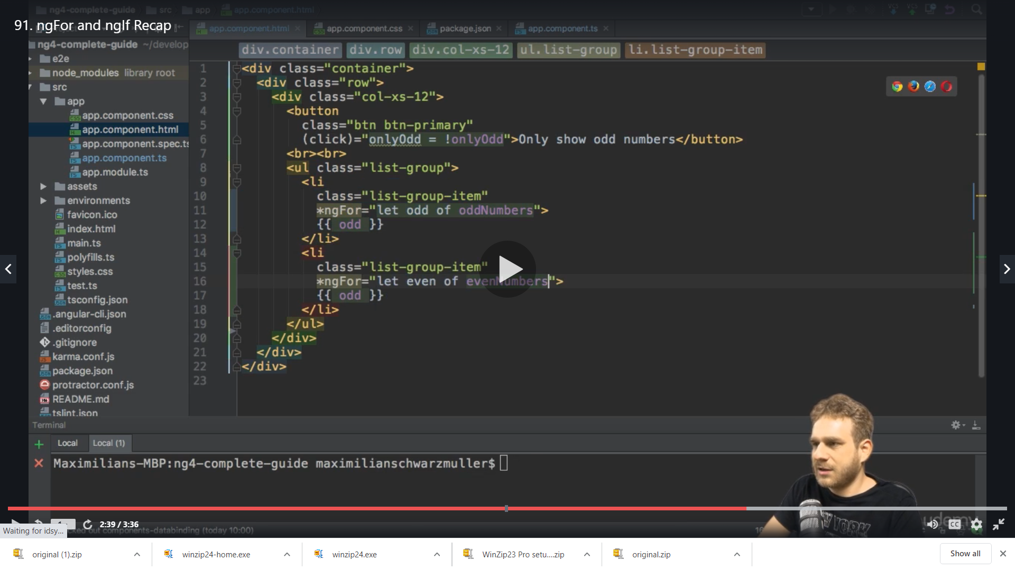

Now to display only one of the two we add condition ,the first one should be displayed only if odd is true

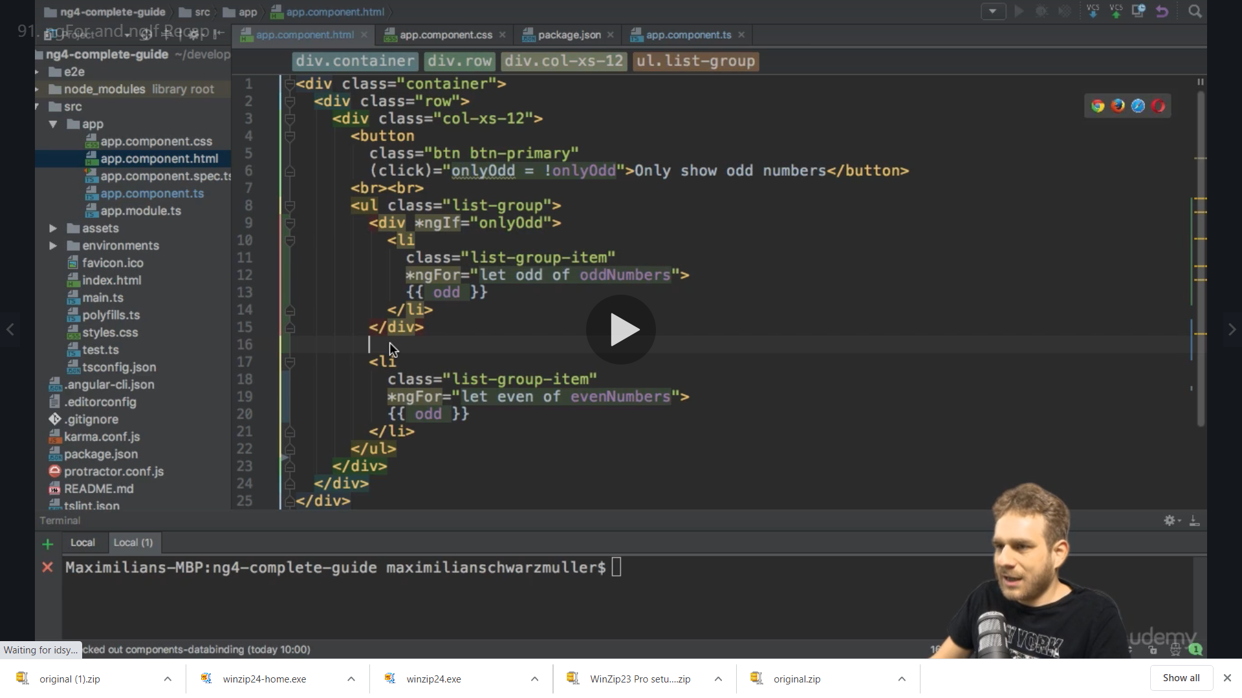

We do for other as well to check not condition

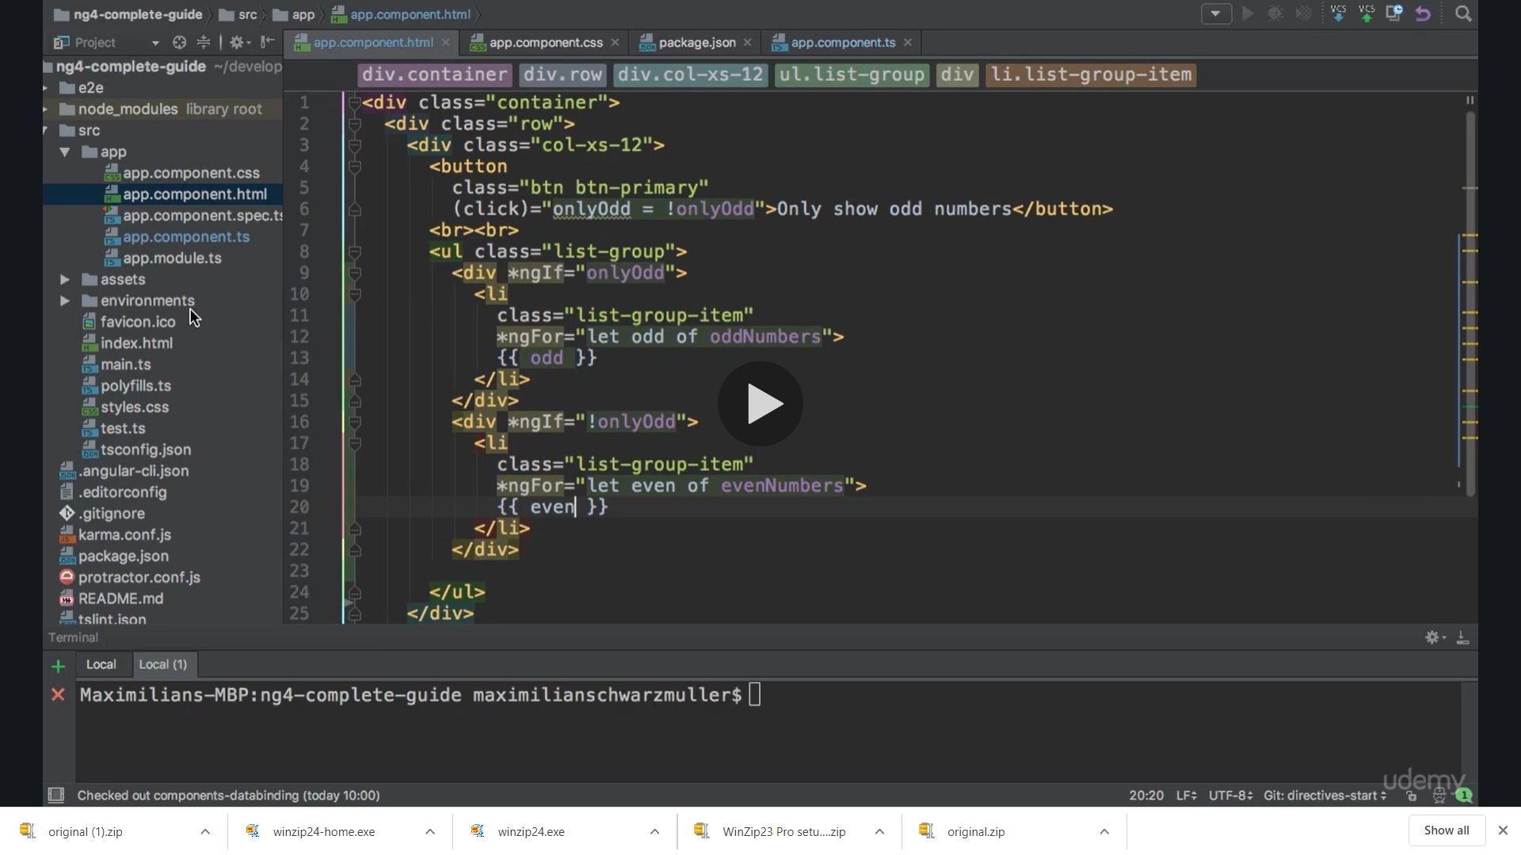

We get the below we can toggle

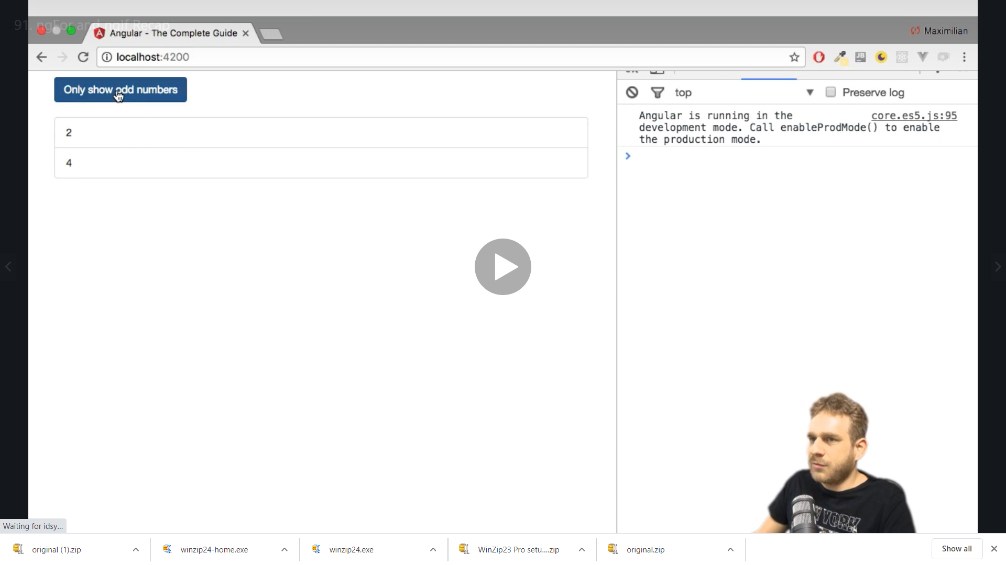

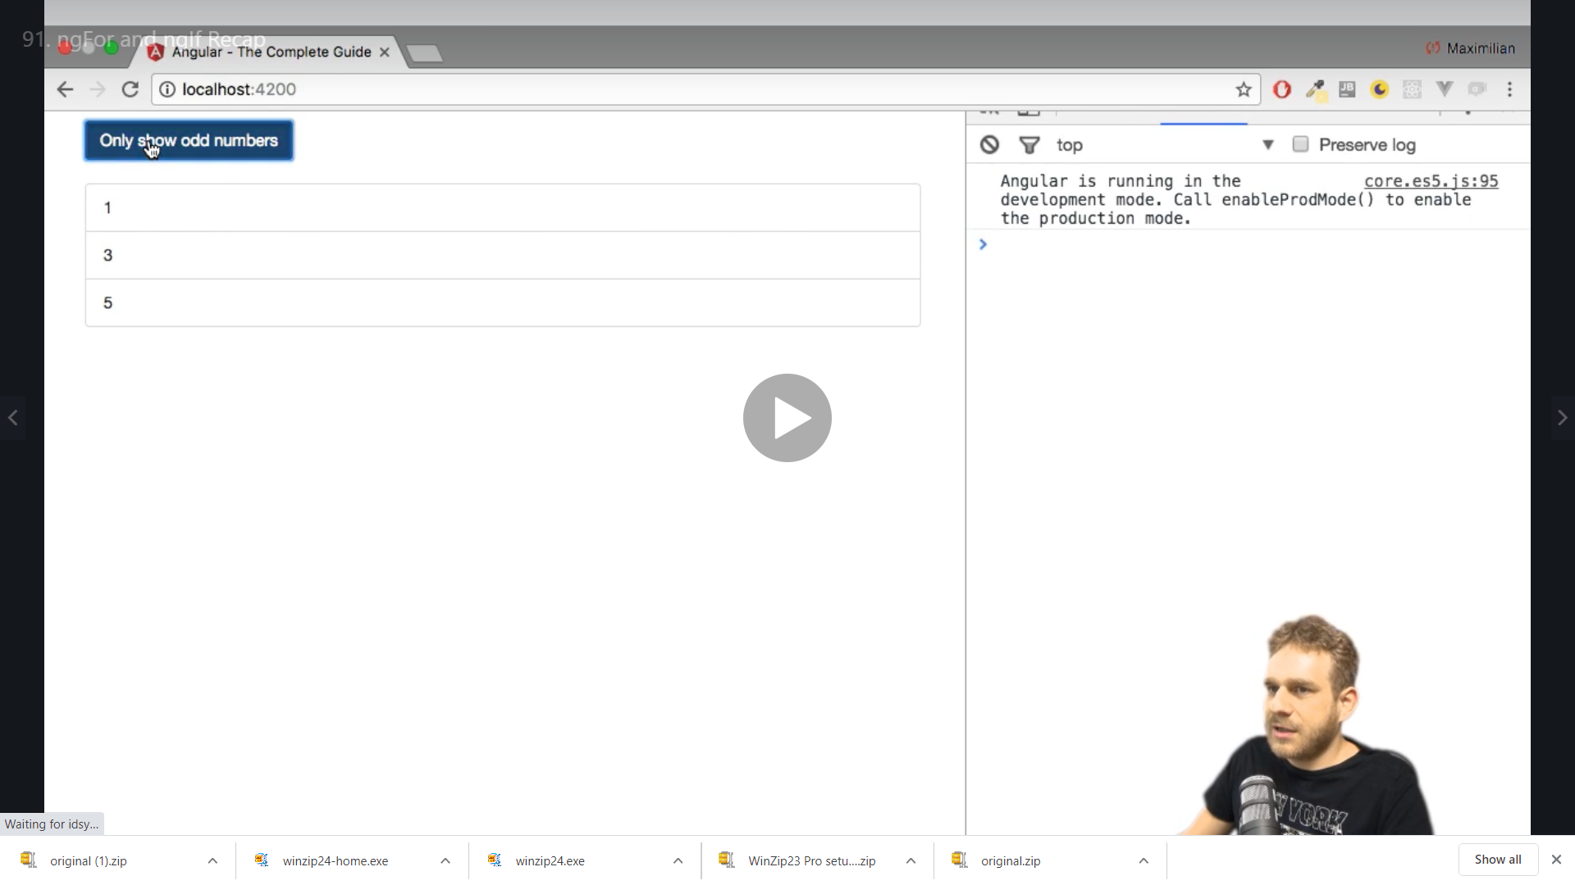

**ngClass and ngStyle recap (These are attribute directives)**



We add a css class for odd

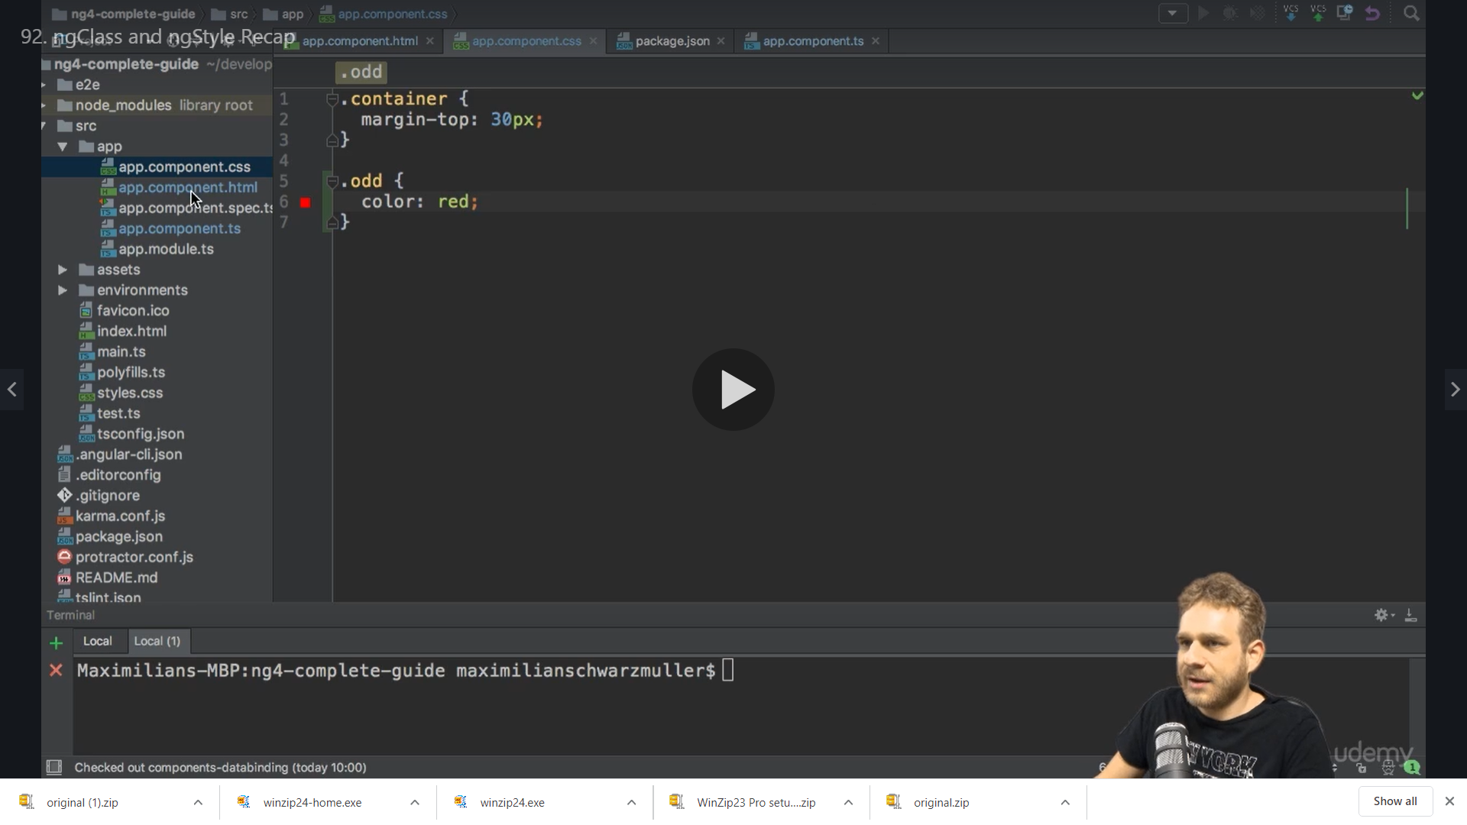

Now on our template we want to assign this class if its odd .

Here [ngClass]=”{**odd**: odd %2 !==0}” **odd** is our css class

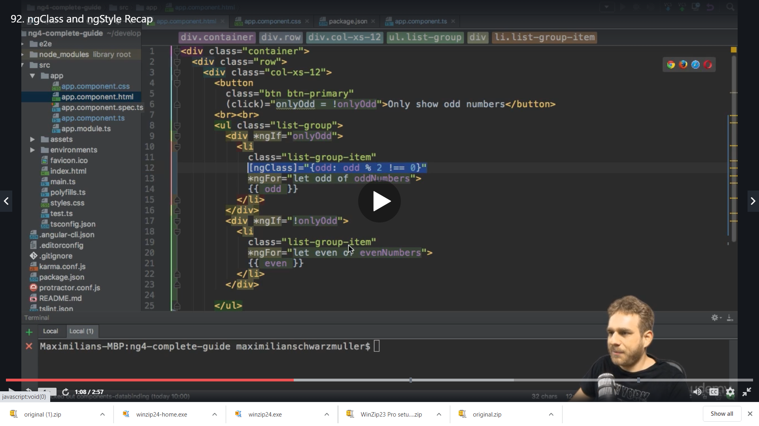

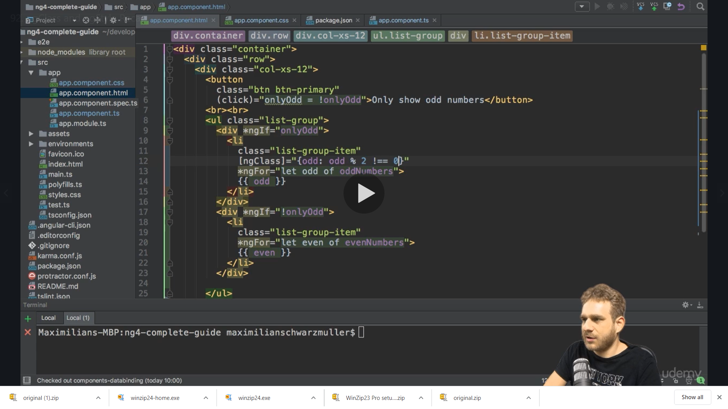

And now we do for the other condition of even as well

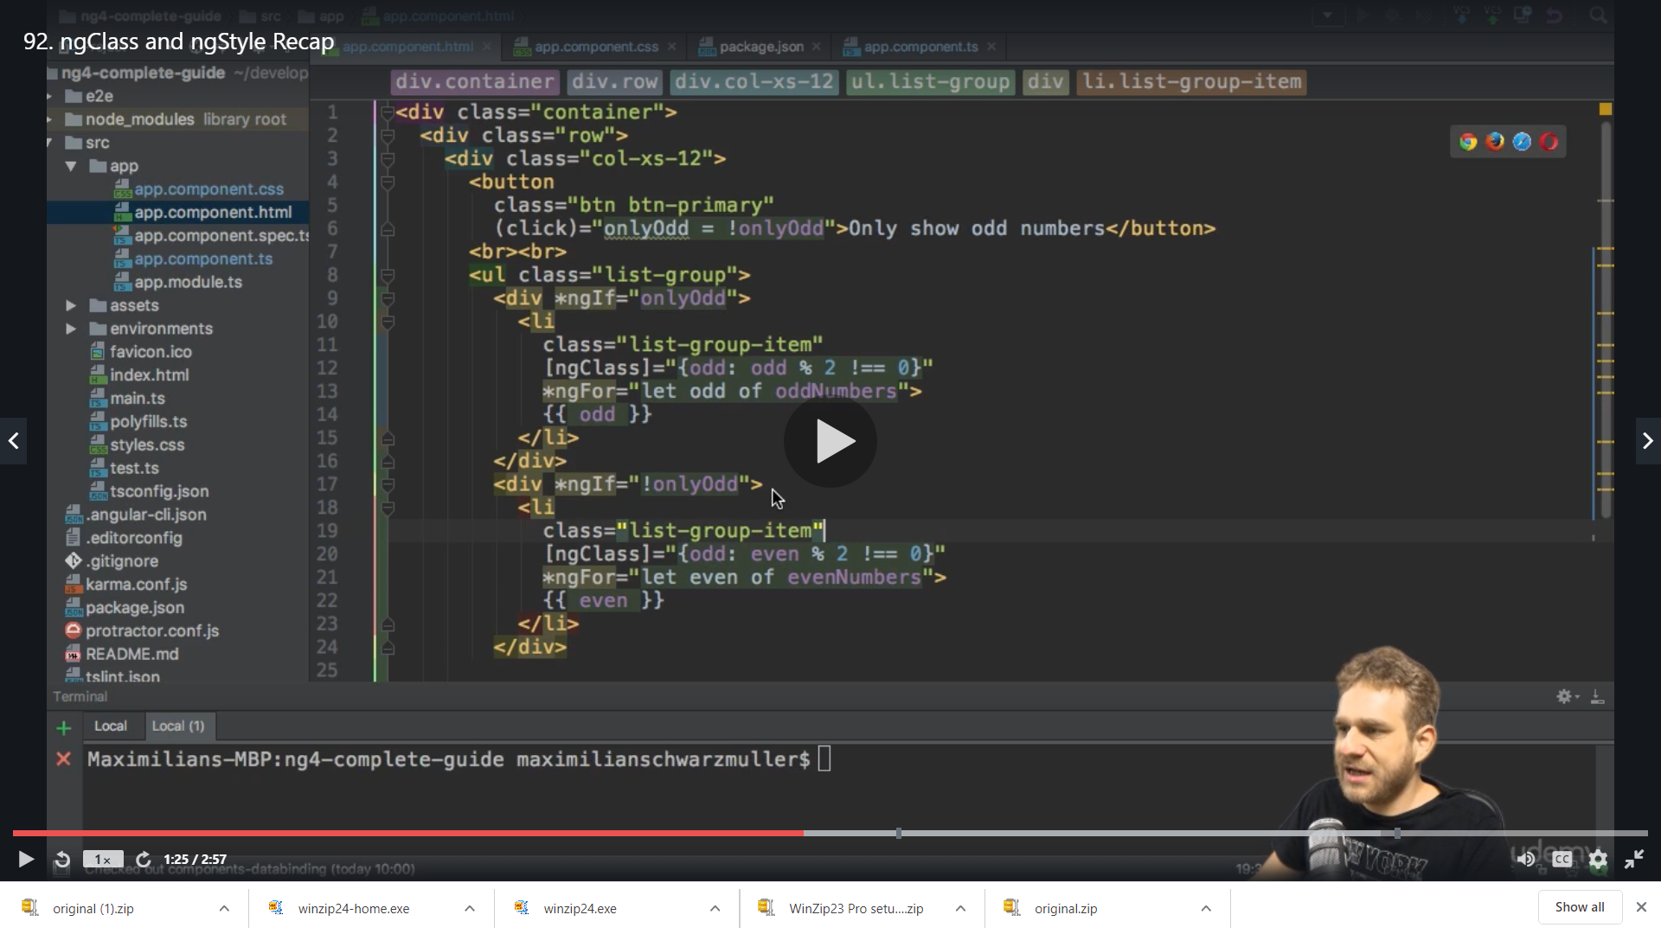

We get even in black

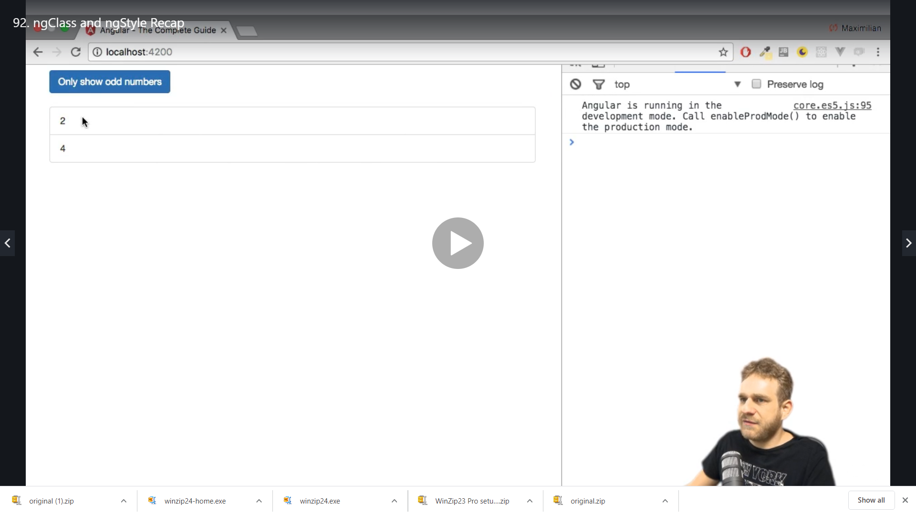

And odd in red

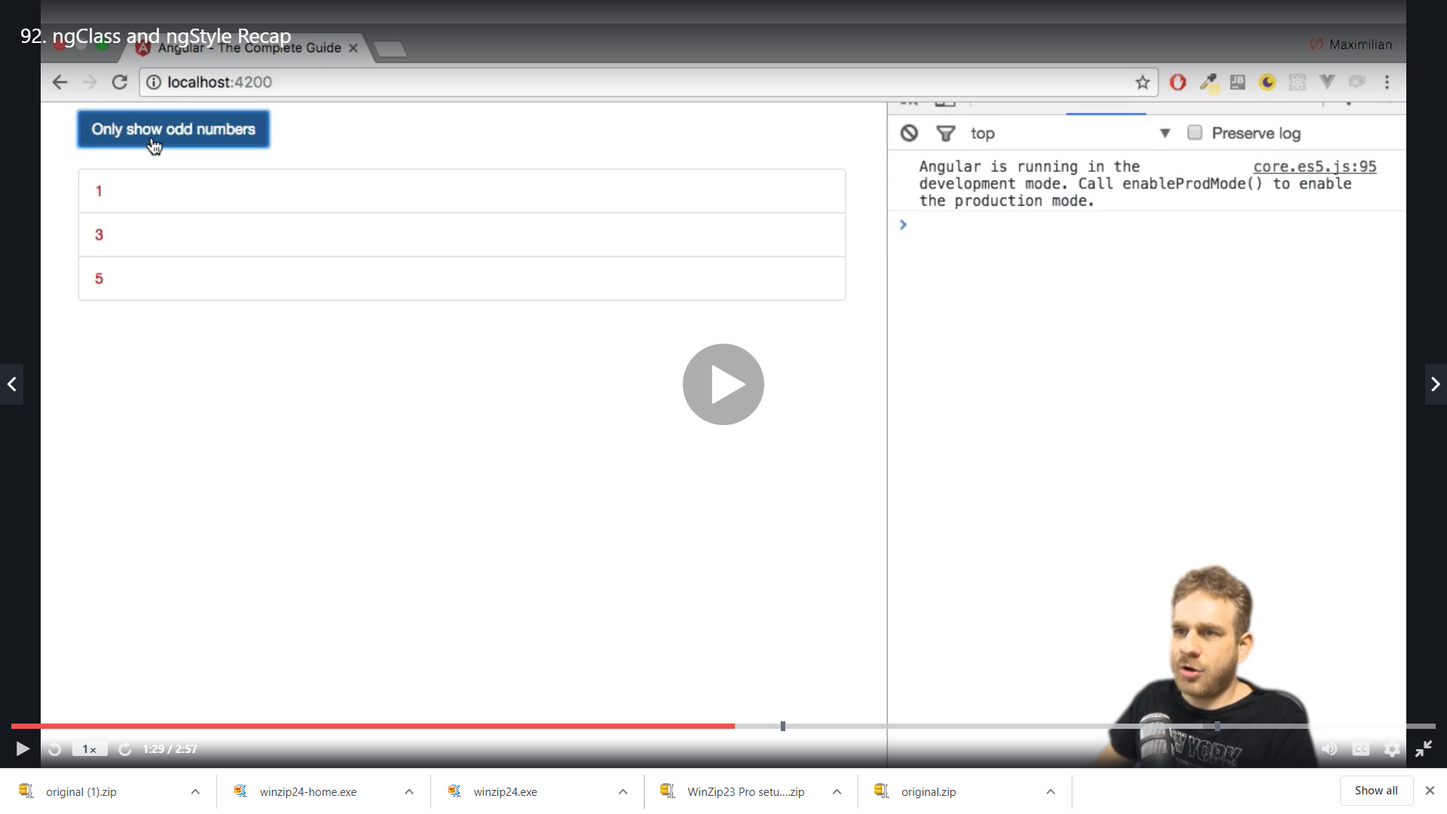

The [] denote that we are binding some property to ngClass directive ie [ngClass]

Now we see ngStyle

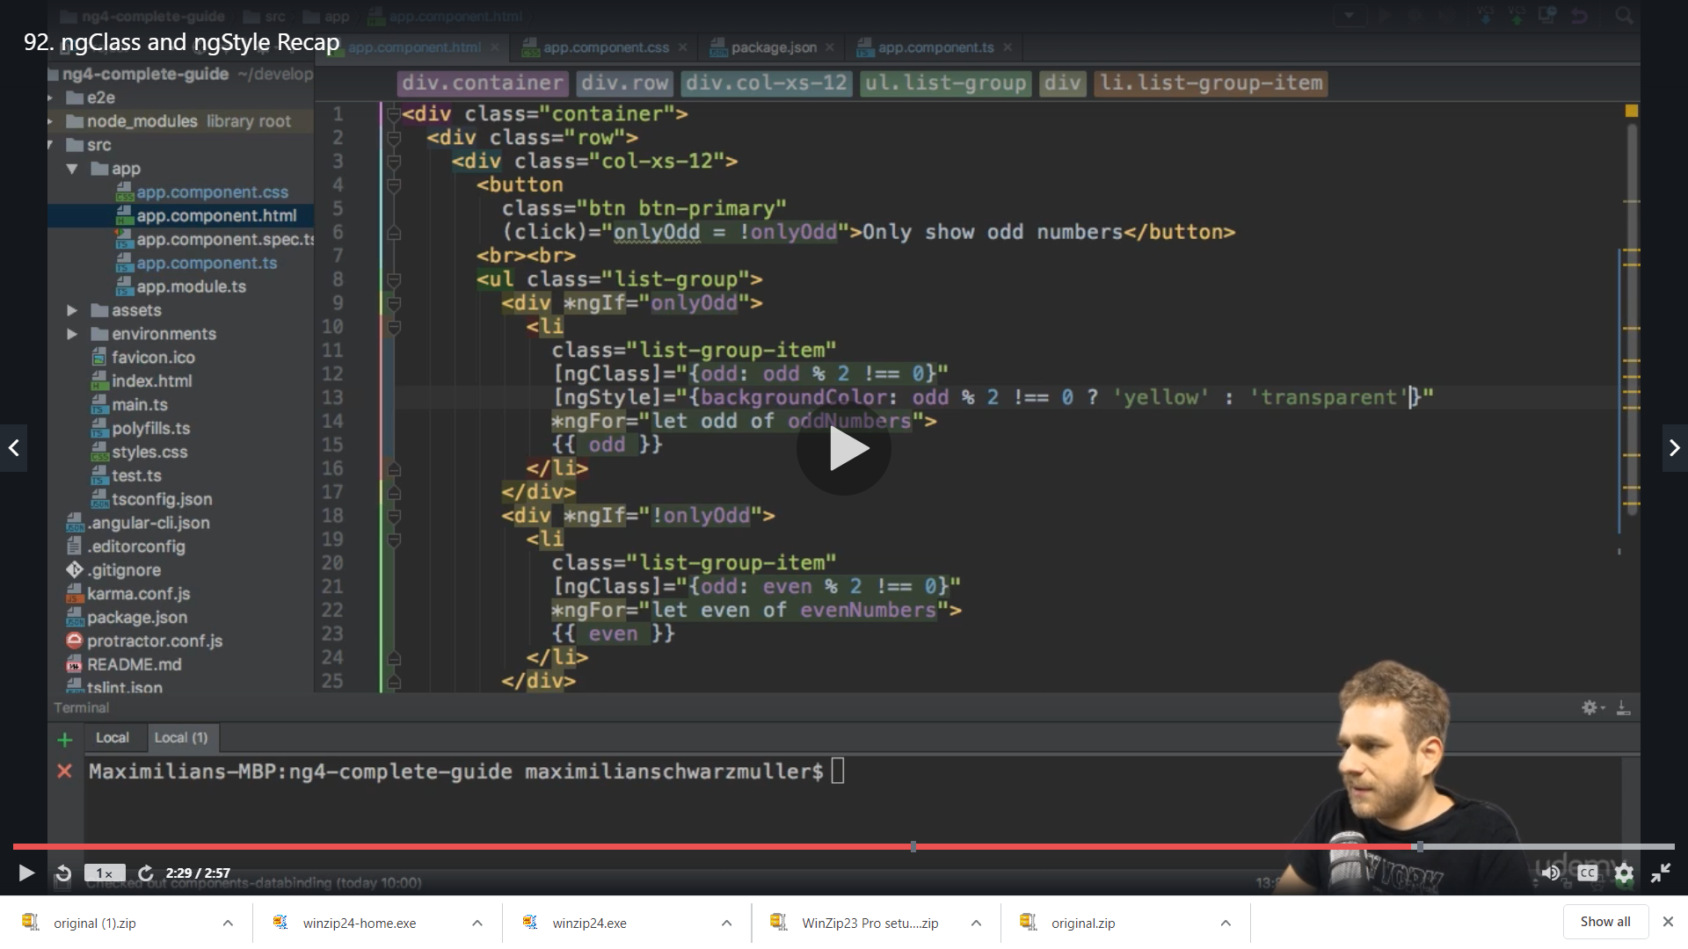

Now we apply ngStyle for other condition as well

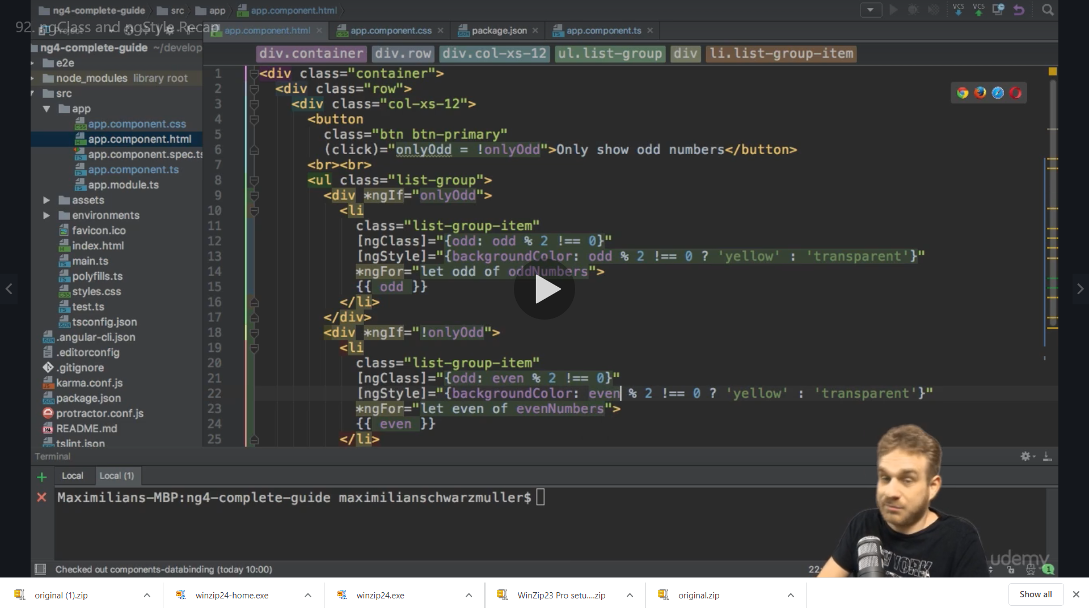

We have even numbers as

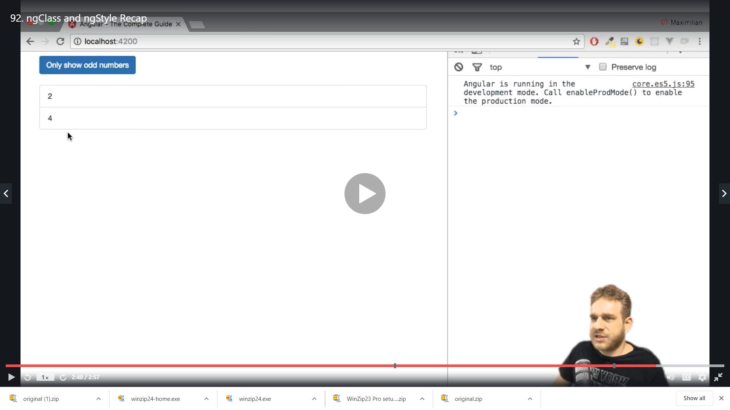

And odd numbers

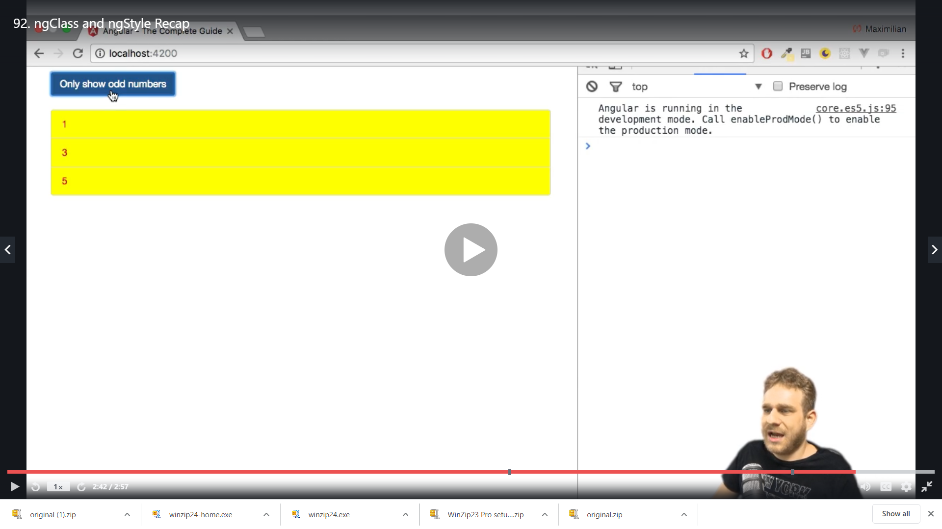

**Creating our own attribute directive**

We want to build a directive which highlites an element when we hover on it

So we create a folder name basic-highlight and create a file with name as below

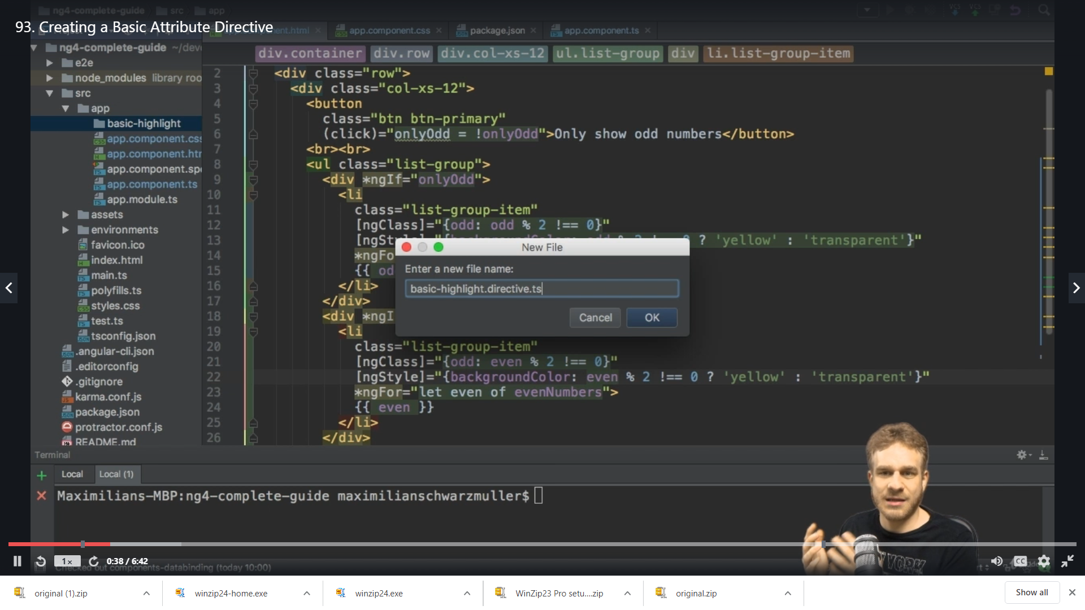

We export a class here and just like @Component we need @Directive here to make it a directive which is imported from @angular/core

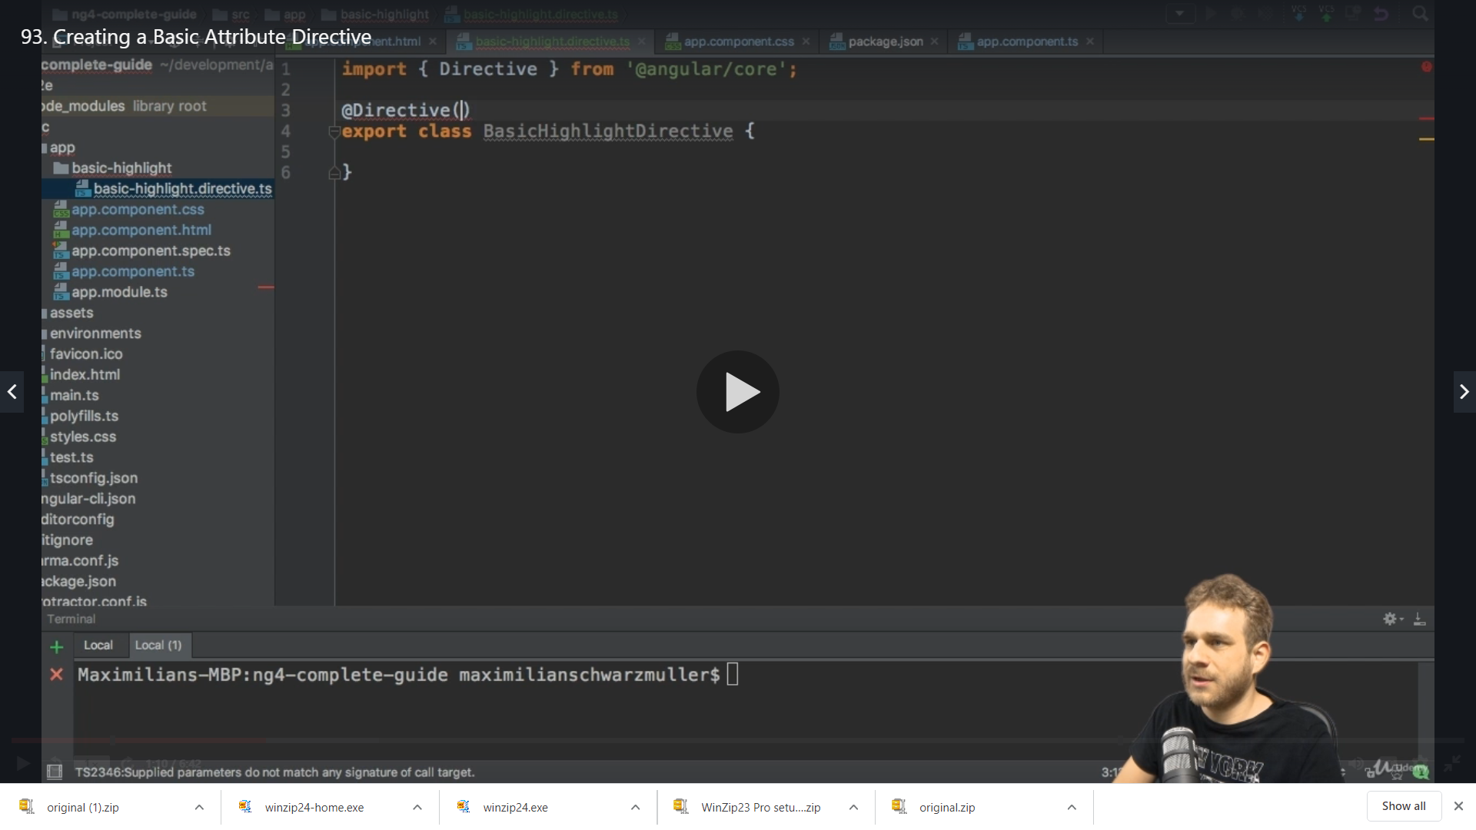

We need to pass object to this decorator to configure this directive

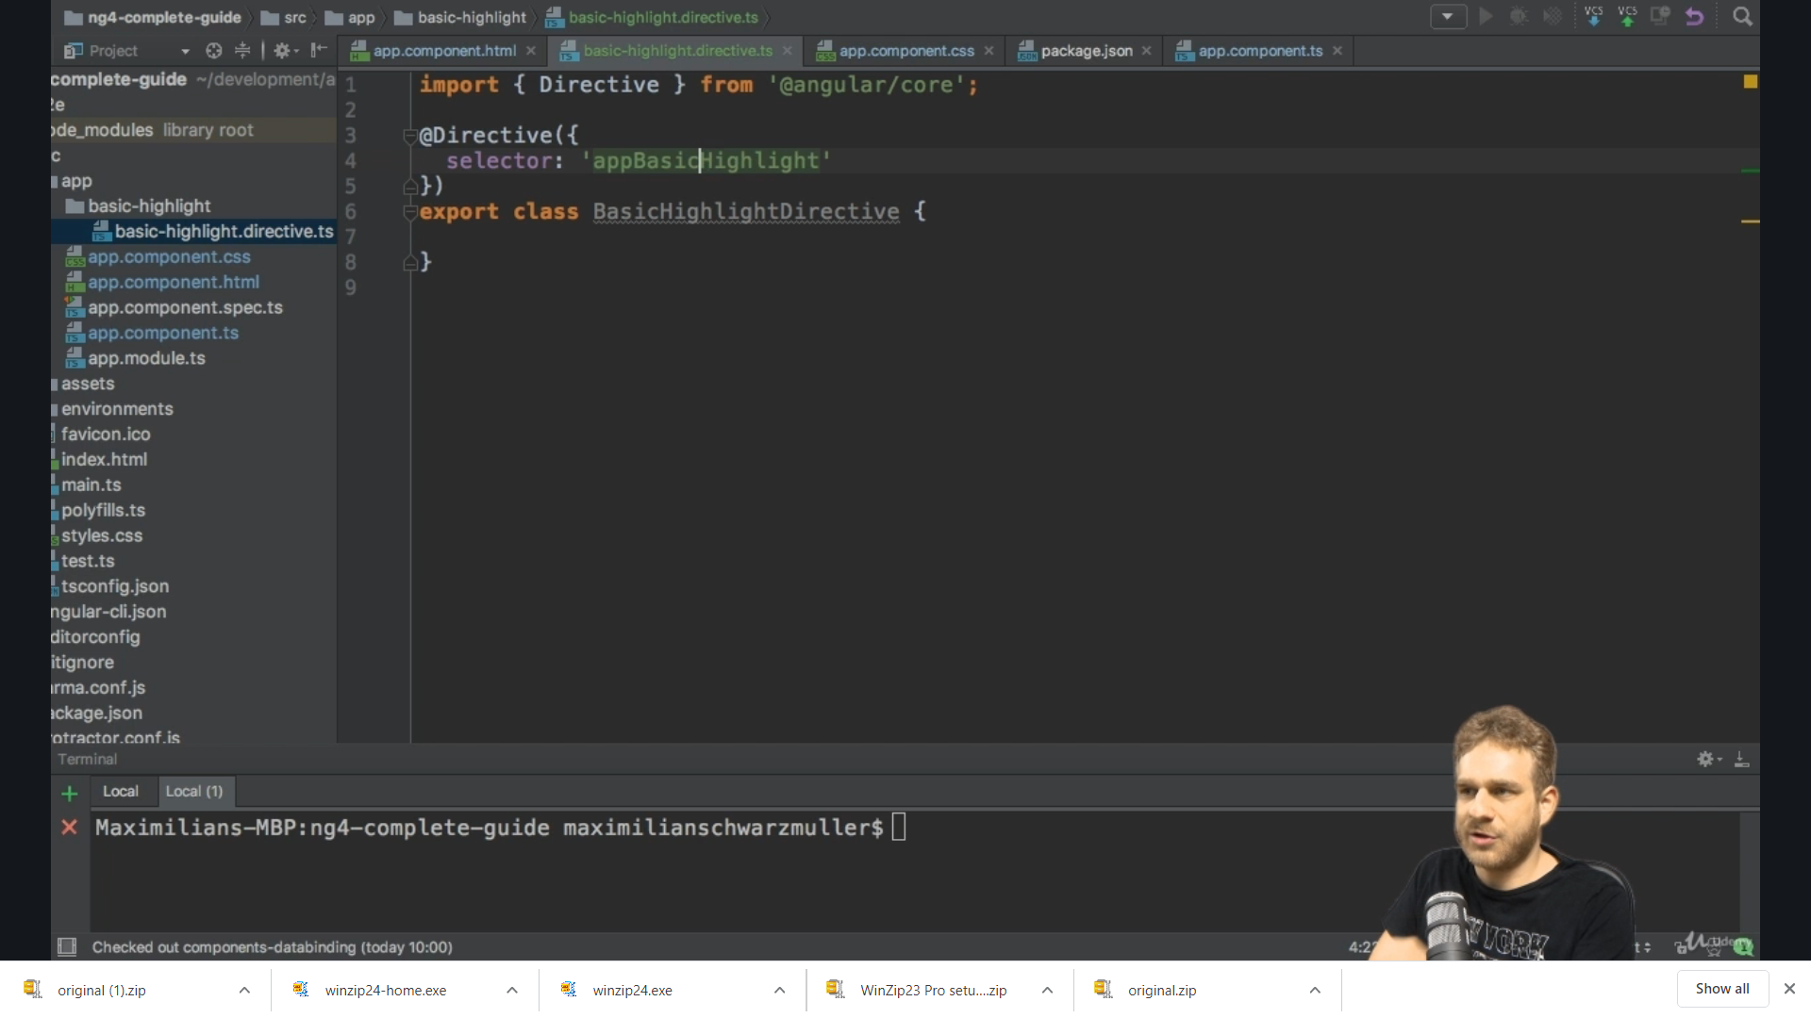

We want to have it as attribute style so we wrap the selector in [] which means this will now be recognized wenever we add appBasicHeighlight without square bracket to an element

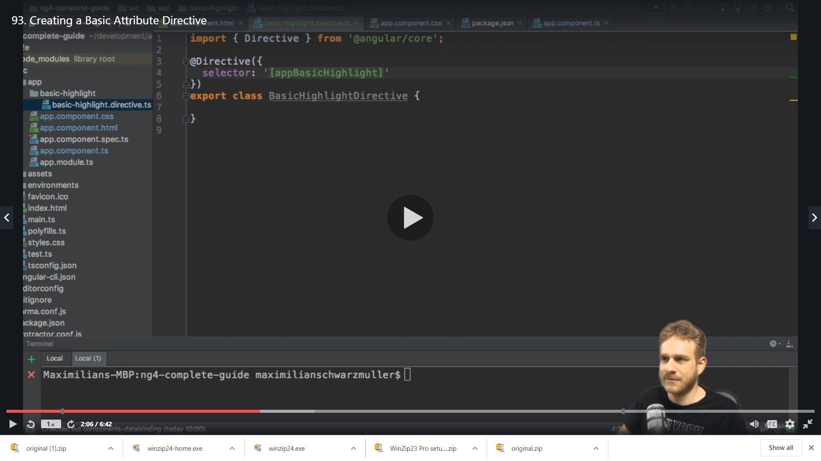

To if this is working we change the background colour of the element where we attach this directive appBasicHeighlight

For that we need to get the access to the element on which the directive sits on and angular gives us this access ,we can inject the element on which the directive sits on into this directive

So to do that on constructor we list a couple of argumnets to get whenever an instance of this class (ie: BasicHighlightDirective) is created

We need a paramenter of type ElementRef we can have any name in place of elementRef

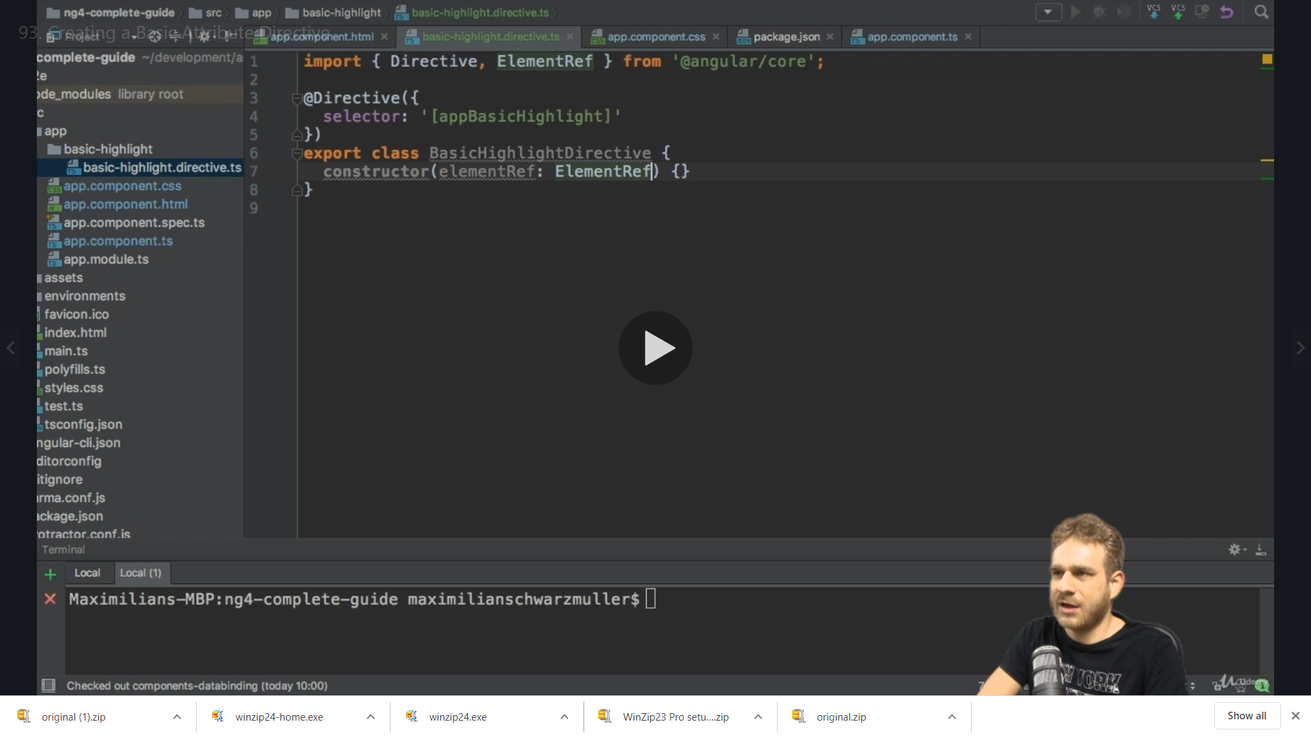

We add private which makes elementRef both the property of this class and automatically assign the value of the instance we are getting to the property from ElementRef

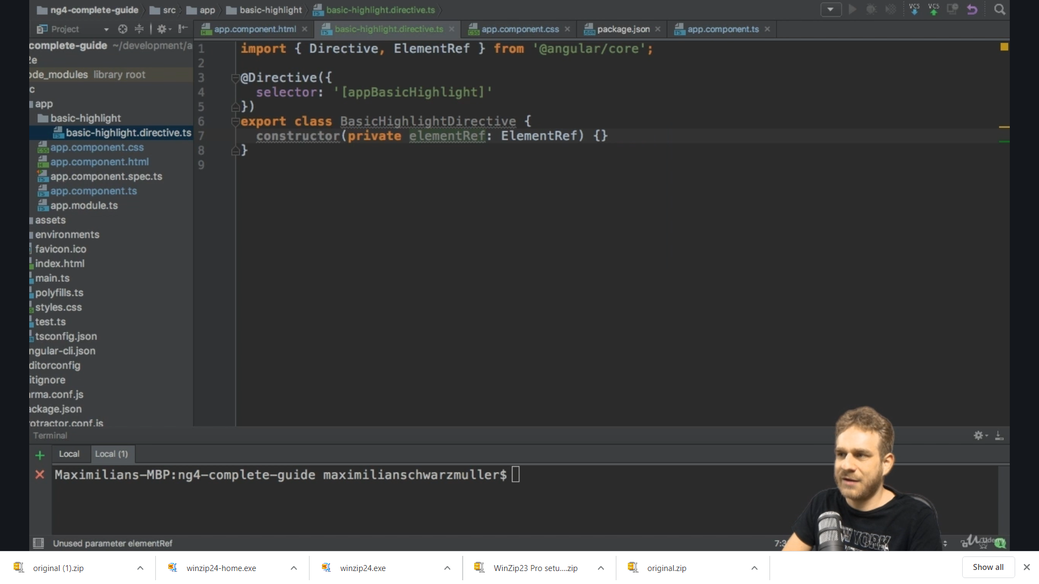

So now we have access to the element we implement the OnInit() and use the elementRef

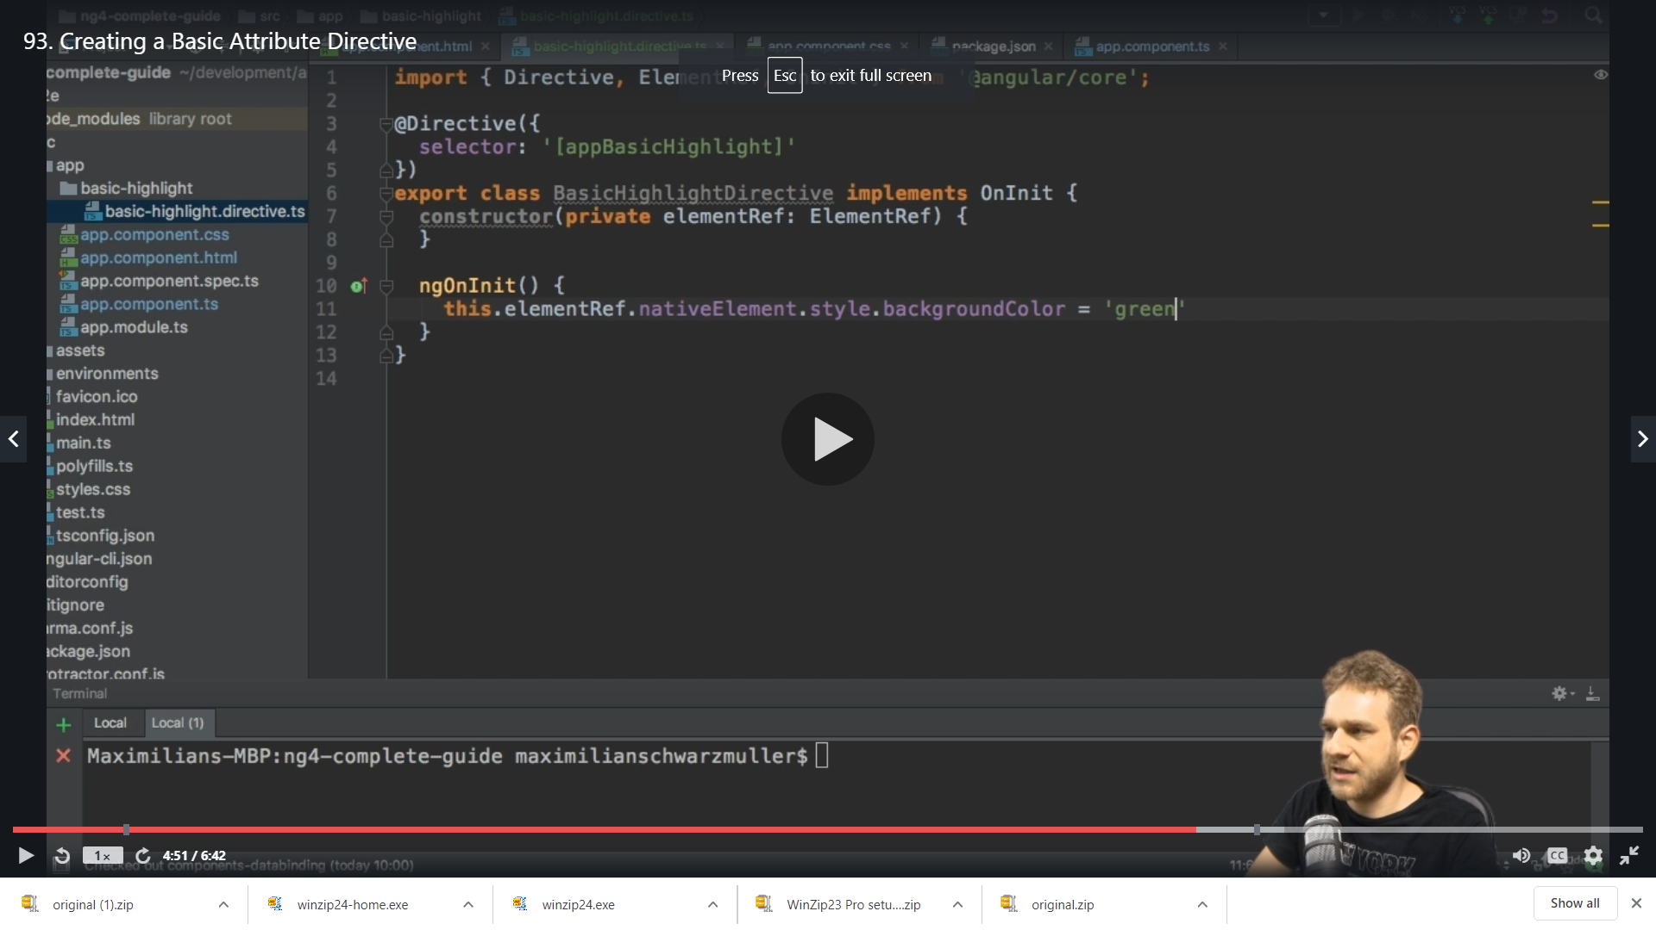

So here we are getting access to the exact element on which the directive was placed on and then we are overriding the style of that element

So now lets use this directive we need to do 2 things

1)Inform angular that we have a new directive

So we go to appmodule

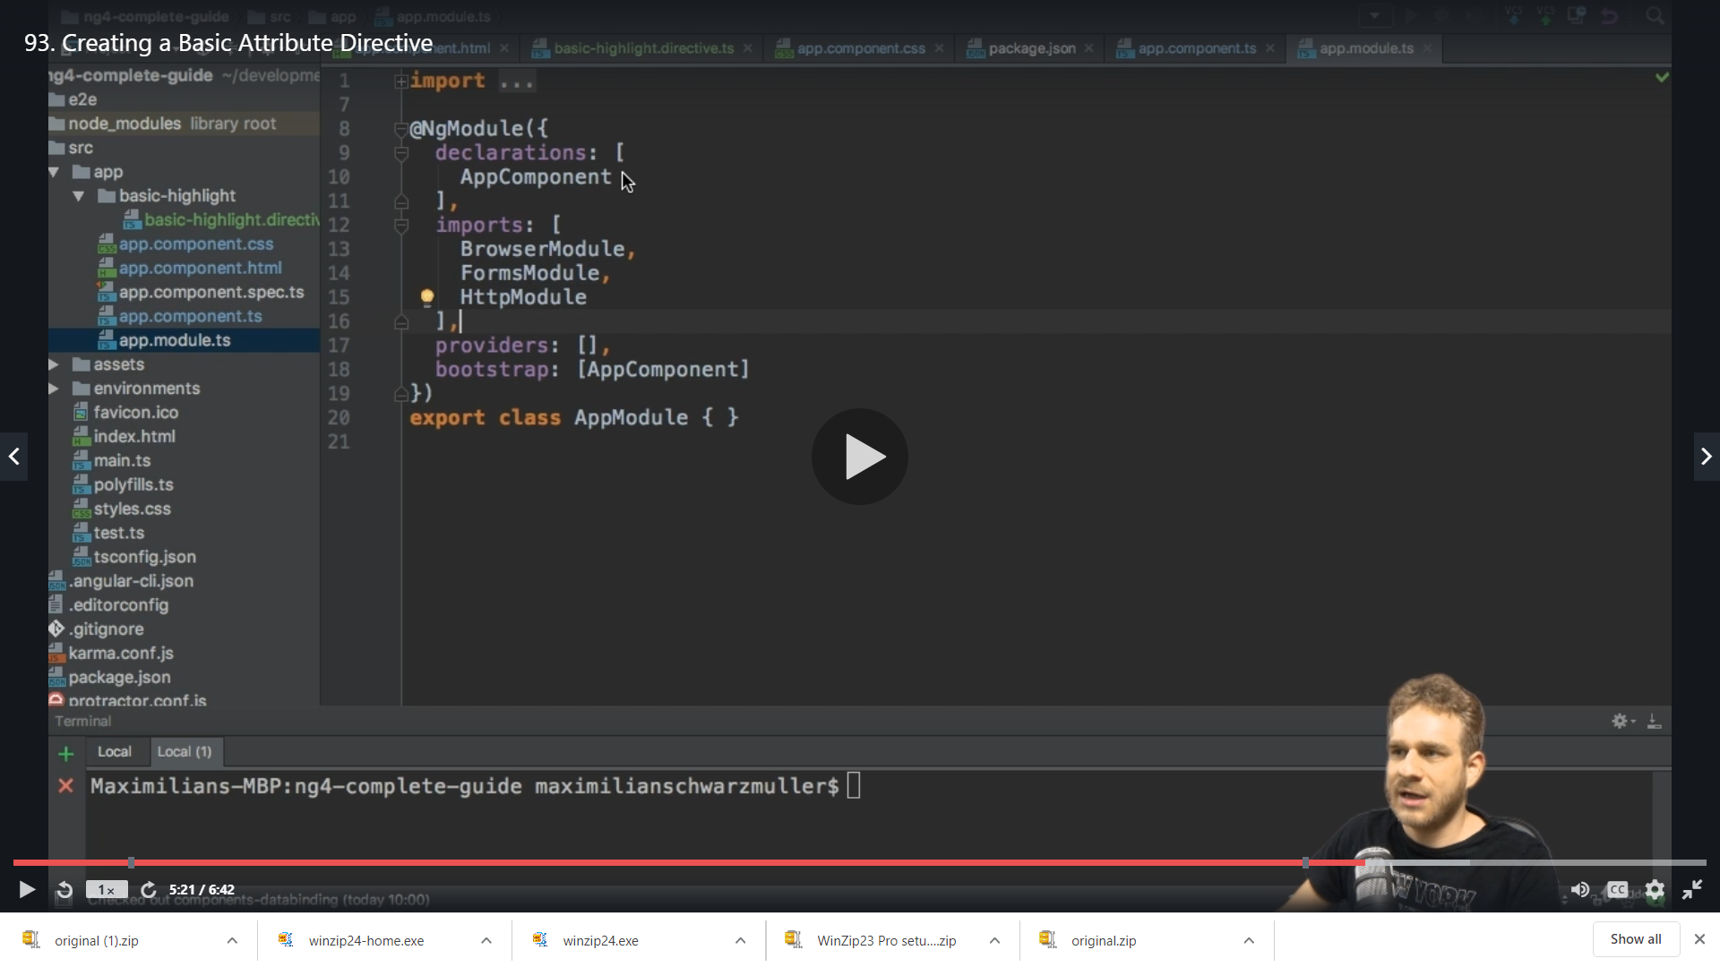

We add our directive

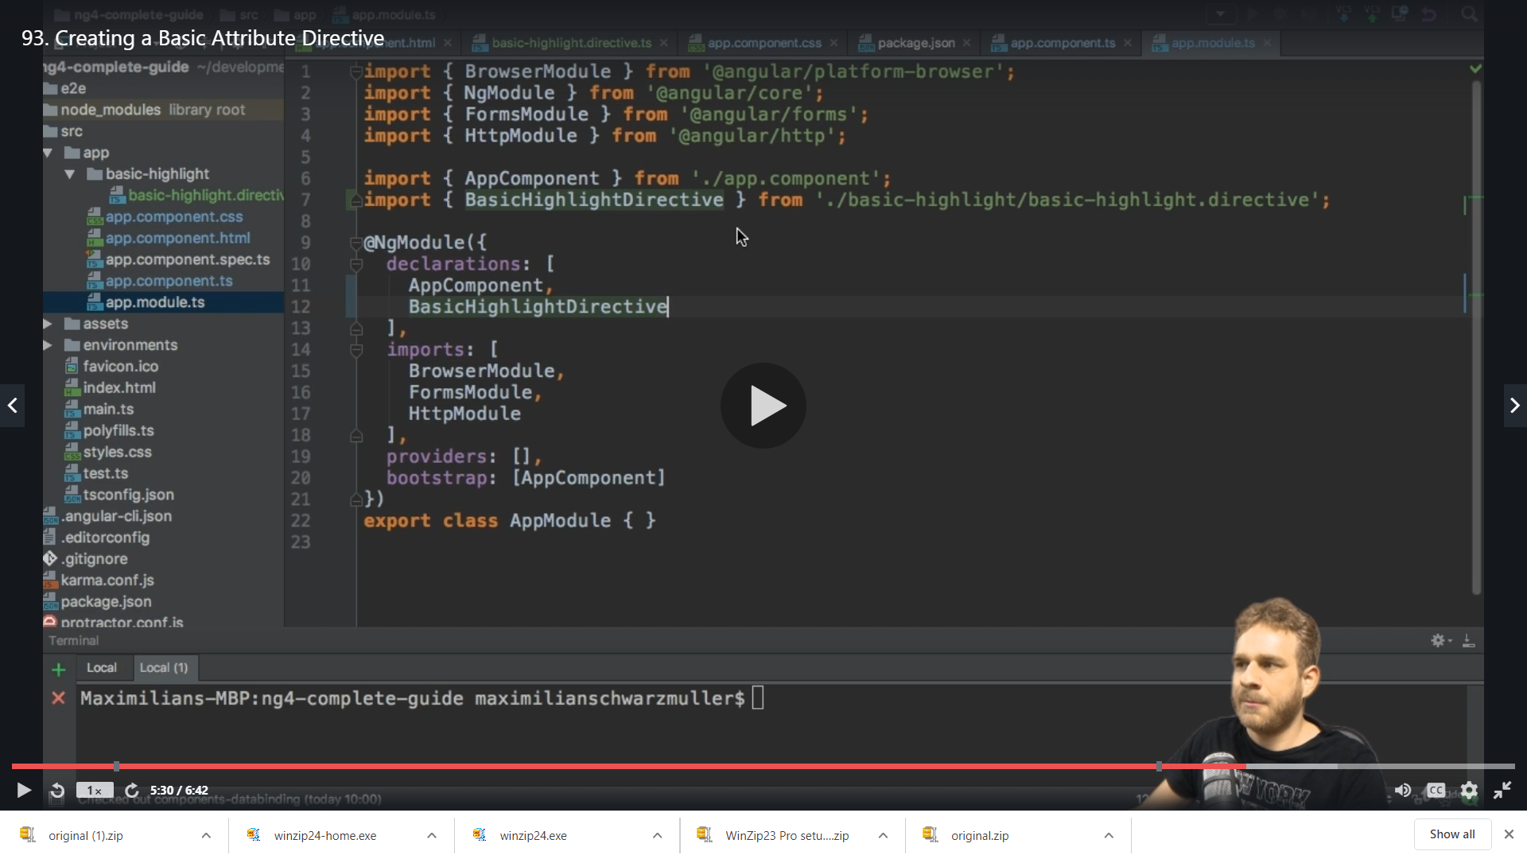

Now we can use it our app

2)We use it in our html

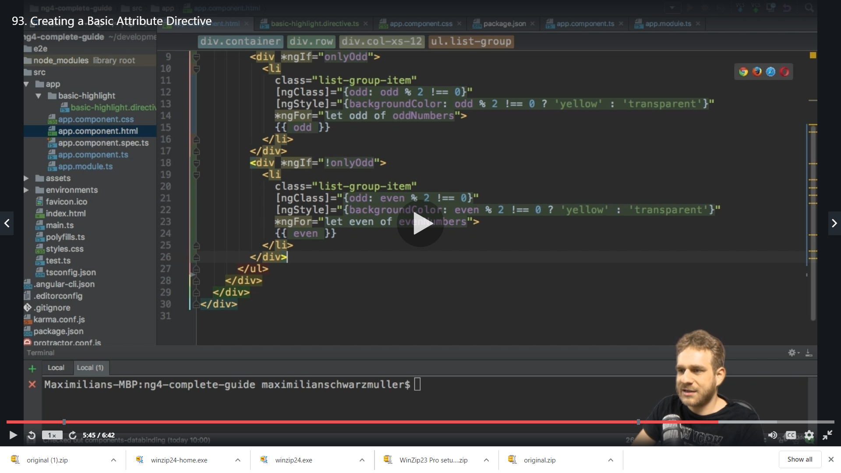

Here we don’t use square brackets and we don’t have to give any value

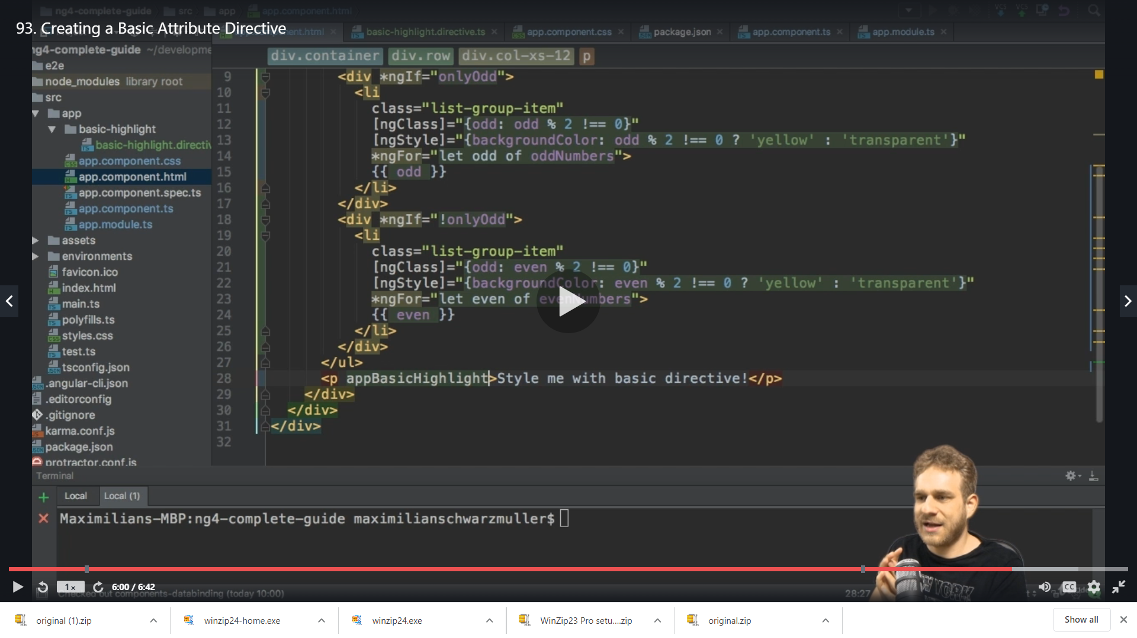

The directive”appBasicHighlight” name is the slector we setup and the [ ] are not part of the name its part of the slector style telling angular to select it as style on an element

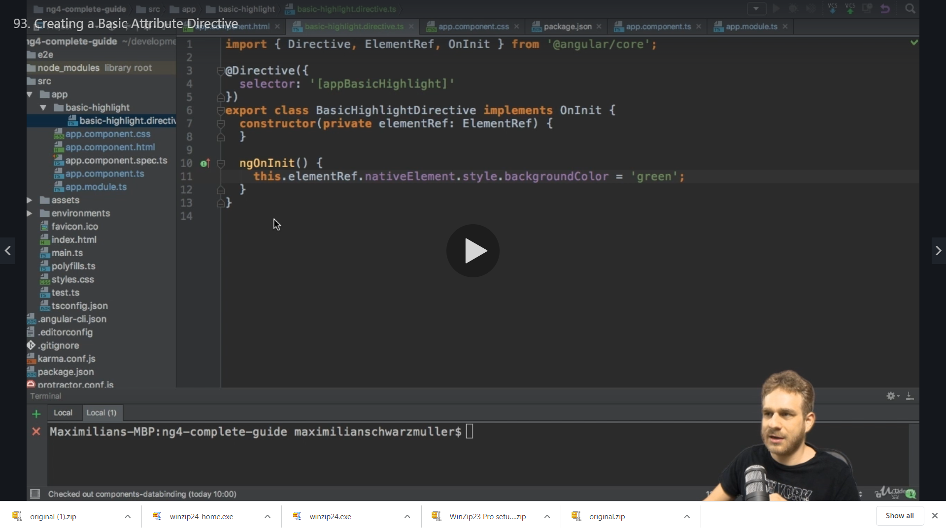

We get on save

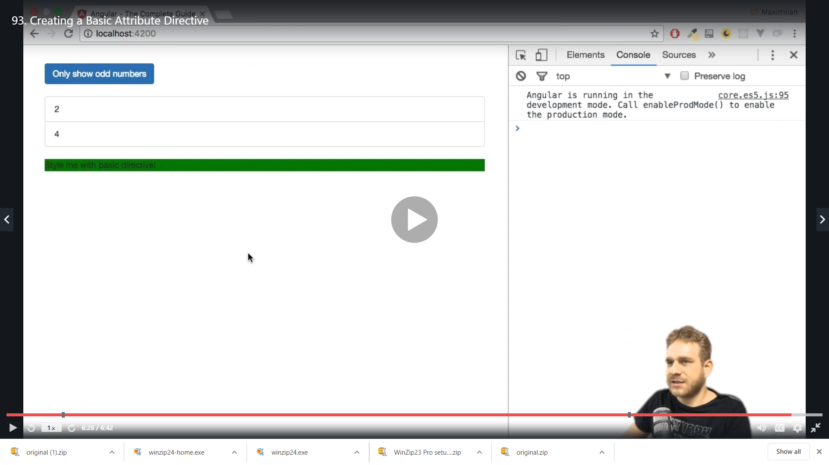

We enhance it further

Accessing elements like this is not a good practice the good practice is like below

**Using the Renderer to build a better attribute directive**

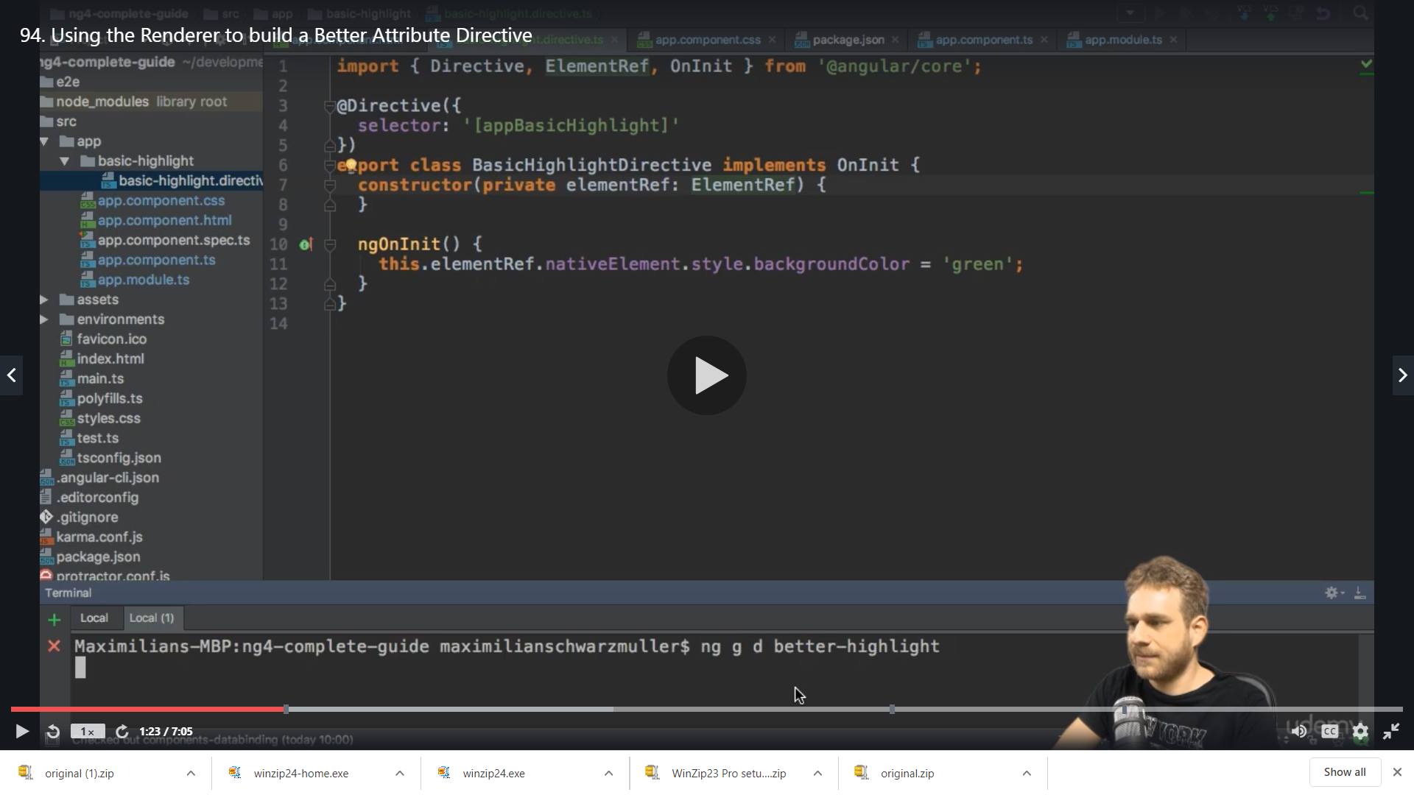

We create a new directive with the Cli ng generate directive under better-highlight folder

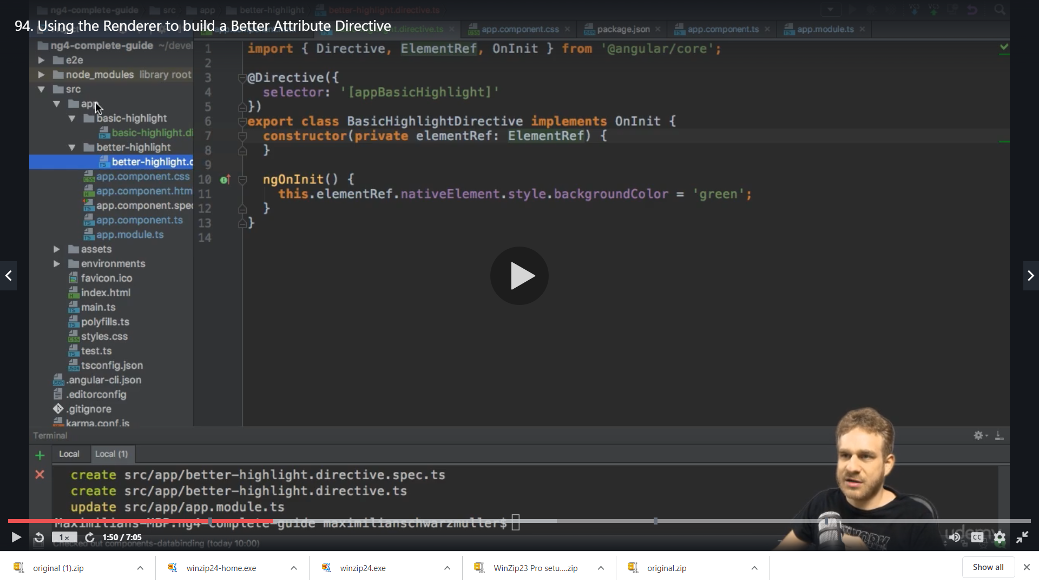

We get the entry in the app module when me make a directive from cli automatically

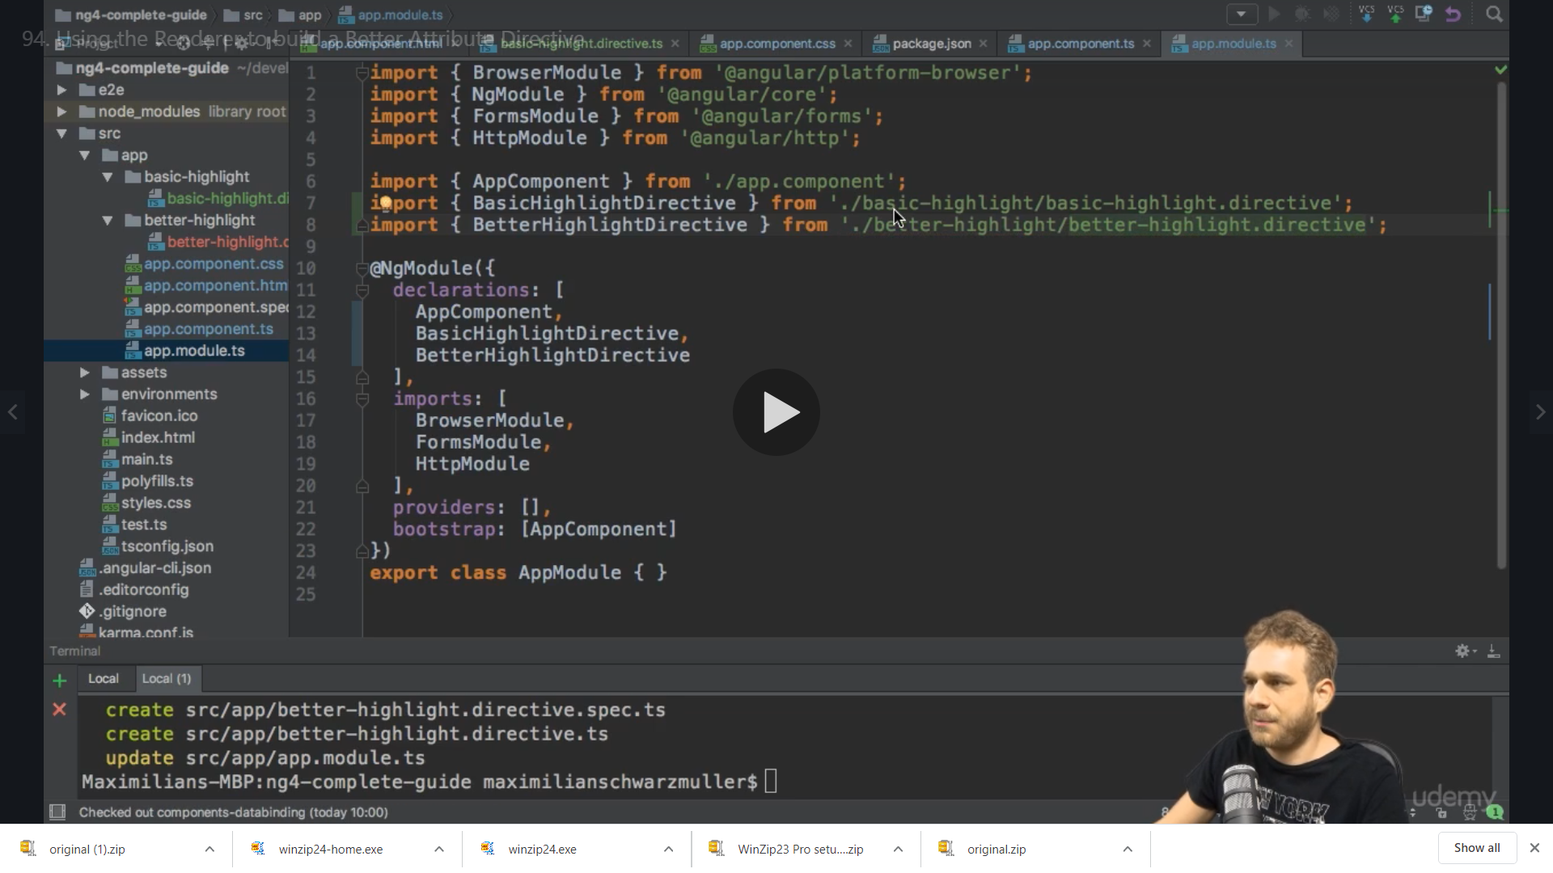

So now in BetterHighlightDirective

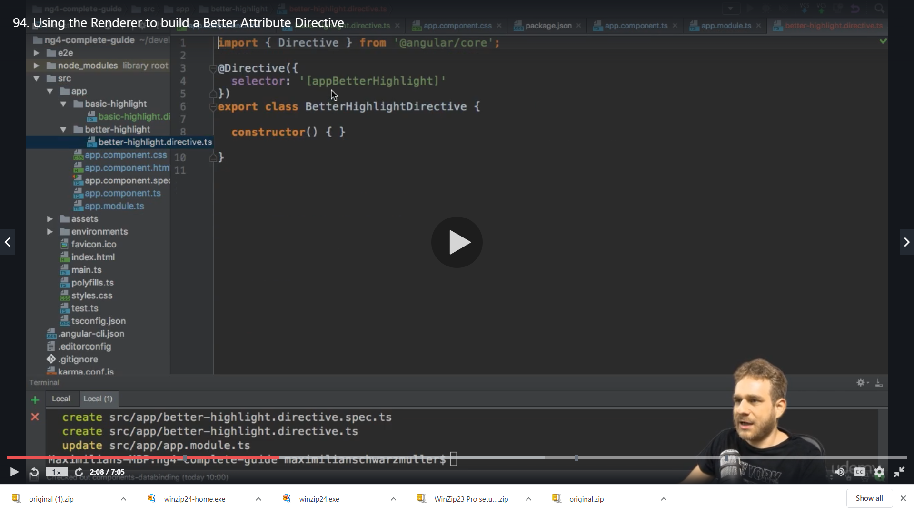

We inject the renderer

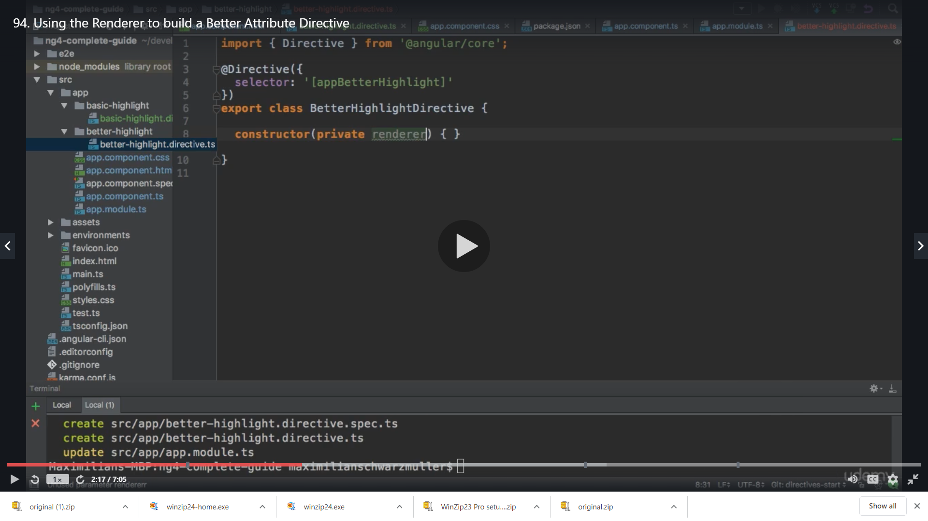

Which is of type Renderer2 which is imported from angular /core

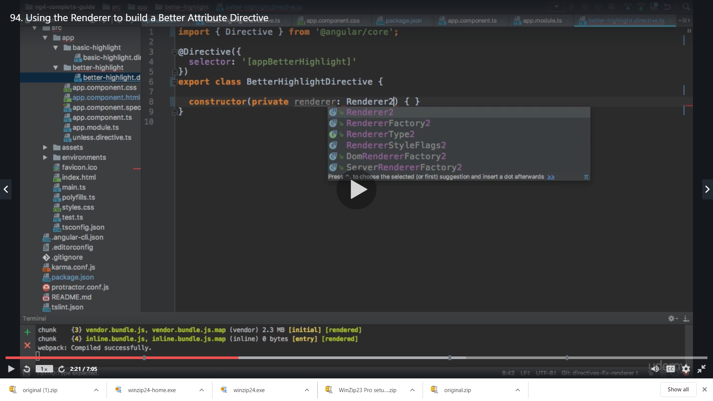

Now we use ngOnInit as we have initialization work ,with renderer we get couple of selectiosn to work wit DOM

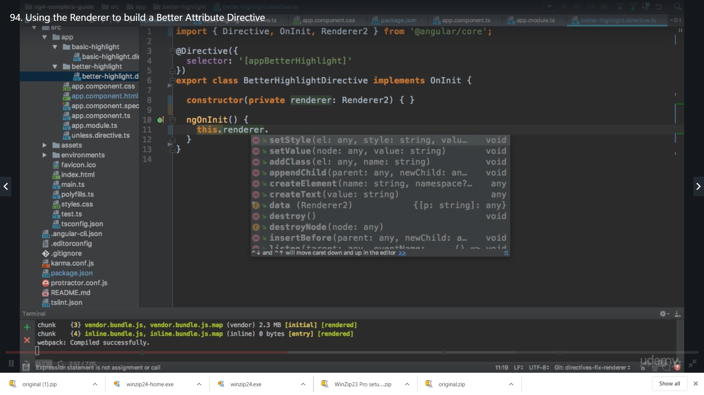

We use setStyle() method ,this method allows us to set the style of element

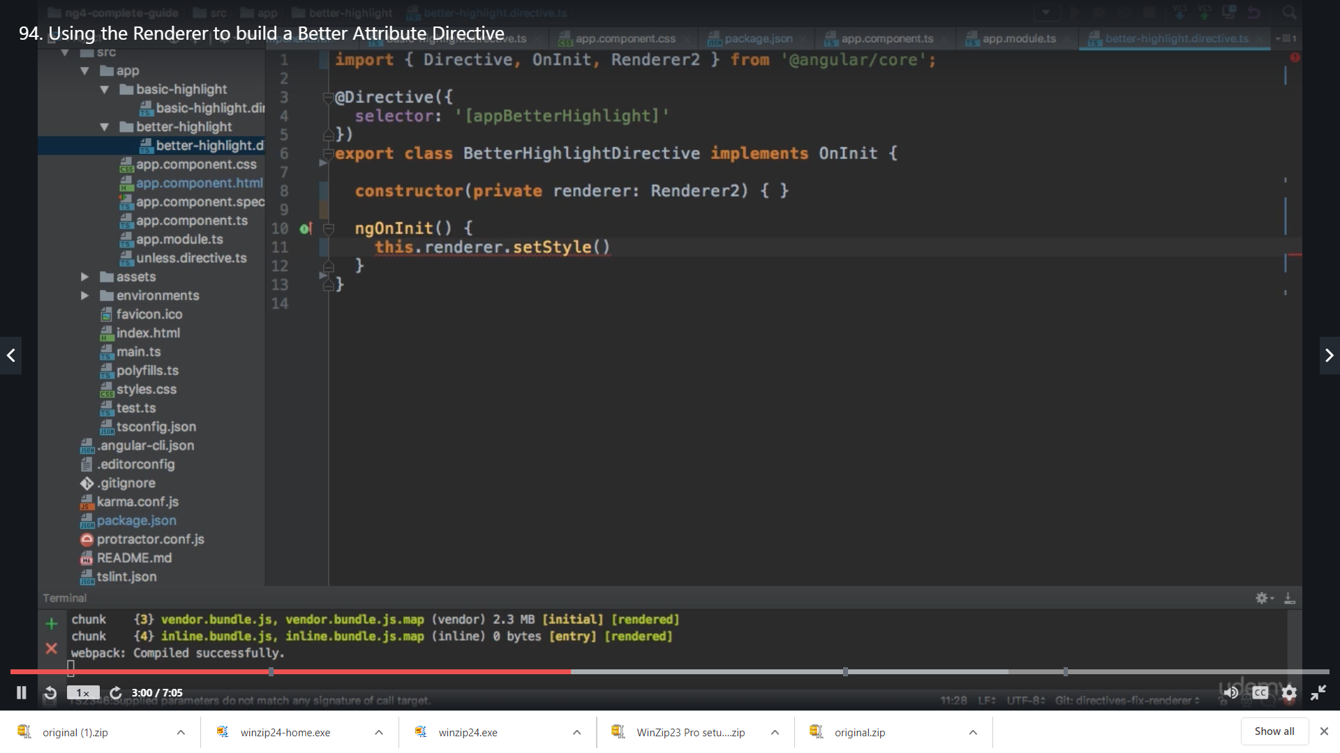

but problem here is that for that we need to have the element for which we need to set the style

So we inject a element reference ie ElementRef in the constructor

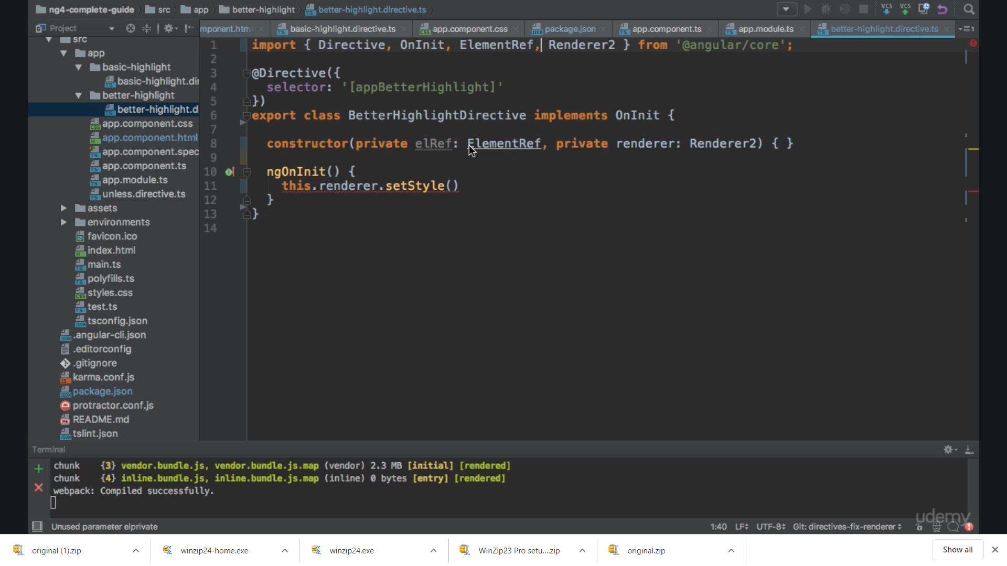

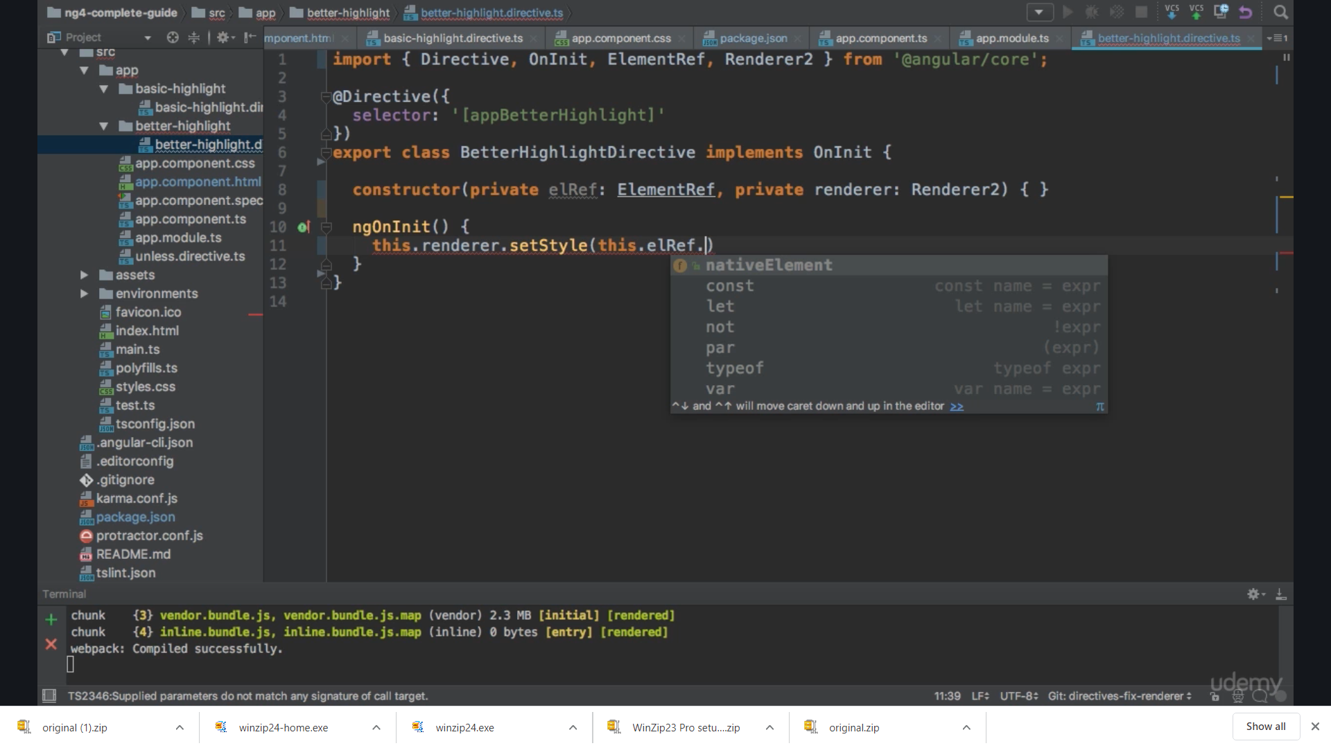

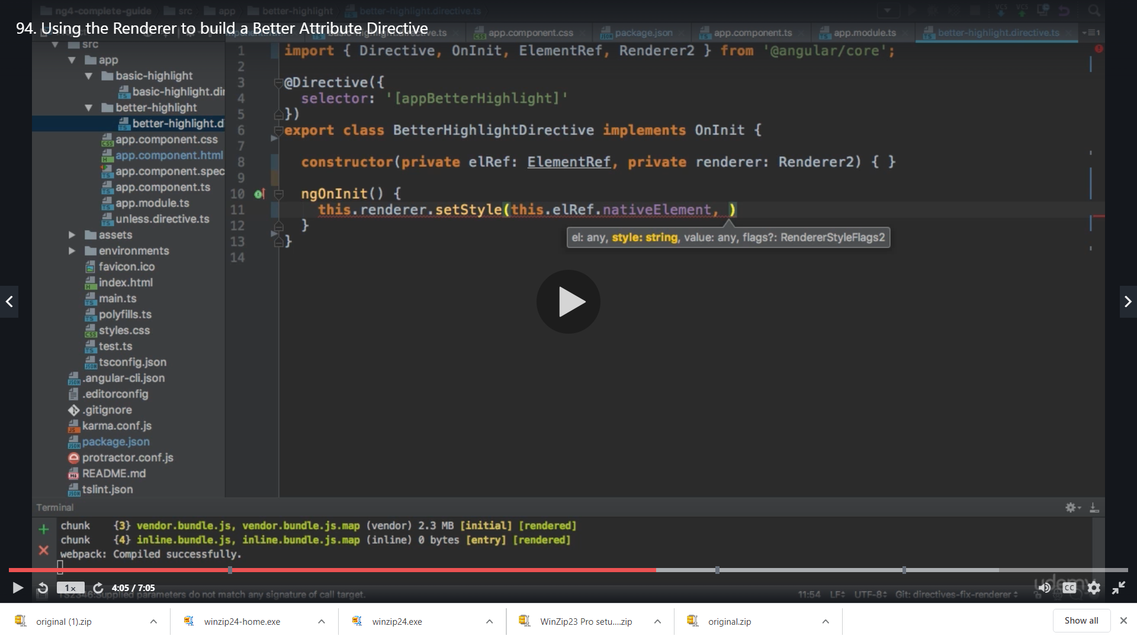

The setStyle() method needs 4 parameters

1)first is which element we want and

2)second is the style we want and

3)thirs is the value we want and

4)the last is the flag object which is optional

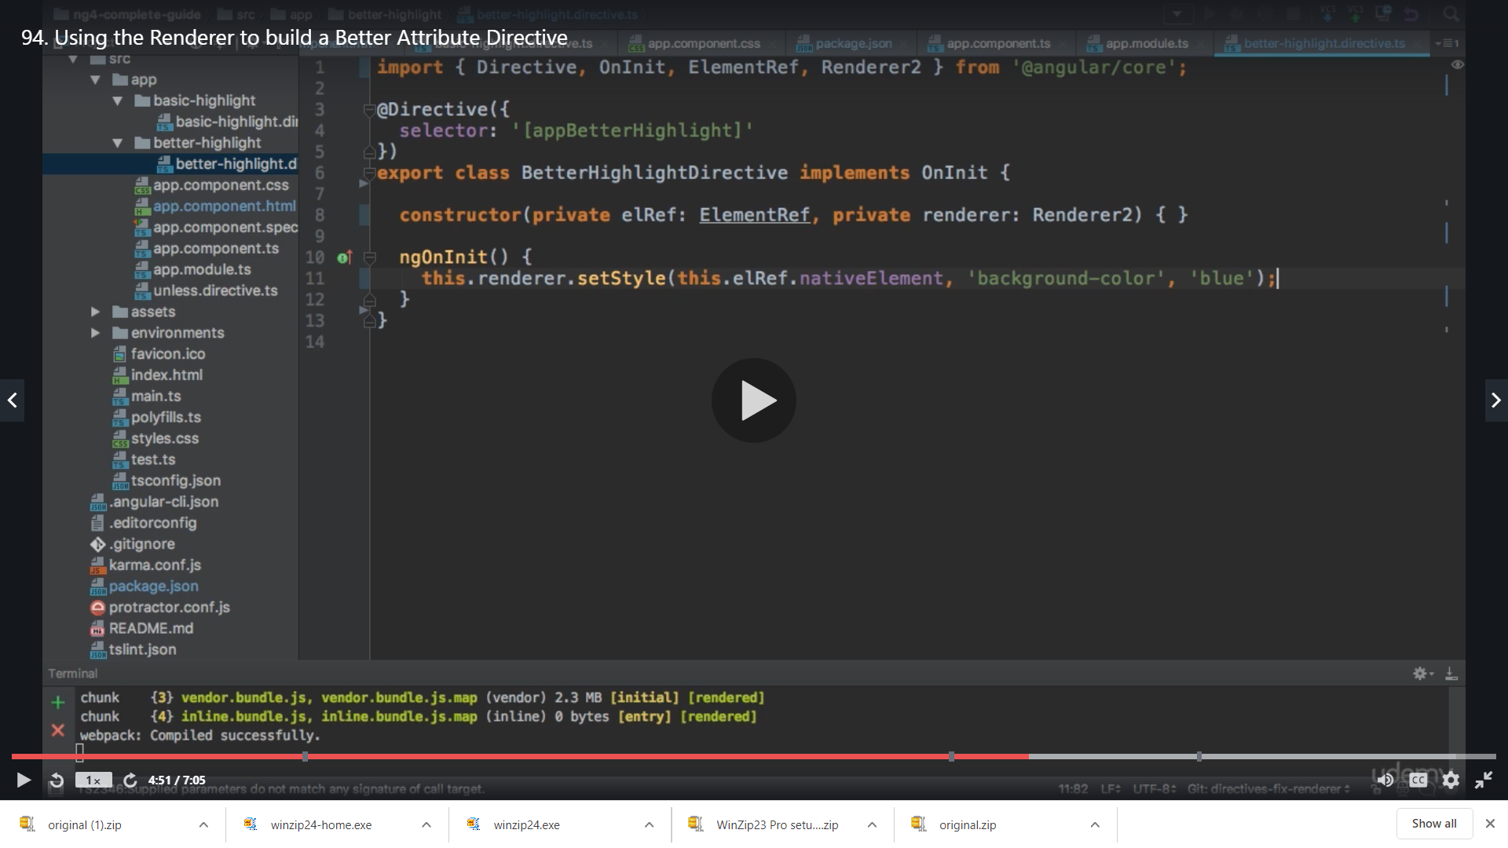

Now we can use this in html

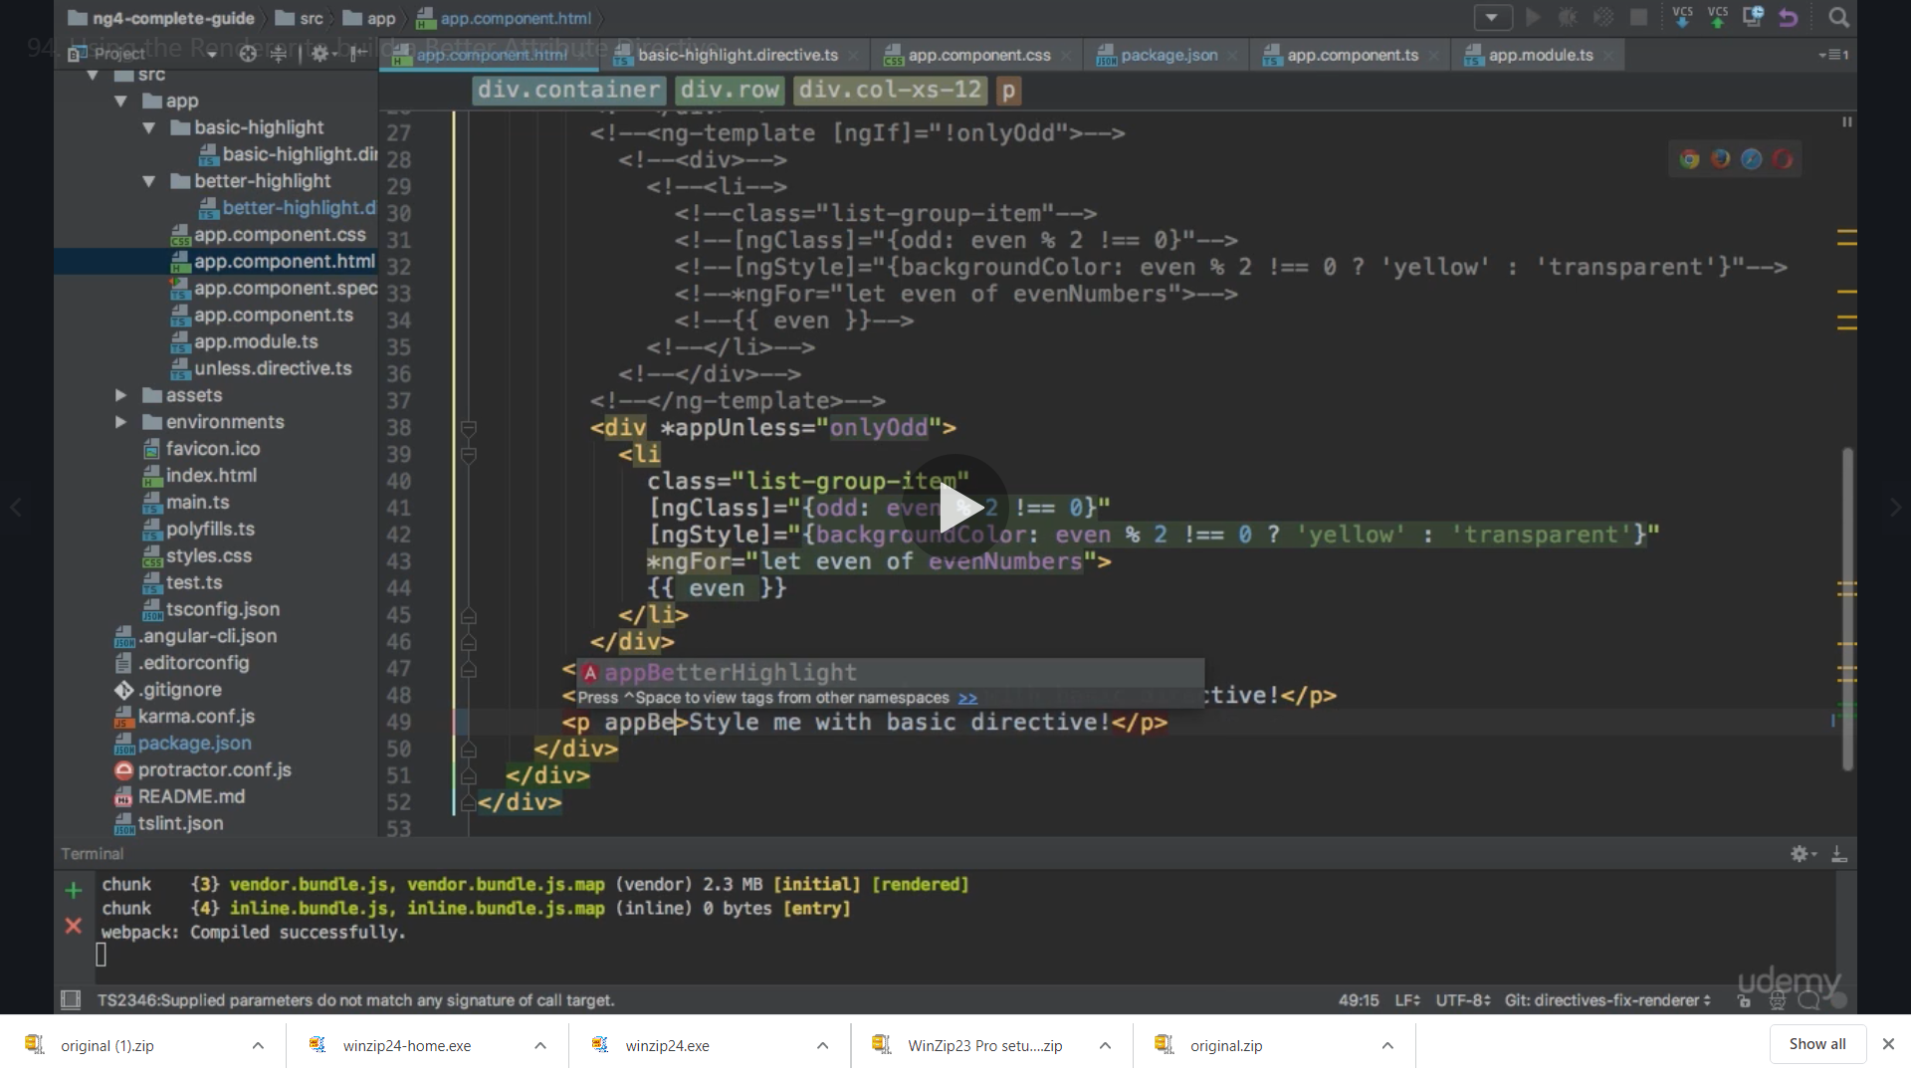

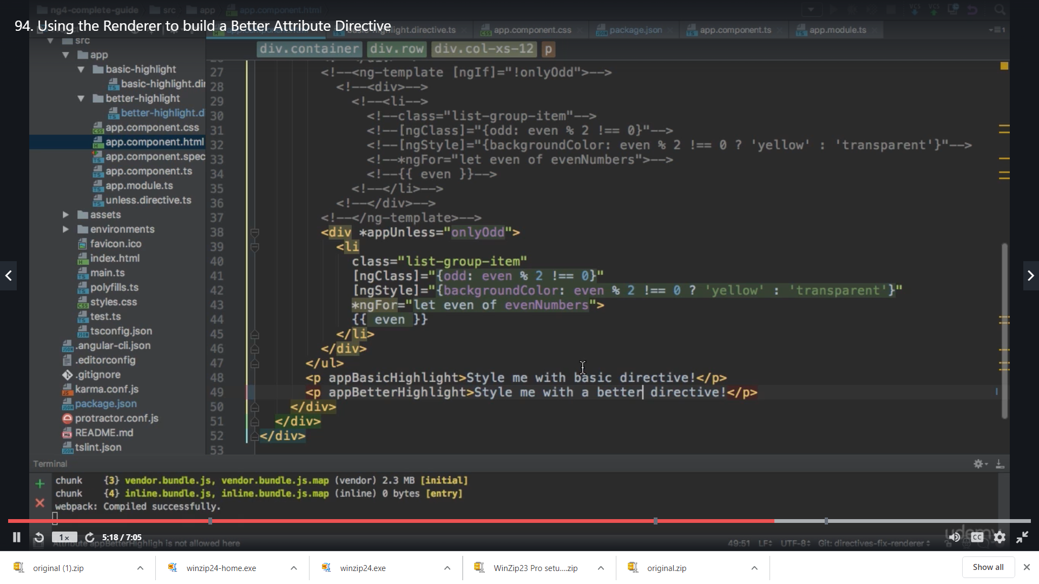

We save and get

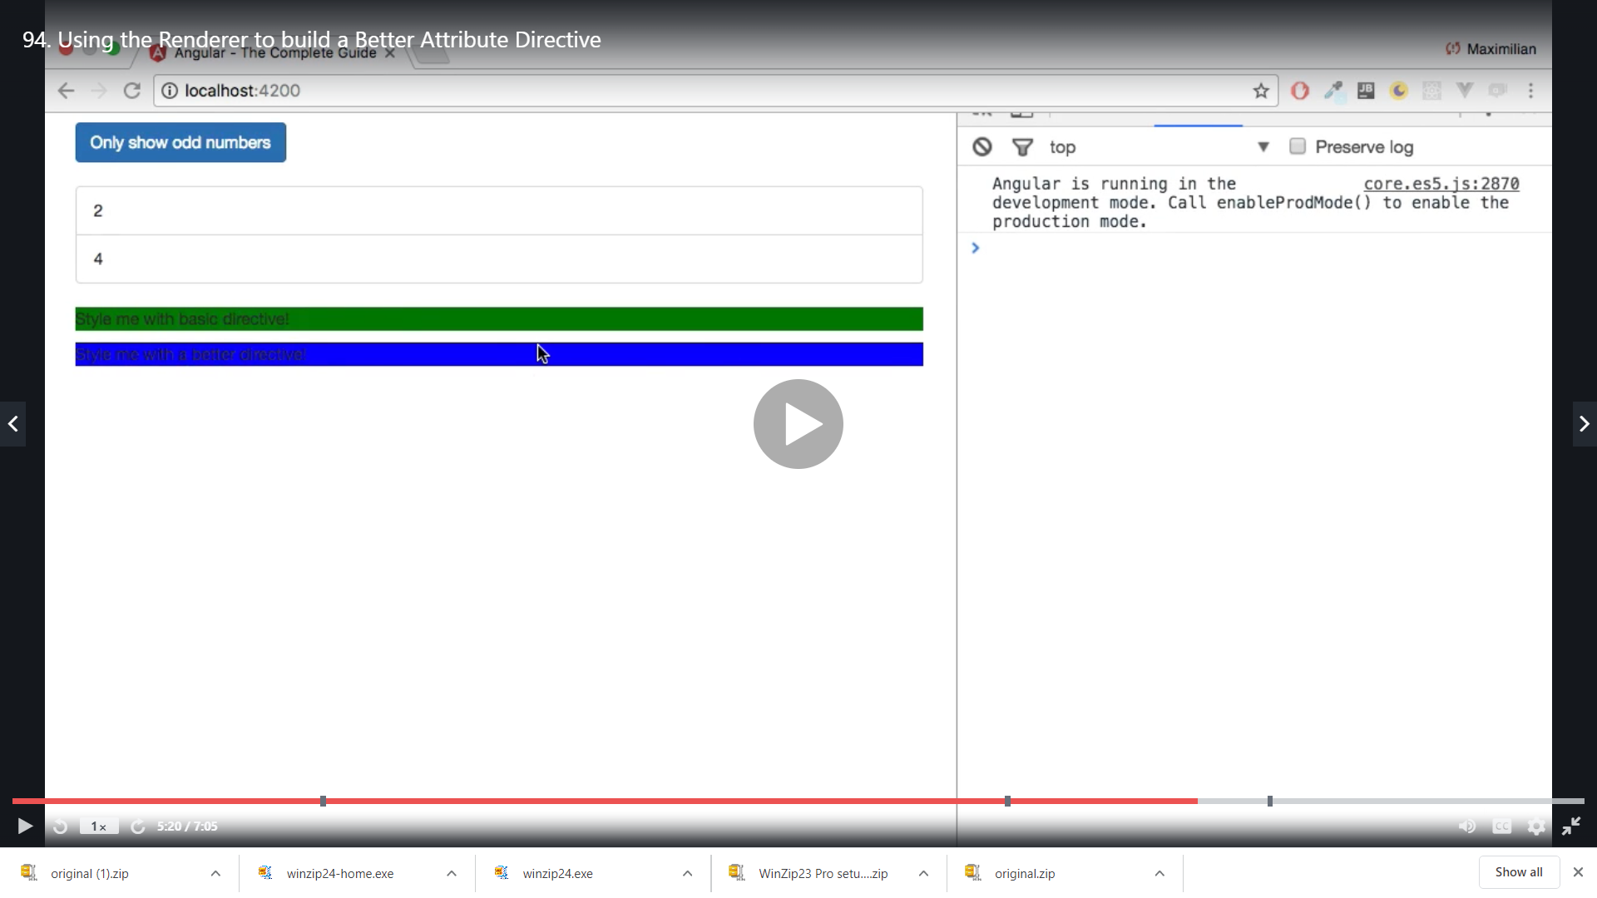

Here we are using the renderer to access the Dom as compared to the first one

Renderer approach is better when we do not have access to the DOM so if we do not have renderer and use the first approach we might get error

(This code will be a little changed ahead the setStyle() method implementation imp)

**More about the Renderer**

Extend this base class to implement custom rendering. By default, Angular renders a template into DOM. You can use custom rendering to intercept rendering calls, or to render to something other than DOM.

In the last lecture, we used the Angular Renderer class to change the style of a HTML element. As explained in that lecture, you should use the Renderer for any DOM manipulations.

Of course, you can do more than simply change the styling of an element via setStyle(). Learn more about the available Renderer methods [here](https://angular.io/api/core/Renderer2).

<https://angular.io/api/core/Renderer2>

**Using HostListener to listen to Listen to Host Event**

@HostListener is Angular's decorator method that's used for listening to DOM events on the host element of both component and attribute directives. @HostListener sets the listeners once the directive is initialized and removes them automatically once the directive gets destroyed.

We are getting th blue background always which we do not want , we want it to get blue only when we hover over it and if mouse is moved away it should go back to no colour

So now in below code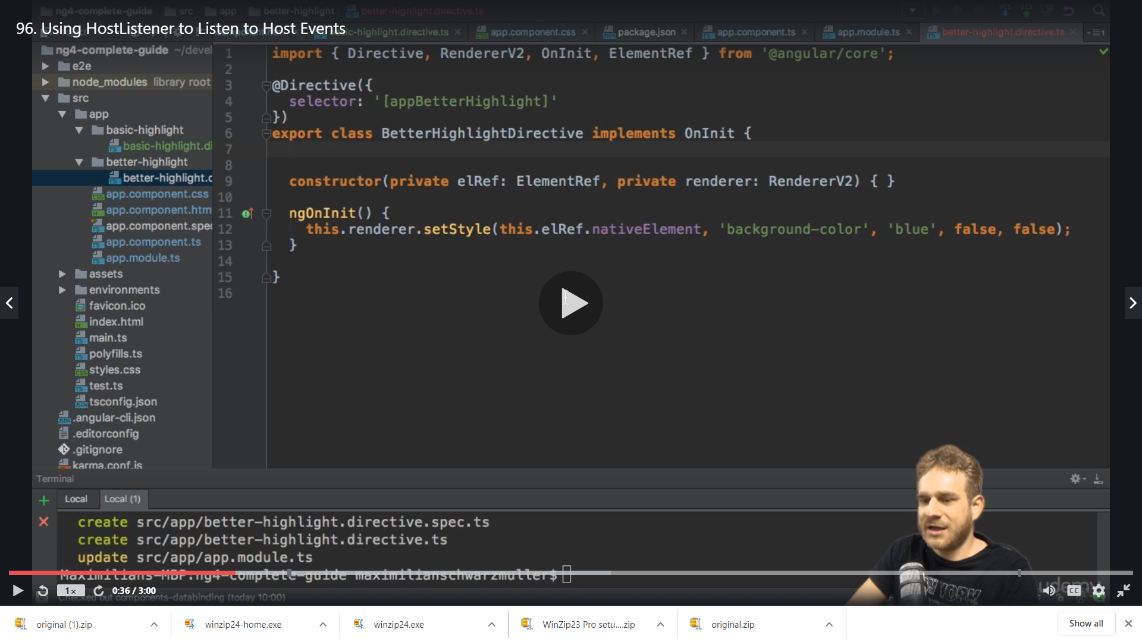

We add a new decorator for HostListener

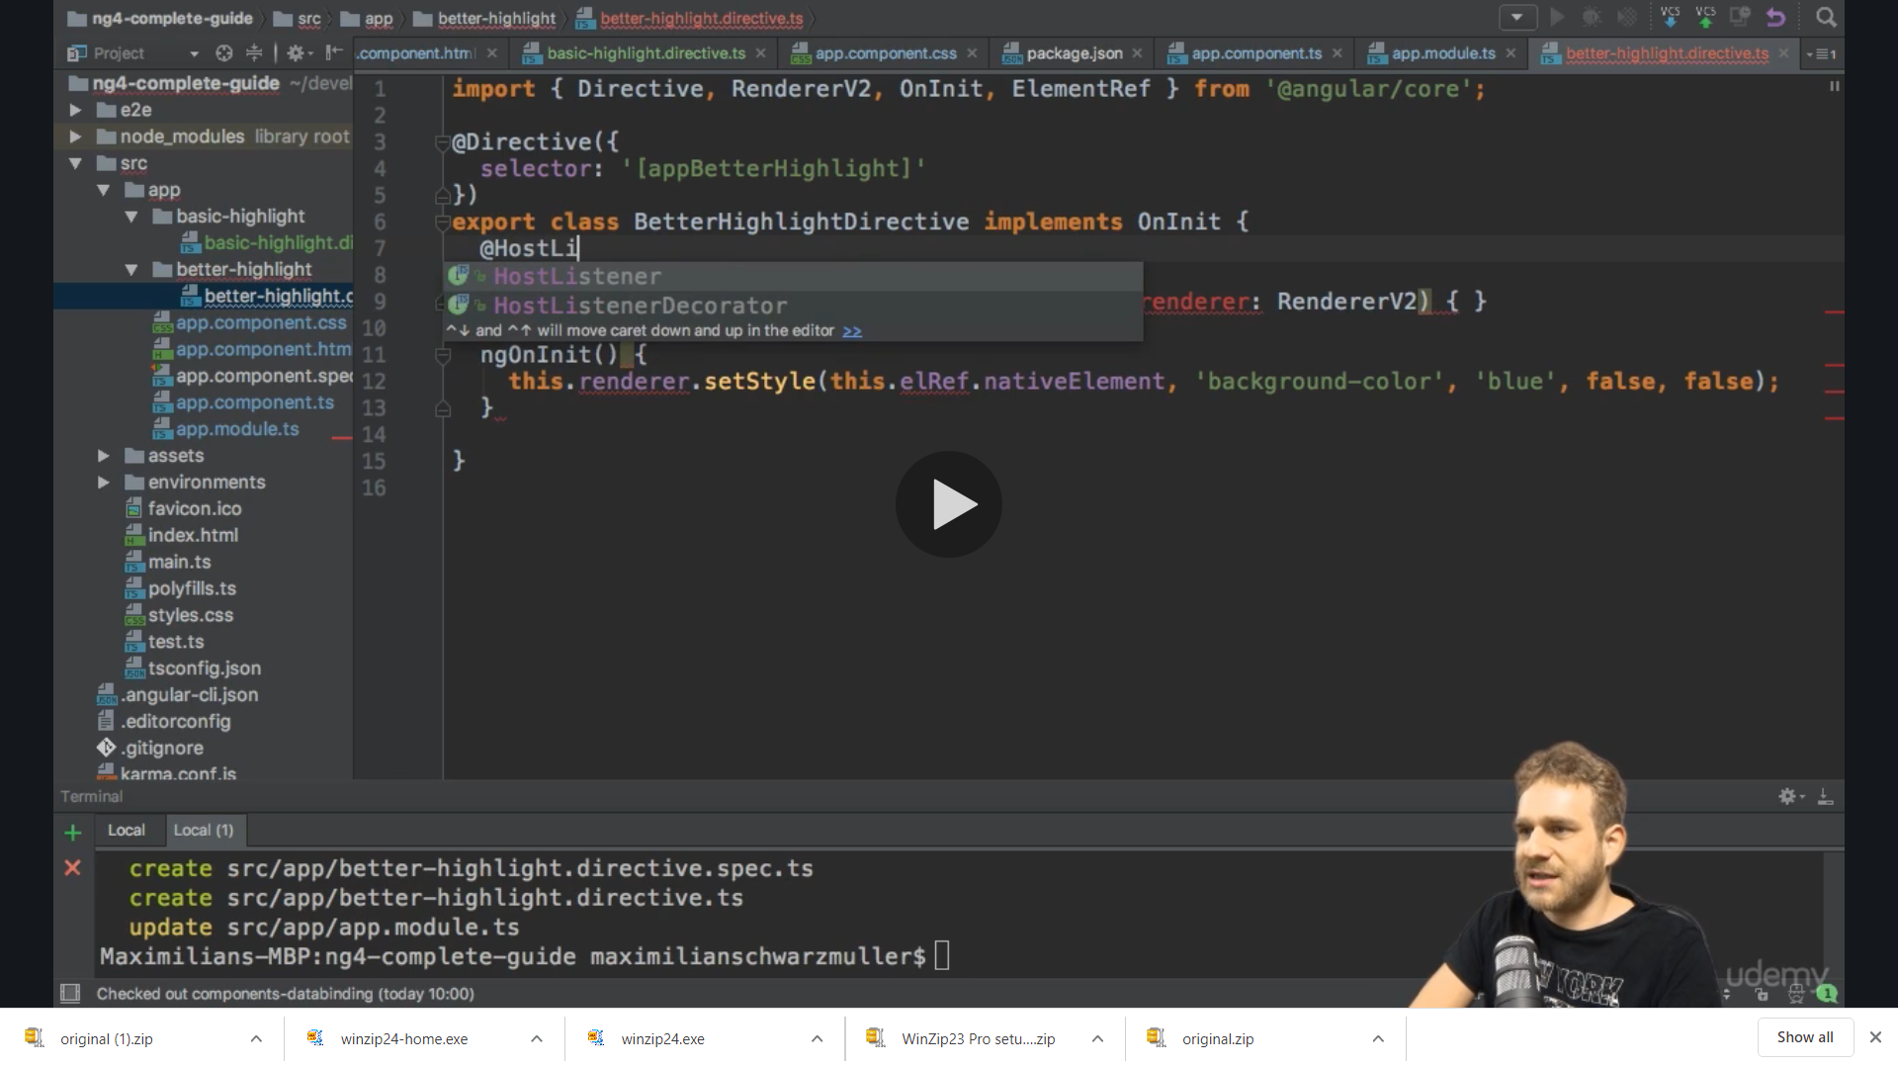

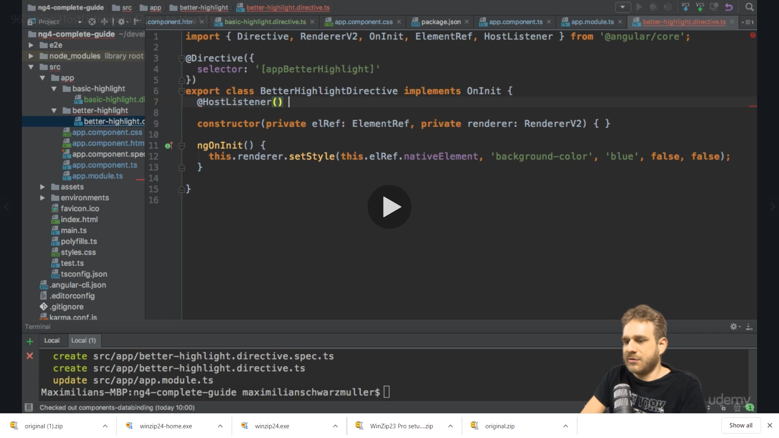

We add it to a method which we will execute

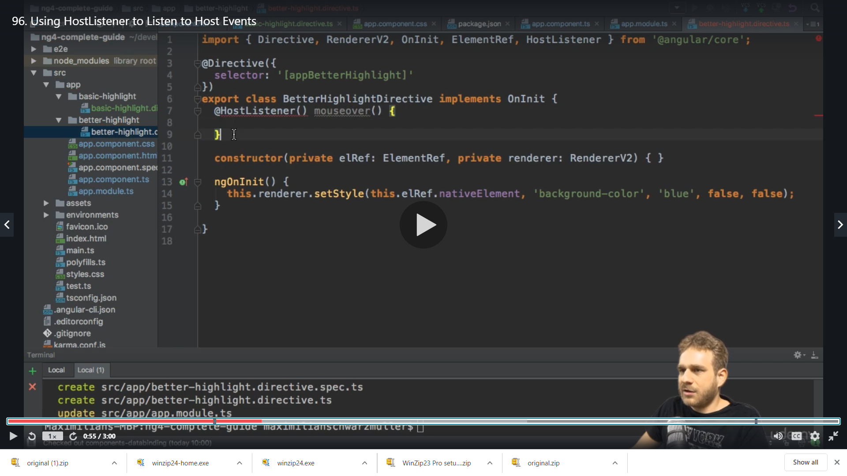

We move it below ngOnInit()

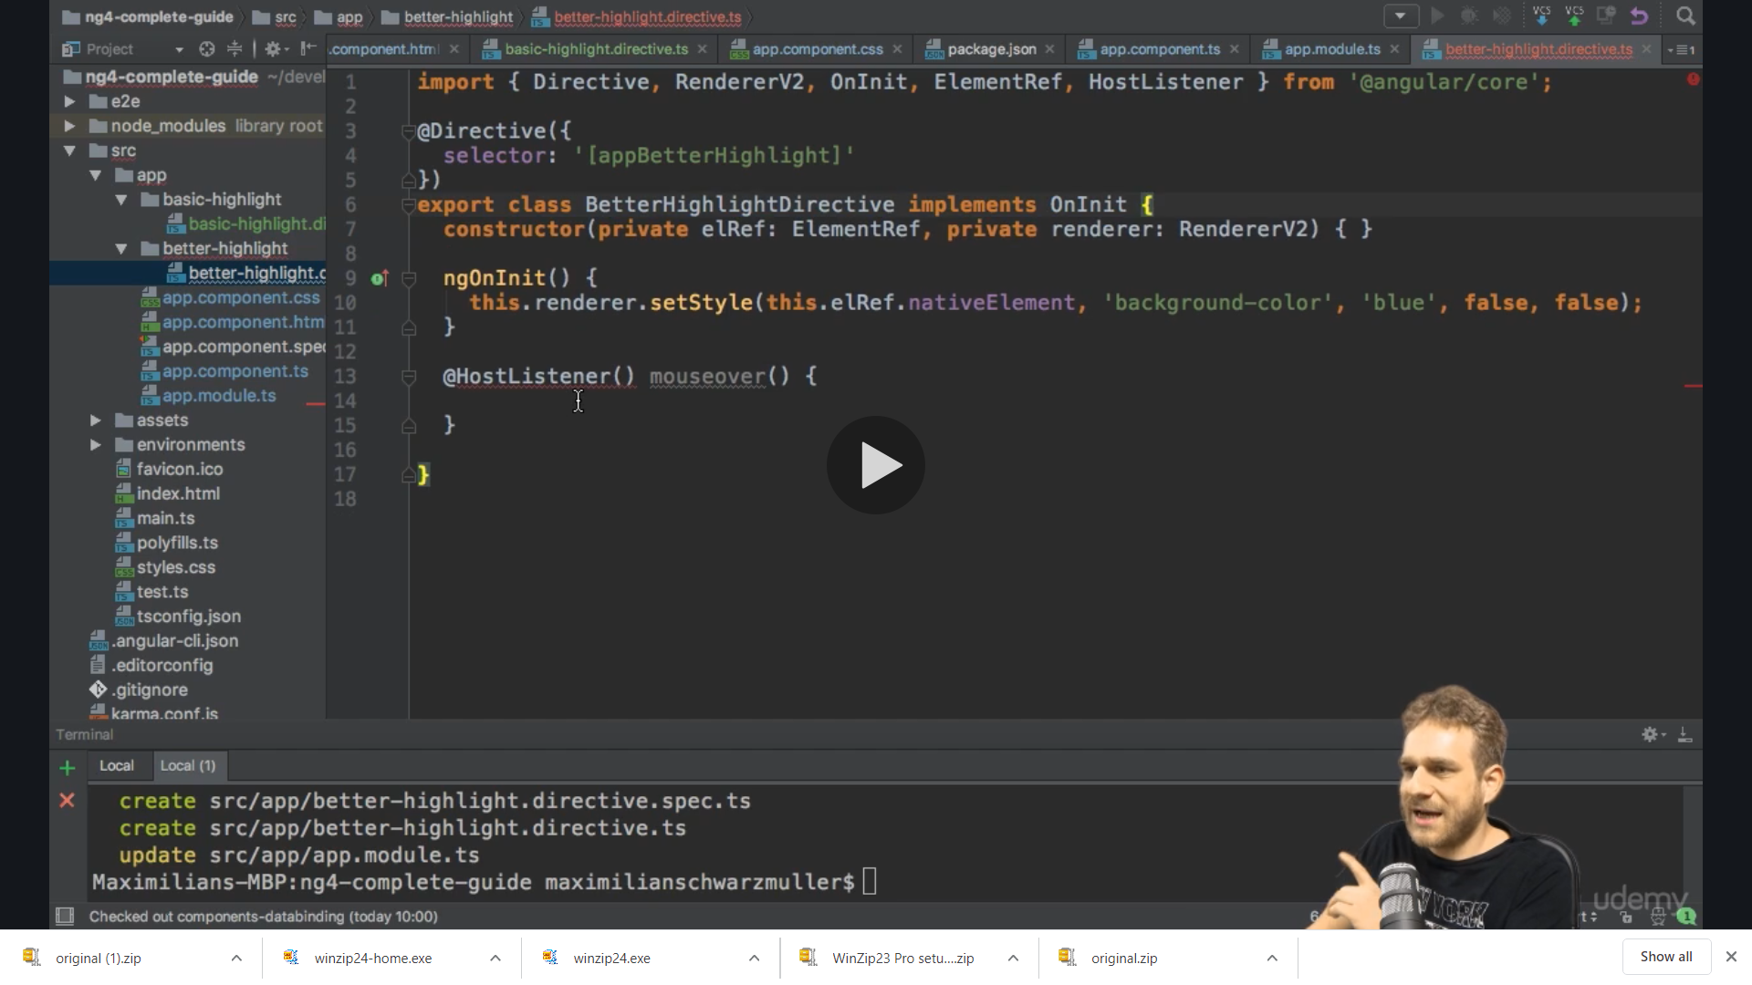

This can trigger it whenever an event occours and that event we can add as string as below just the same we have for event binding and property binding

@HostListener(‘mouseenter’) eg click ,mouseenter,mouseover ,mouseleave etc

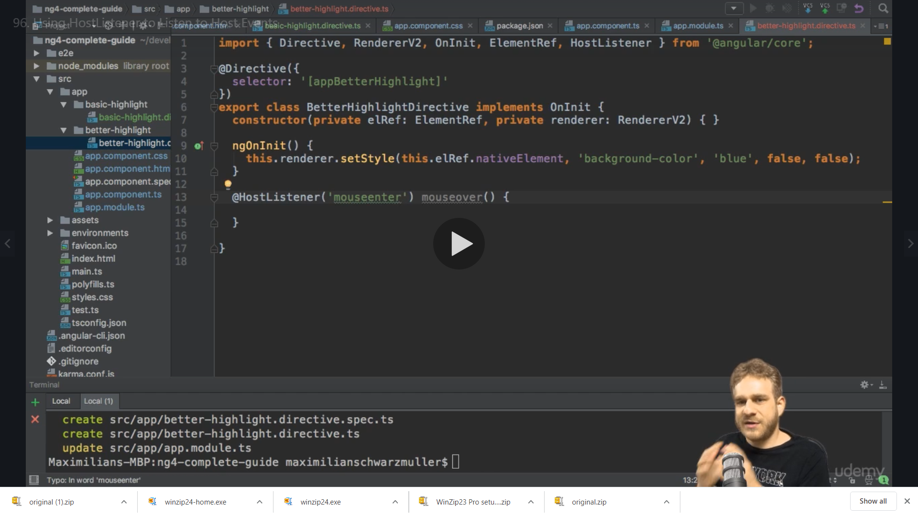

Now we receive the event data in our method parameter as type Event we can also pass our custom event here

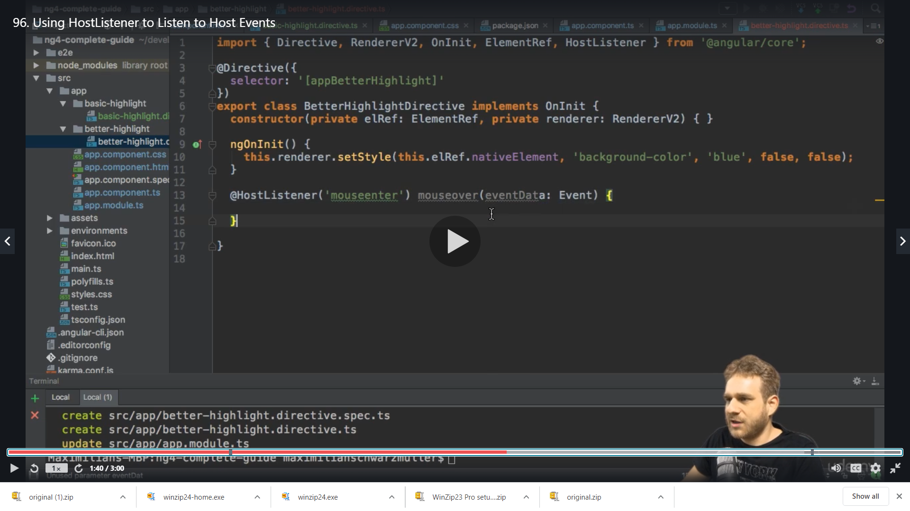

Now we want to change the background color of element ,so we cut past the previous code for color in this method from ngOninit

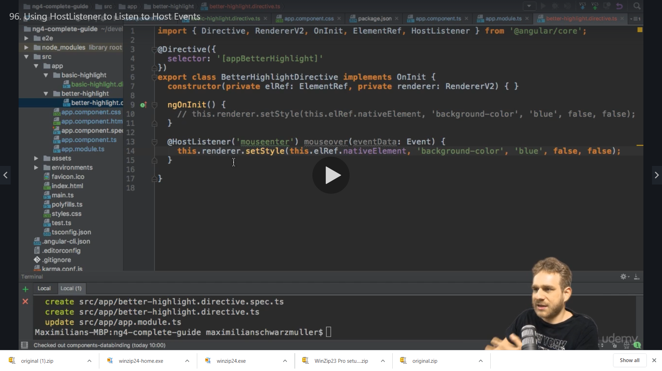

We copy paste the same and add another method inplace of mouseover and we change the name of the event from mouseenter to mouseleave and background color to transparent

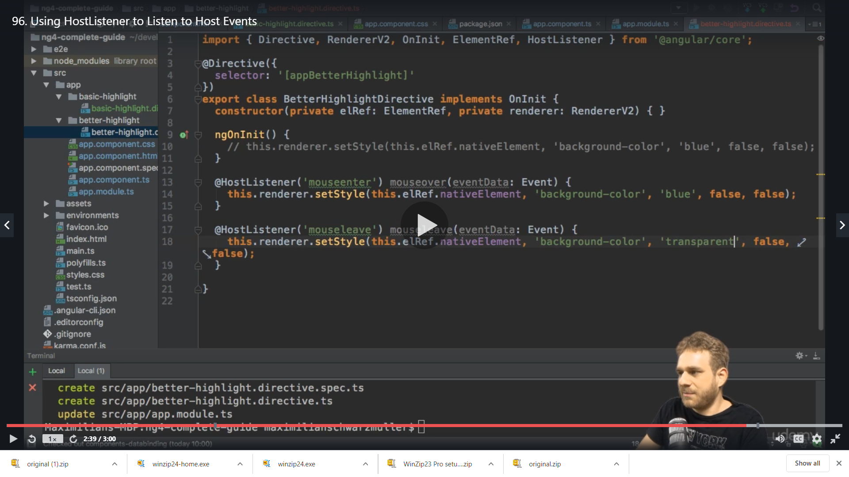

Now eneh we hover we get the color

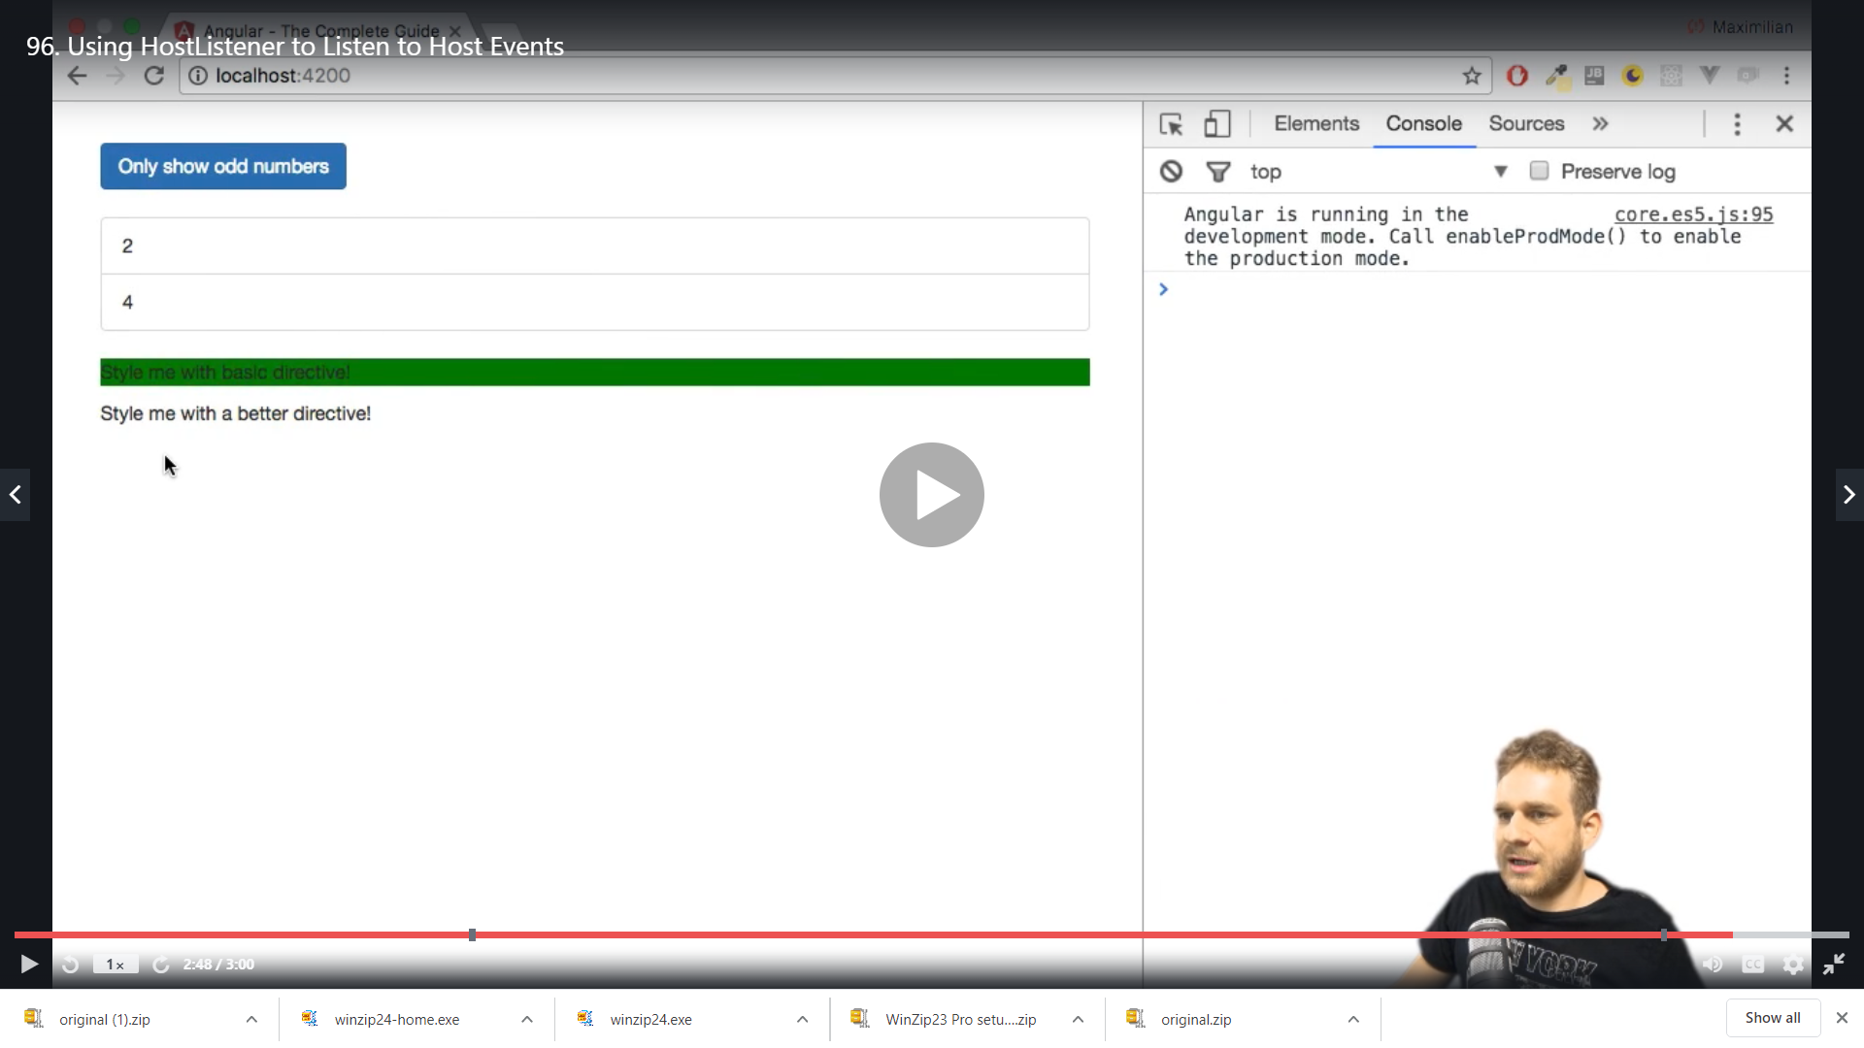

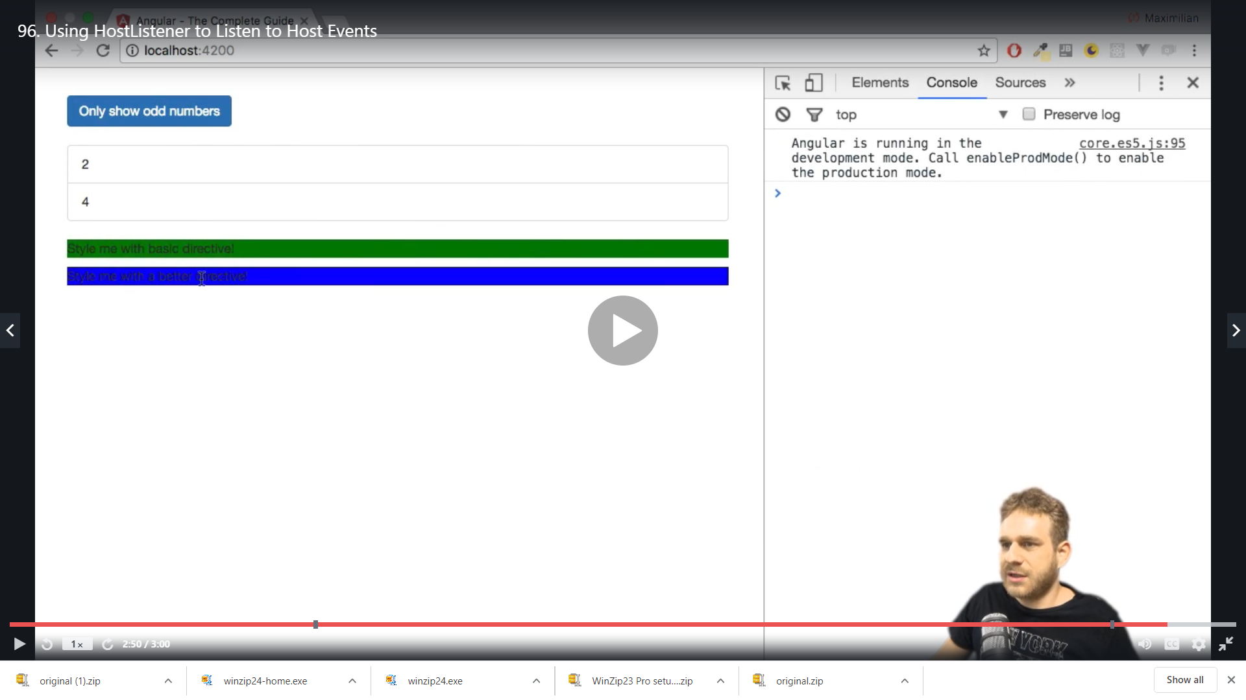

Here our HostListener is reacting now to user events

**Using @HostBinding to Bind to Host Properties**

This Decorator marks a DOM property as a host-binding property and supplies configuration metadata. Angular automatically checks host property bindings during change detection, and if a binding changes it updates the host element of the directive.

This is even easier wasy if we just want to change the background color as we did

So we add new decorator HostBinding

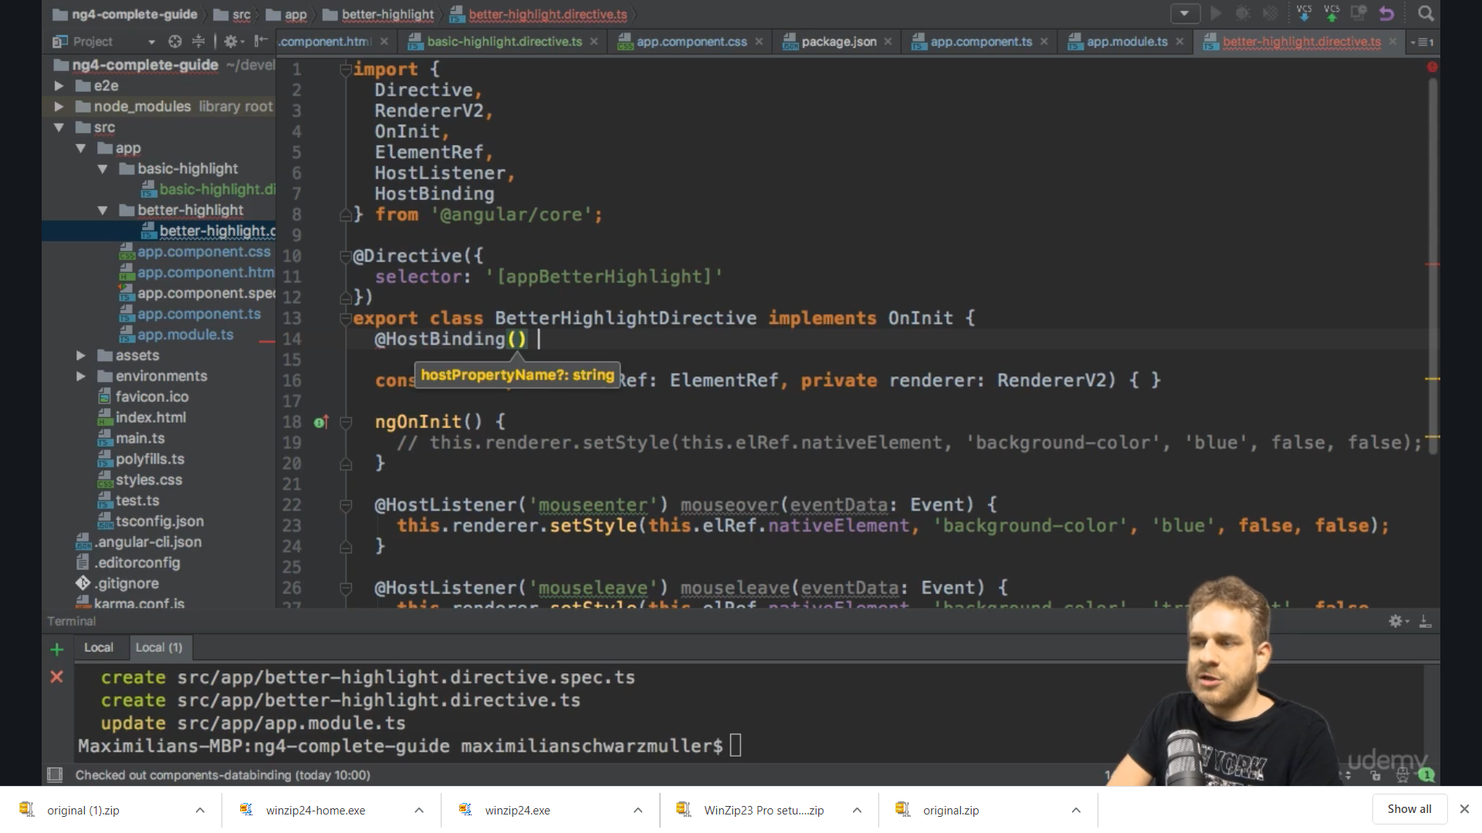

We need to bind it to a property we create backgroundcolor

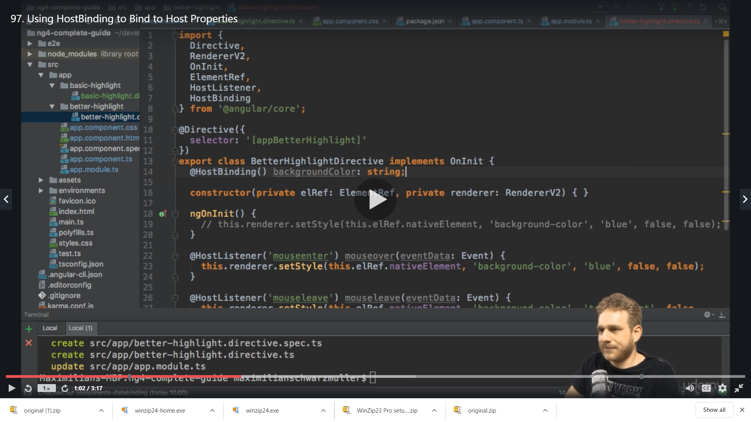

In @HostBinding(‘’) we can pass a string defining to which property of the hosting element we want to bind ,Camel case is imp here as we are accessing DOM property no “background-color” allowed – is not accepted here

We are telling Angular on the element this directive sits please access the style property and the sub property the backgroundColor and we set this to whatever background color we have set

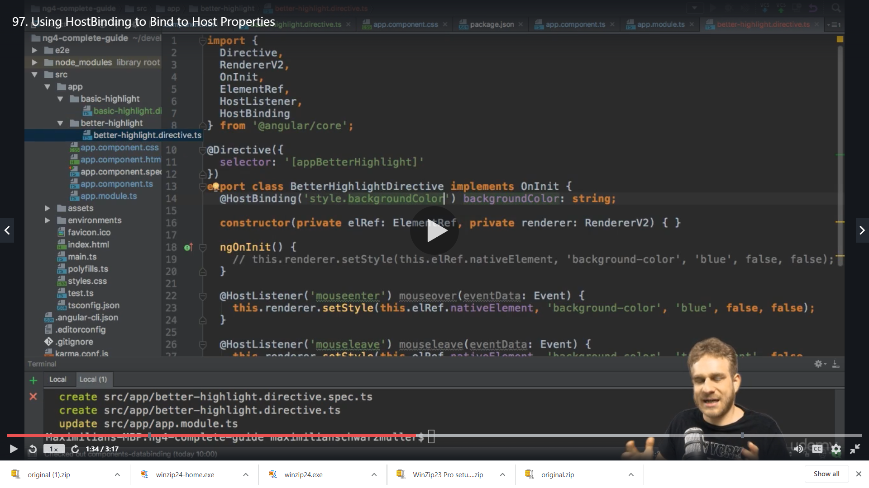

So we set the background color value to blue and transparent

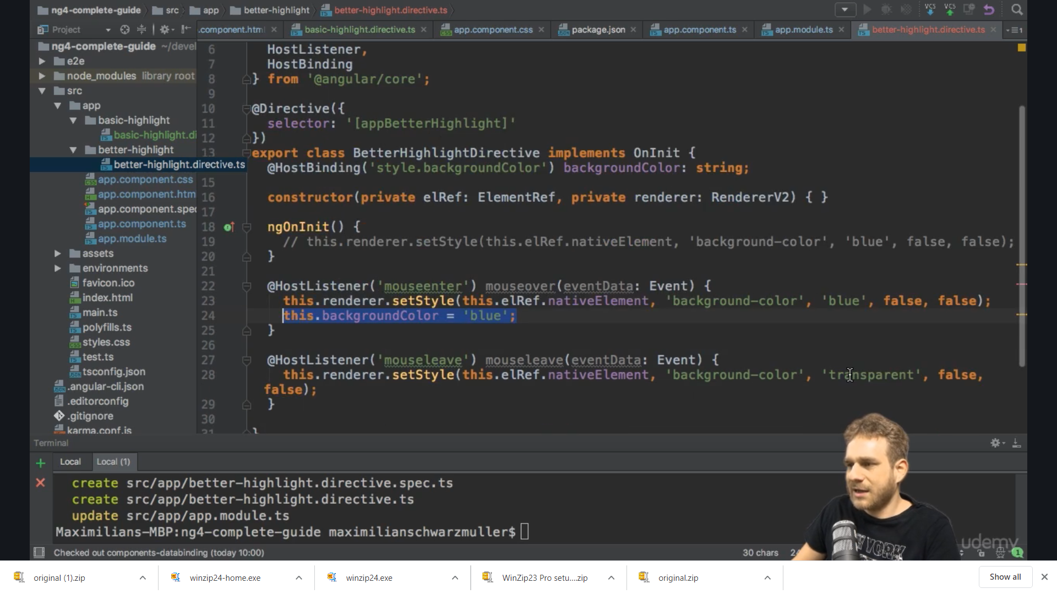

Transpatrent

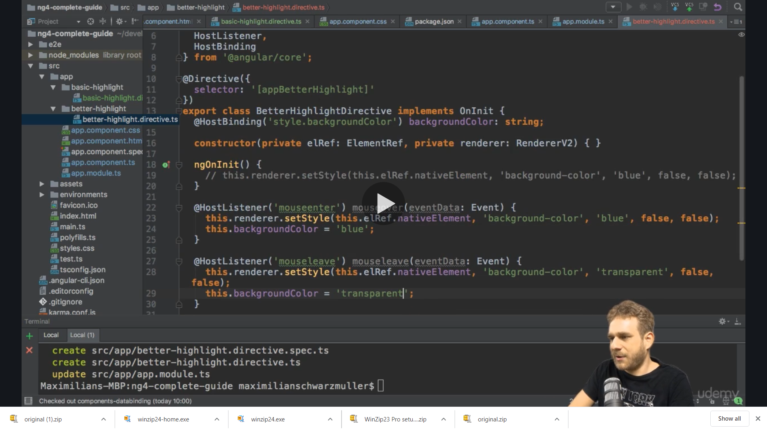

We will comment out the renderer code and set the backgroundColor value only as we do not need render now in this example

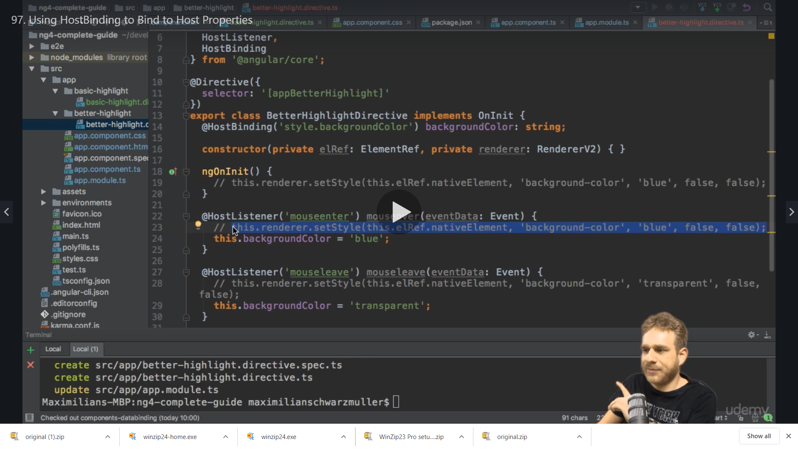

We also need to set the initial color before the mouse hover so that we do not get error

So

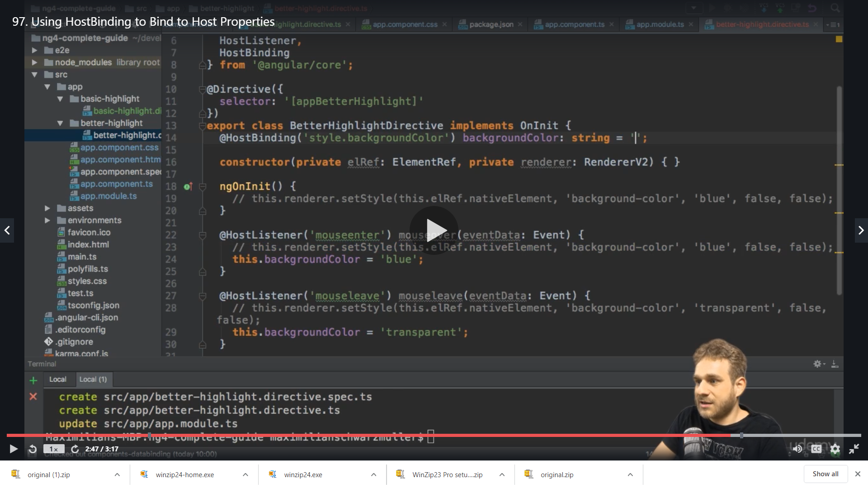

We set to transparent

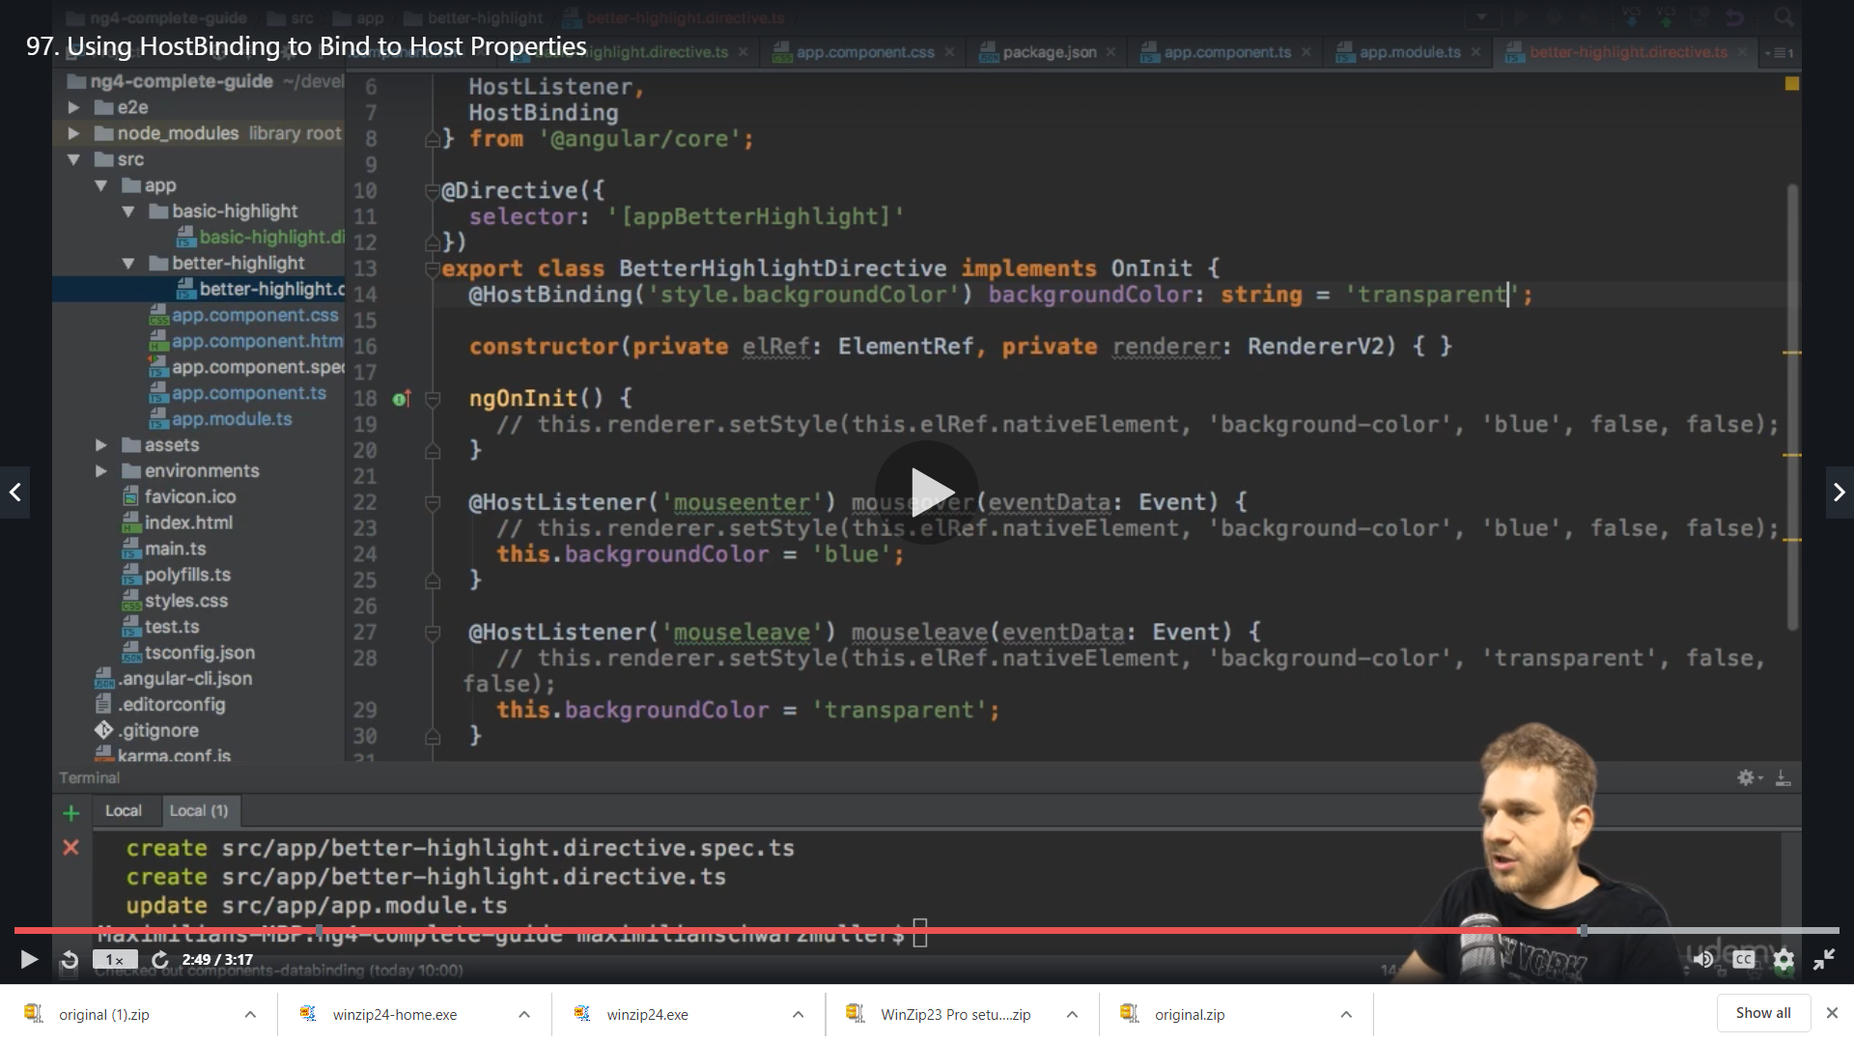

Result

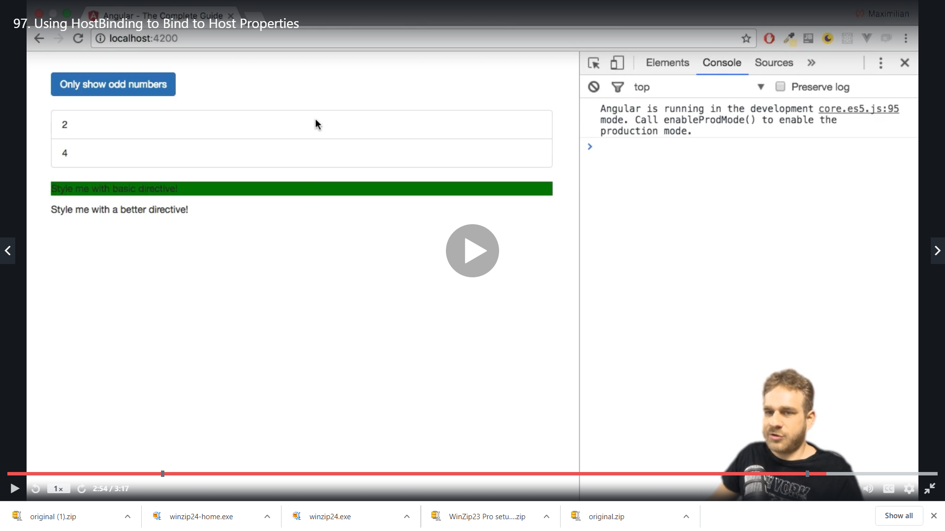

On hover

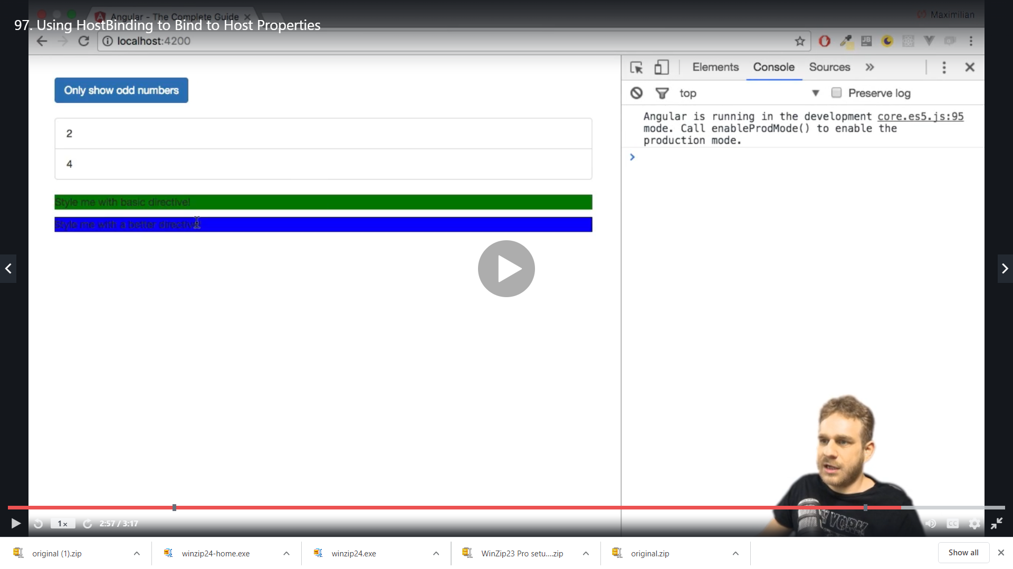

It works as before but not works on the basis of @HostListener and @HostBinding together without renderer

This is the way of working with element inside the directive we can bind to any property of the element we are on

**Binding to Directive Properties**

The color is hardcoded in the code so we can inprove it and we do it by custom property binding

We add 2 @Input define a property and assign it value

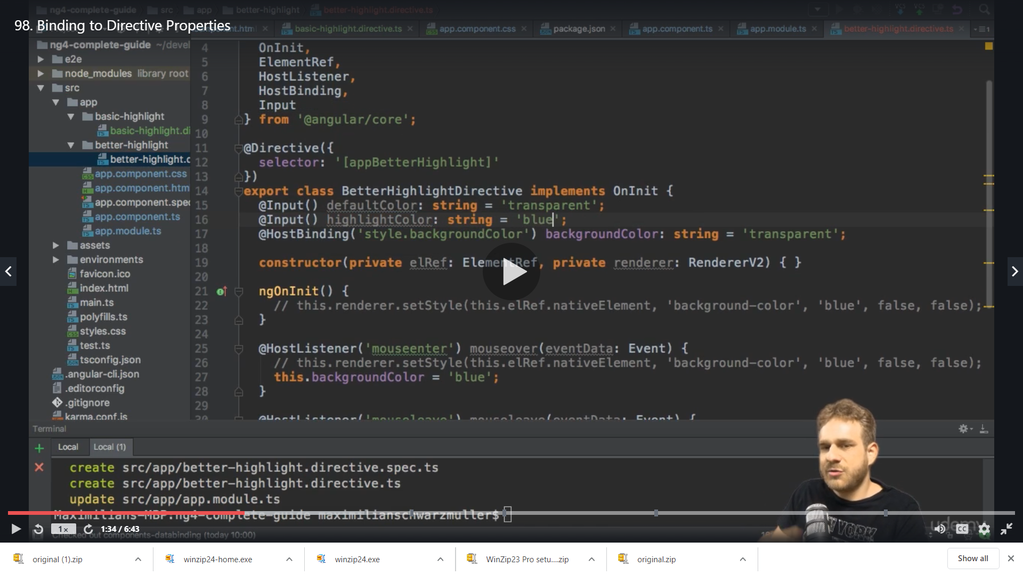

We change the backgroundColor hardcoded with our new property value ie this.defaultColor and this.highlightColor everywhere we had hardcoded color value

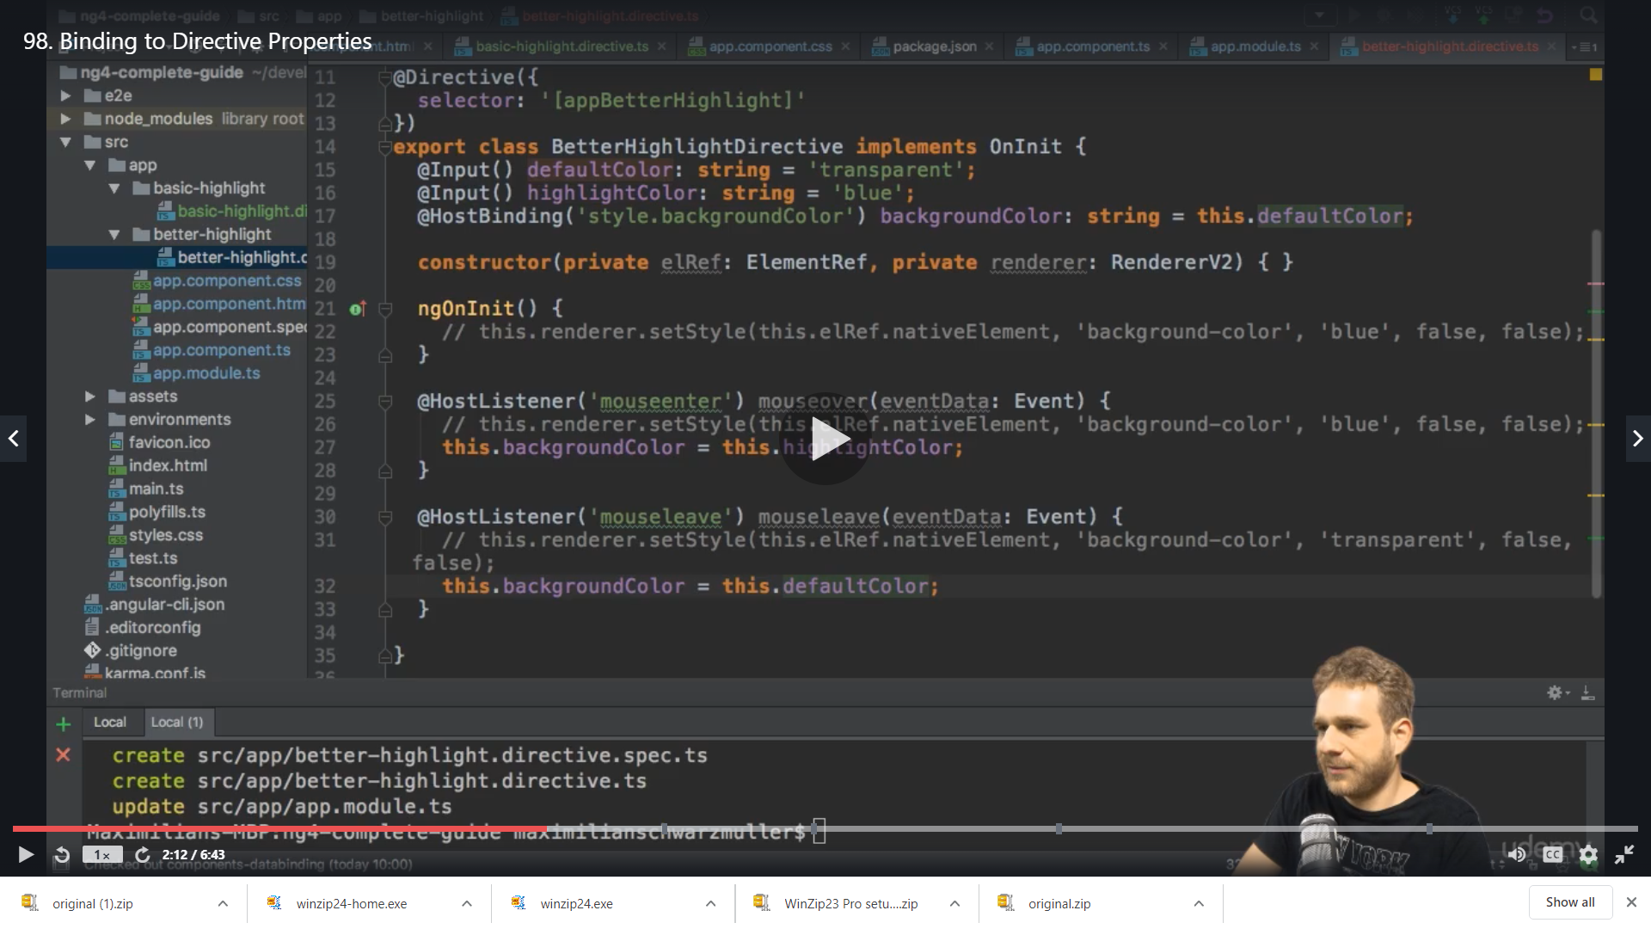

Works same

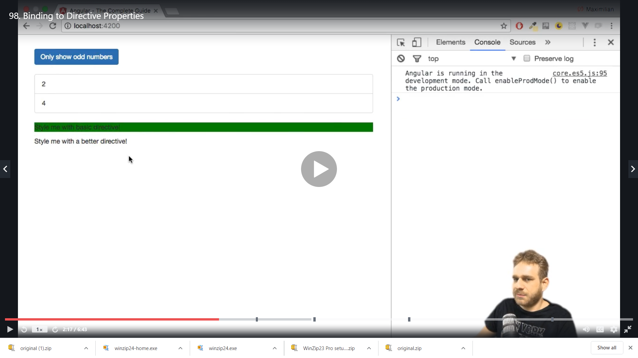

Now we can bind this from outside

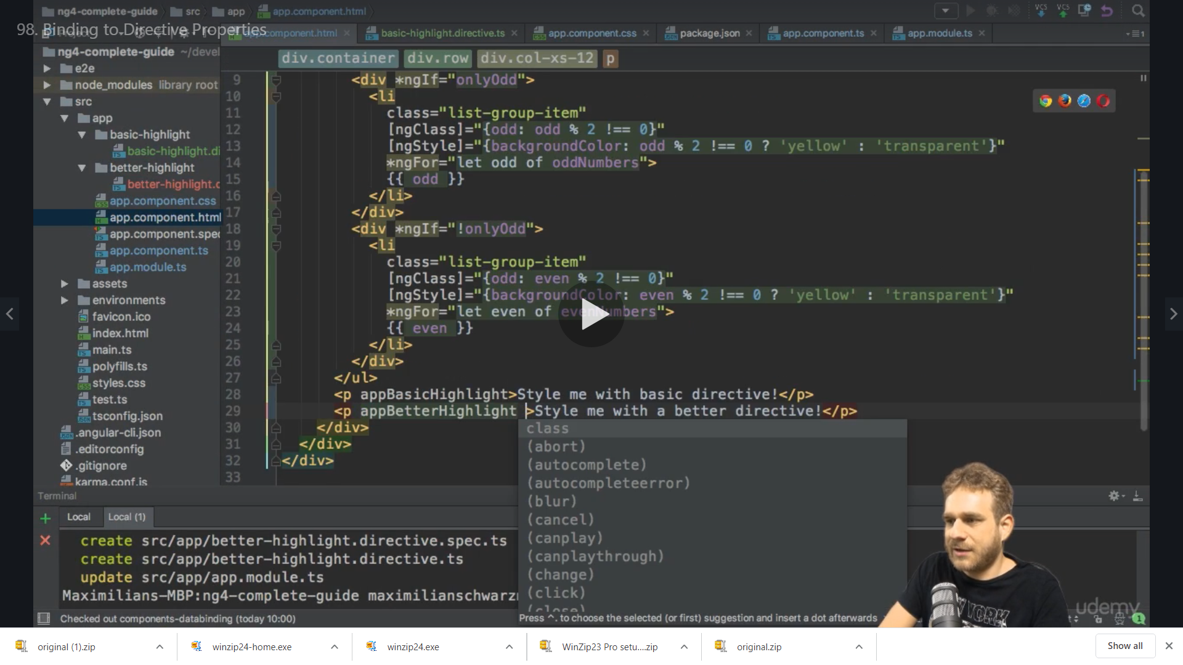

We can not bind to defaultColor and highlightColor

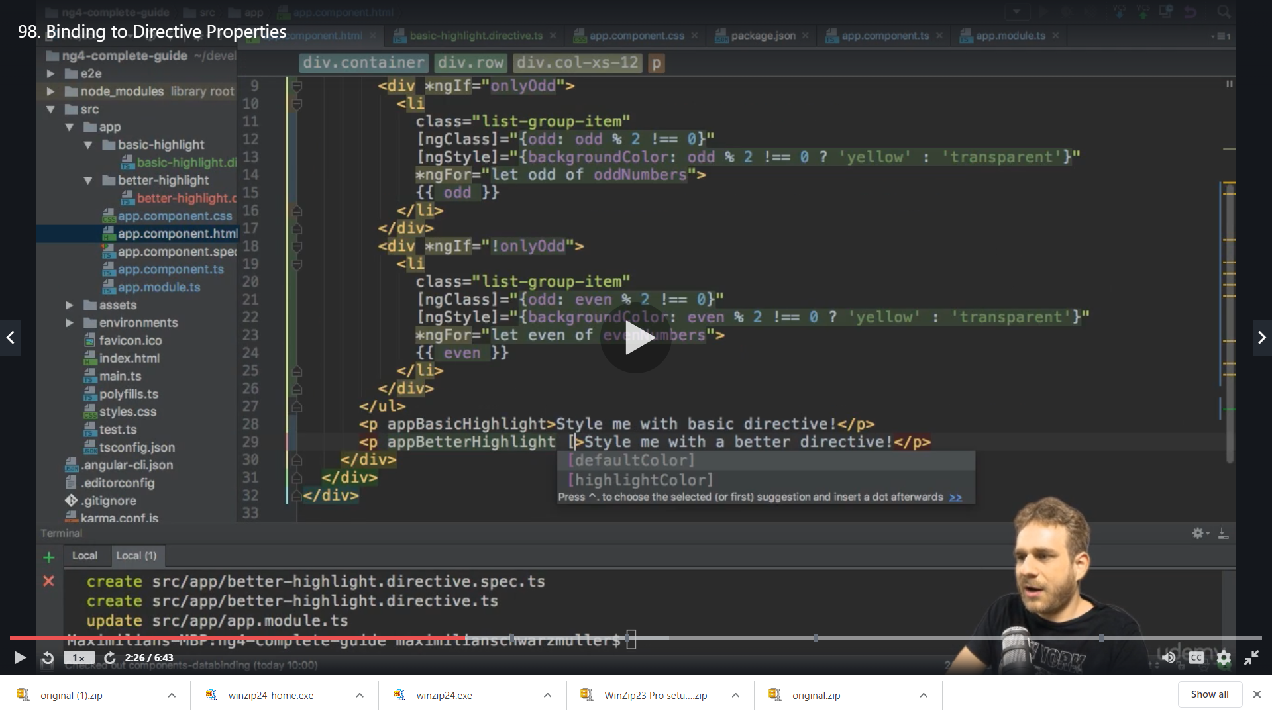

We set them to yellow and red

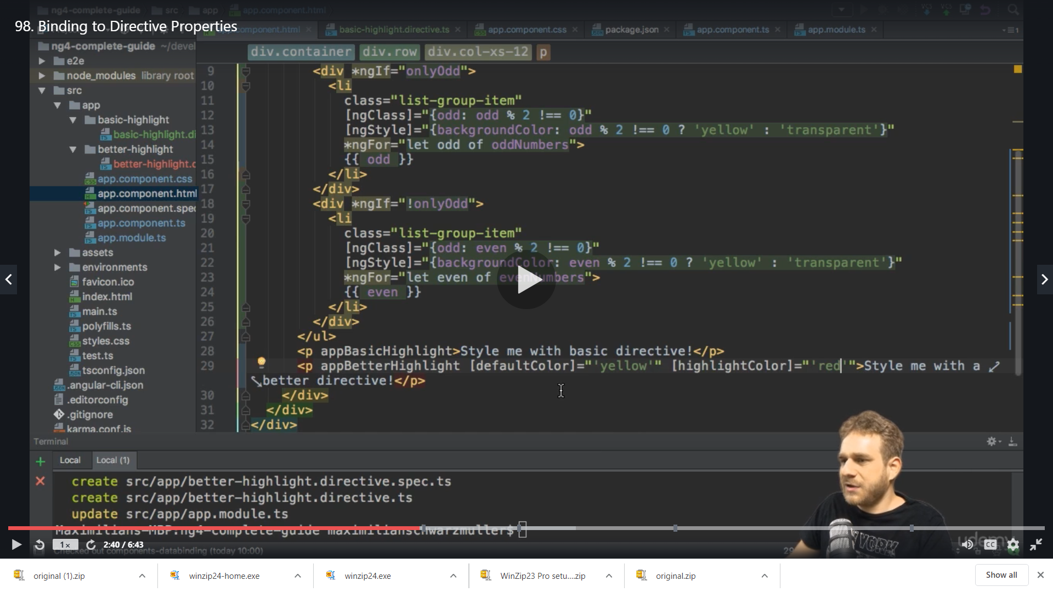

Result on hover

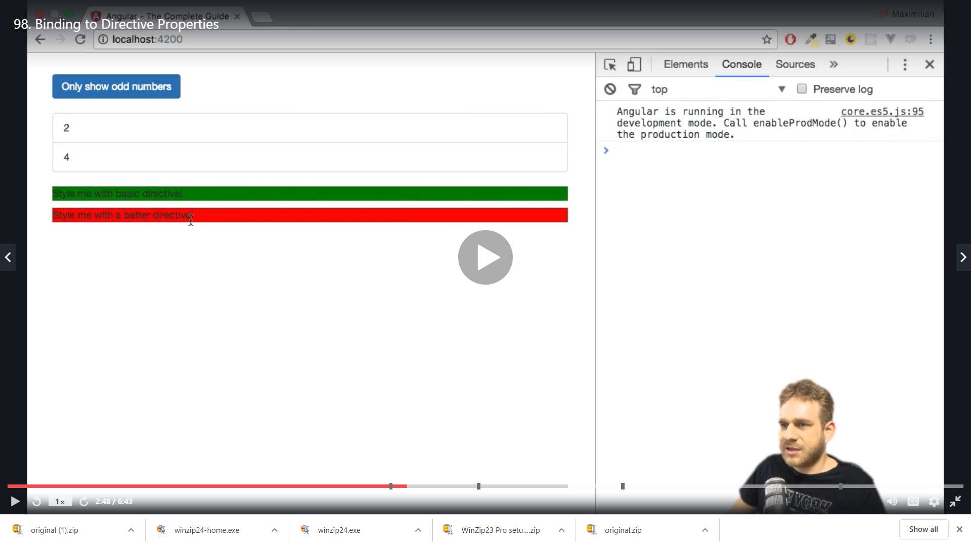

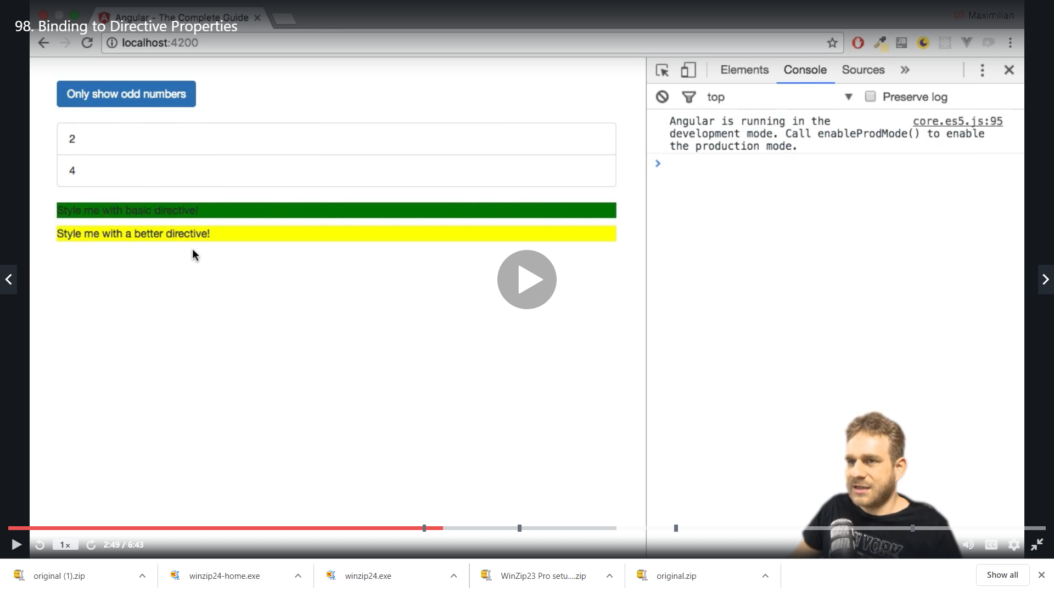

Here is a bug initial before hover it is white the reason is

The default color is not set in the beginning

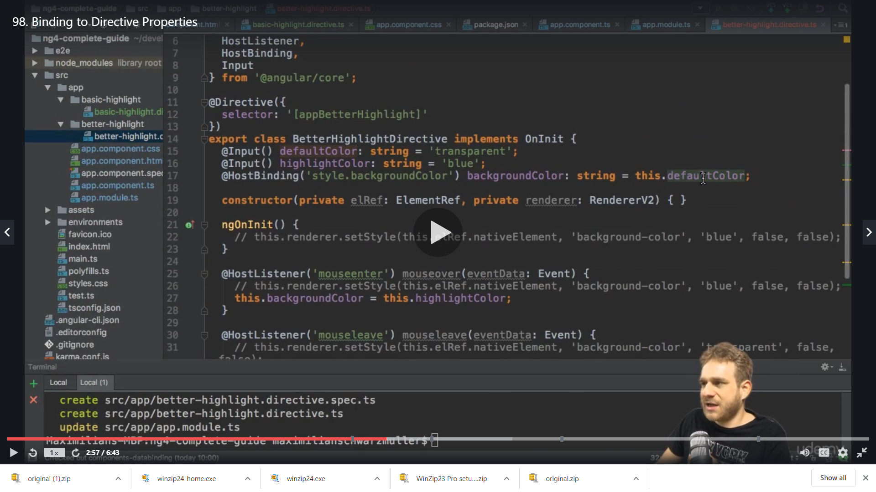

So we initialize it on ngOninit

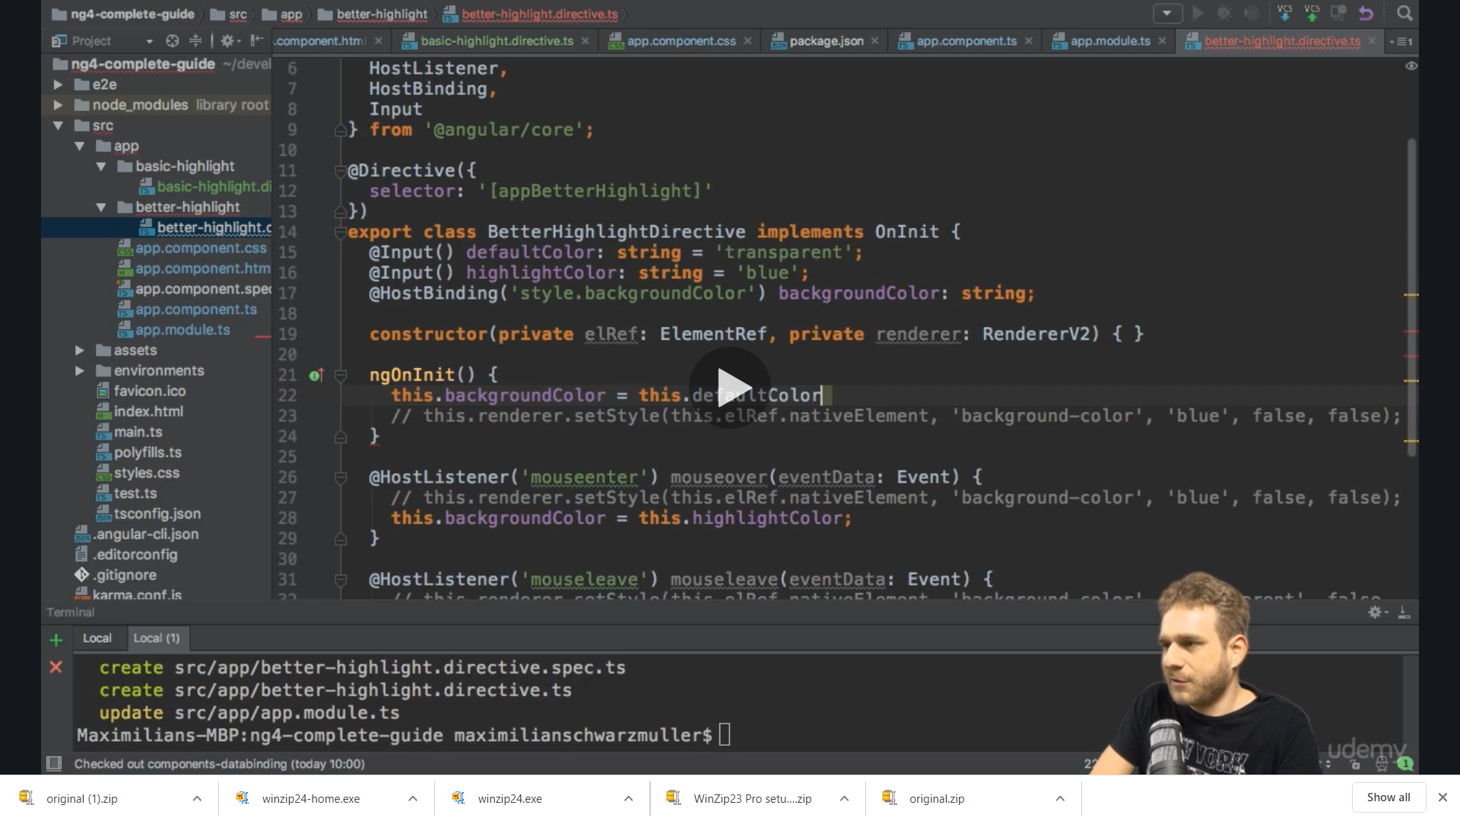

Now it works fine y7ellow by default

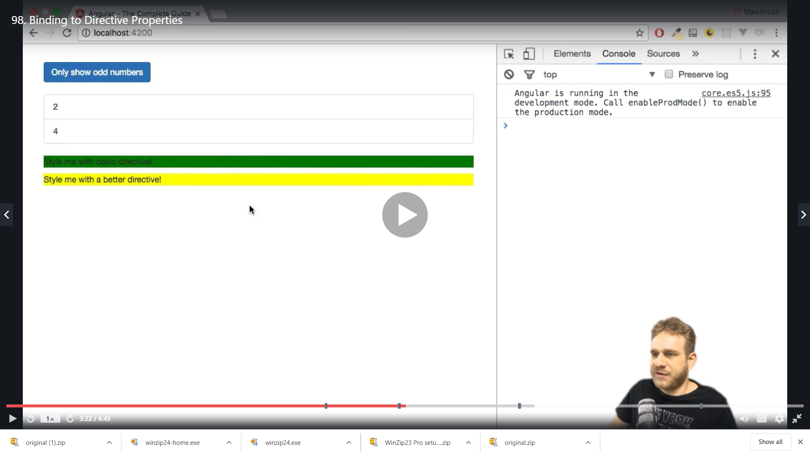

We can use the selector as alias

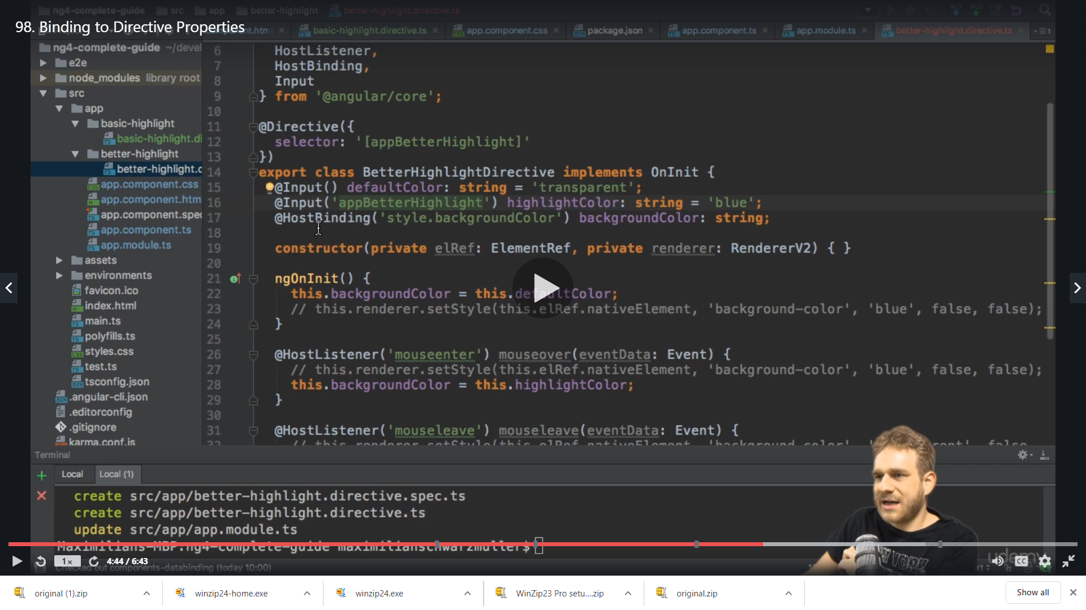

We change the highlightColor with appBetterHighlight

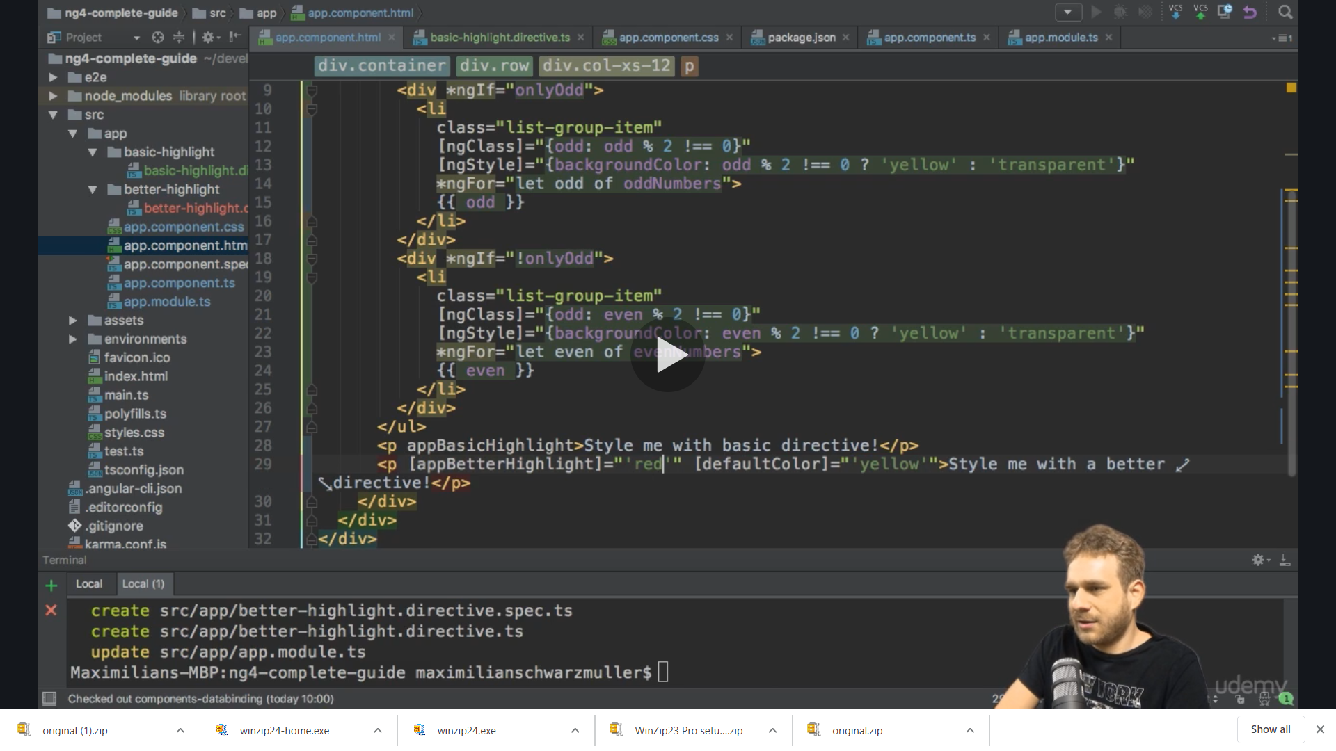

Works same

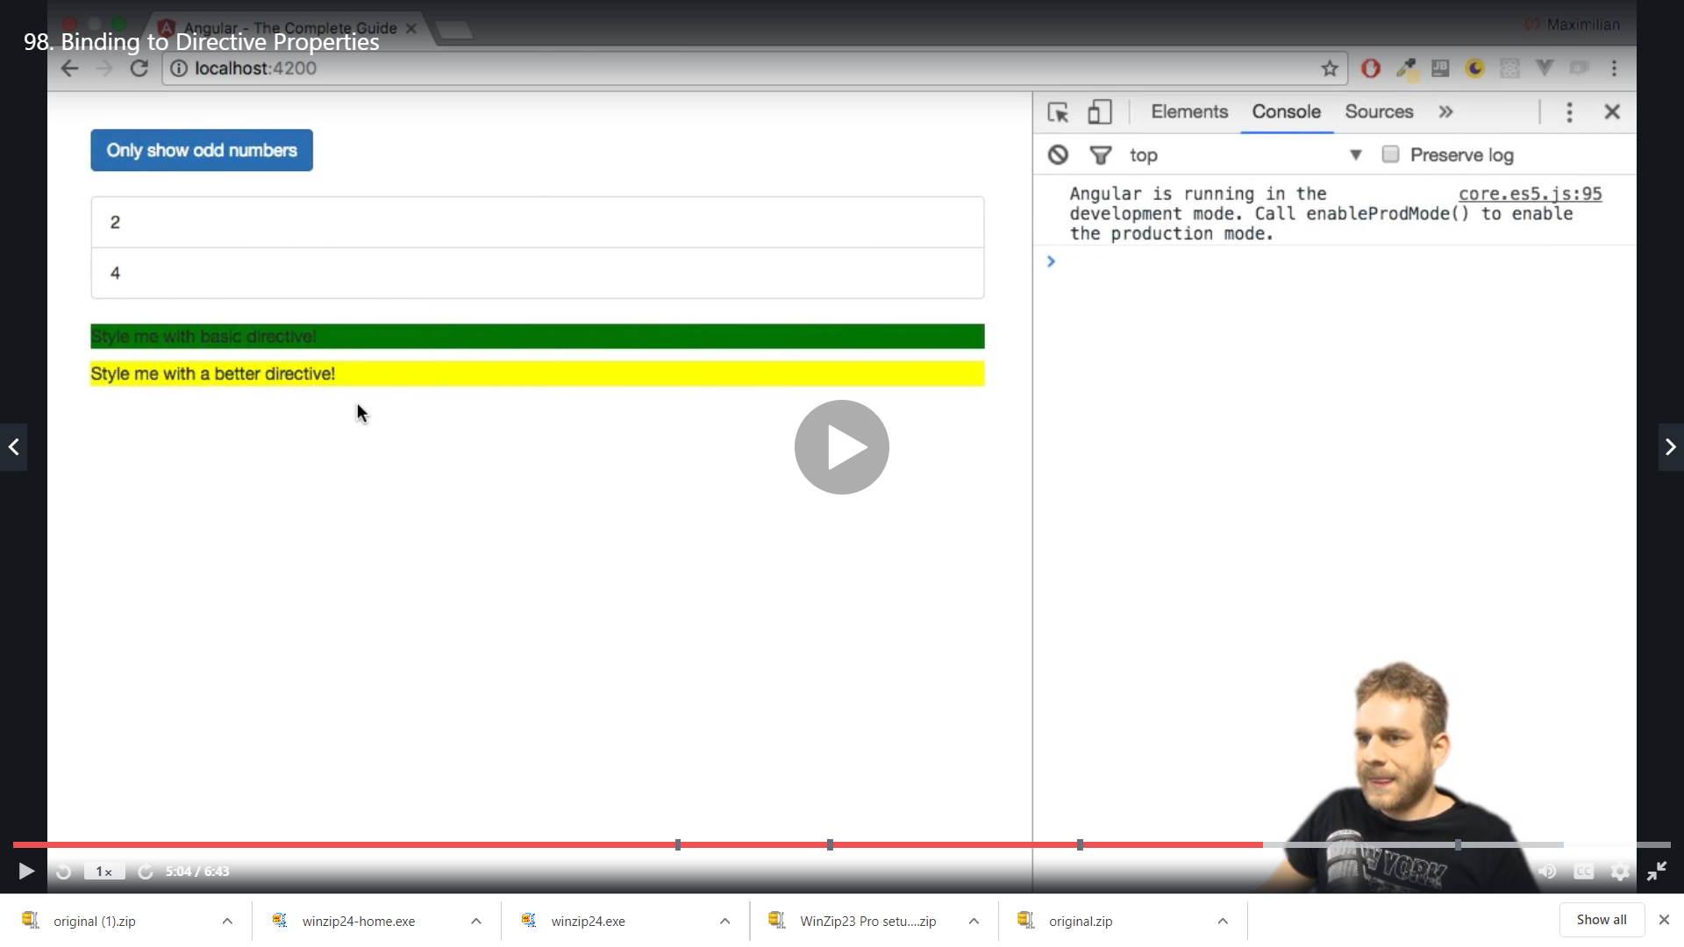

However this is not recommended it should only be used if we have same name and we need alais for a property

One more thing about property binding

defaultCode=”yellow” will also work in place of [defaultCode]=” ‘yellow’ “ if we are passing the string

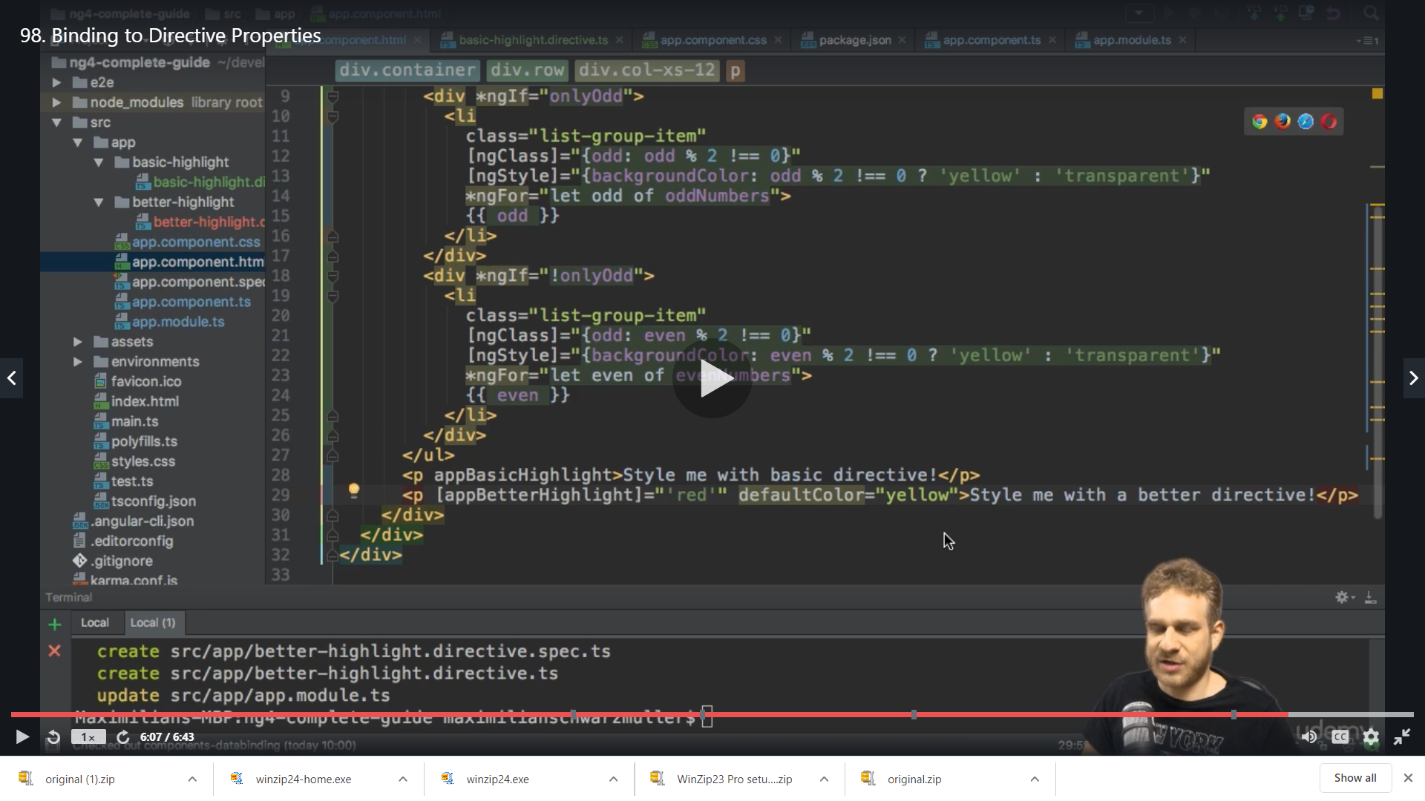

Works fine

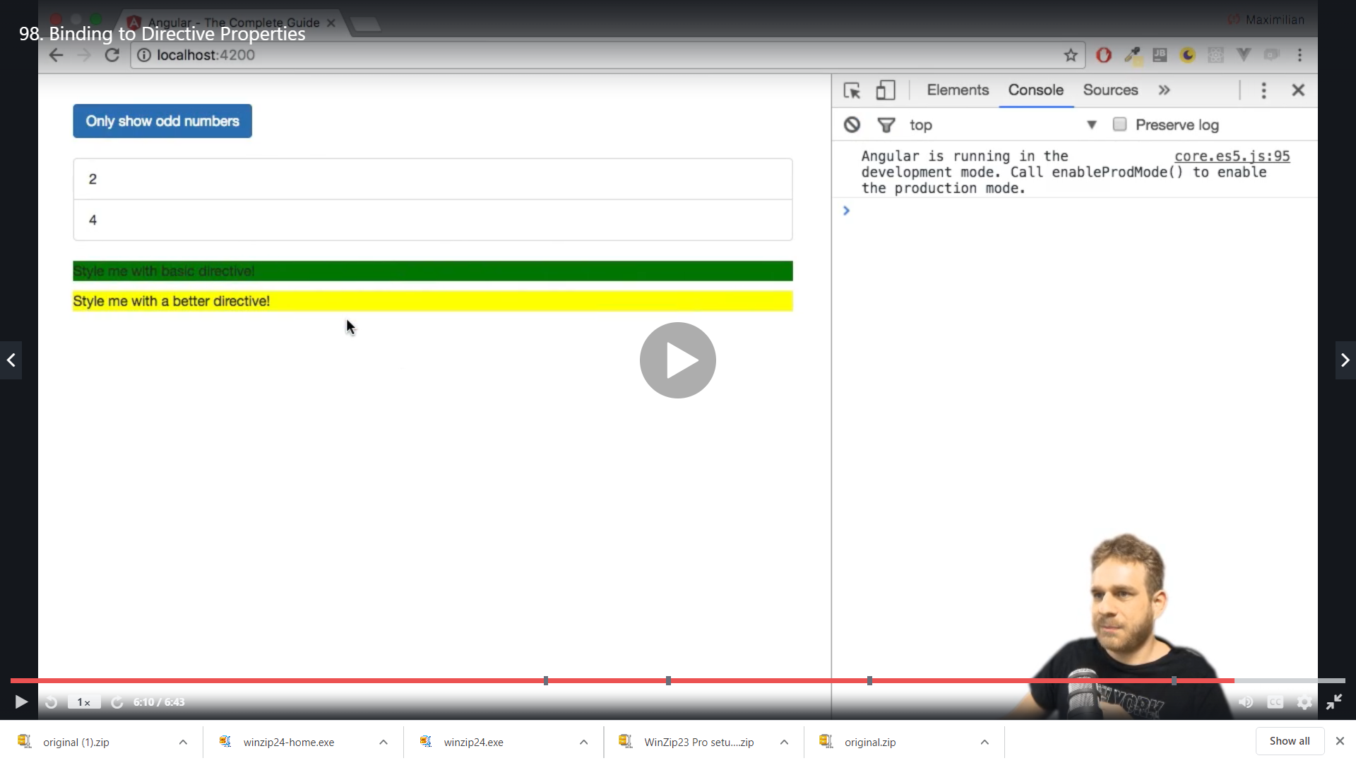

**What happens Behind the Scenes of structural directives**

We will see why this start is required *ngIf ,*ngFor etc

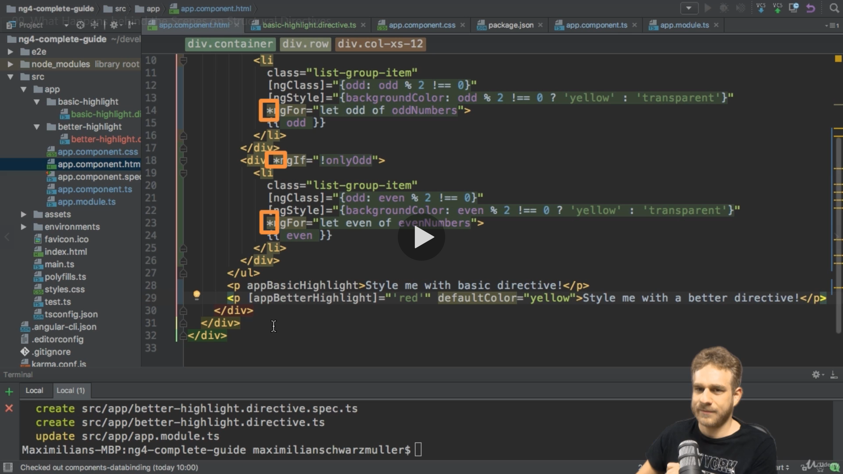

This start * indicated angular that it is a structural directive , internally angular will transform this * to something else

We replicate the same code in <ng-template >

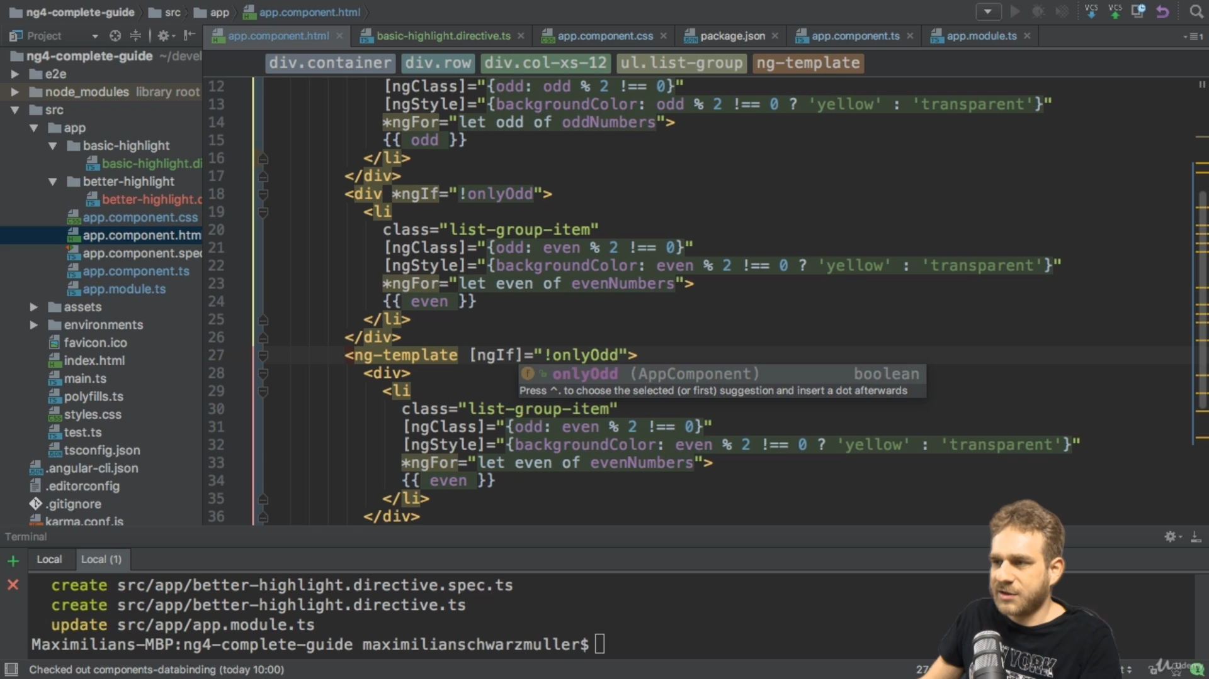

But here we use [ngIf] and not * because the ng-template itself is added to the dom on basis of condition ie the structure is changed on condition so we use ngIf as property binding

Result is we see the list twice

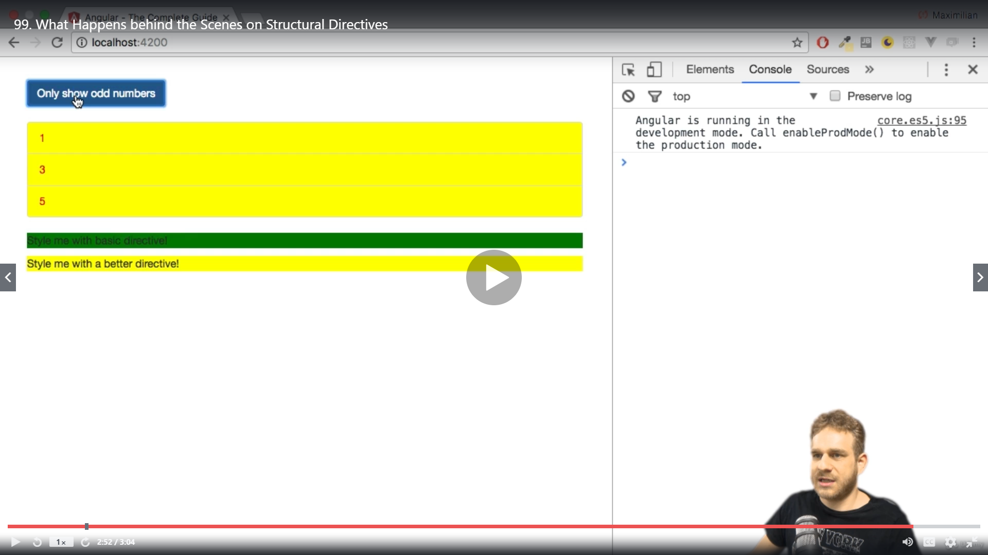

**Building a structural directive**

We will create a directive with the help of CLI ie: ng g d unless

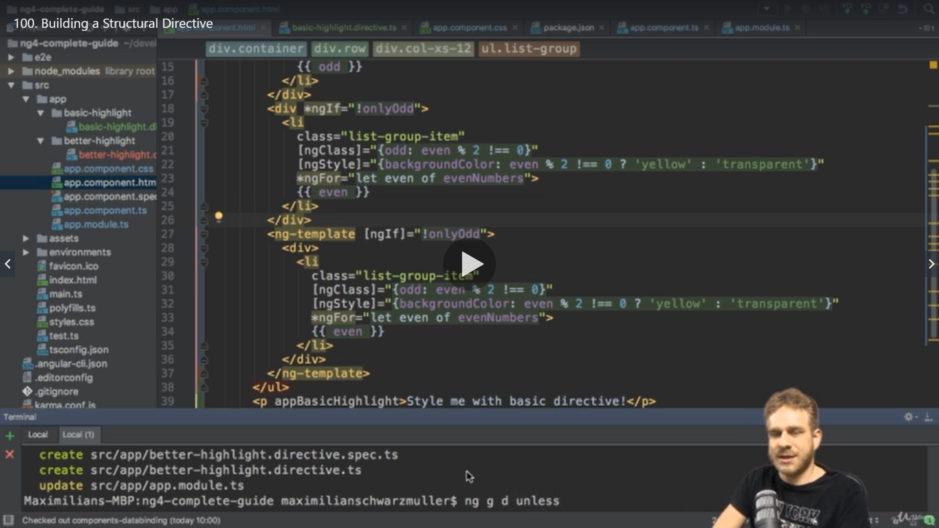

We get below directive

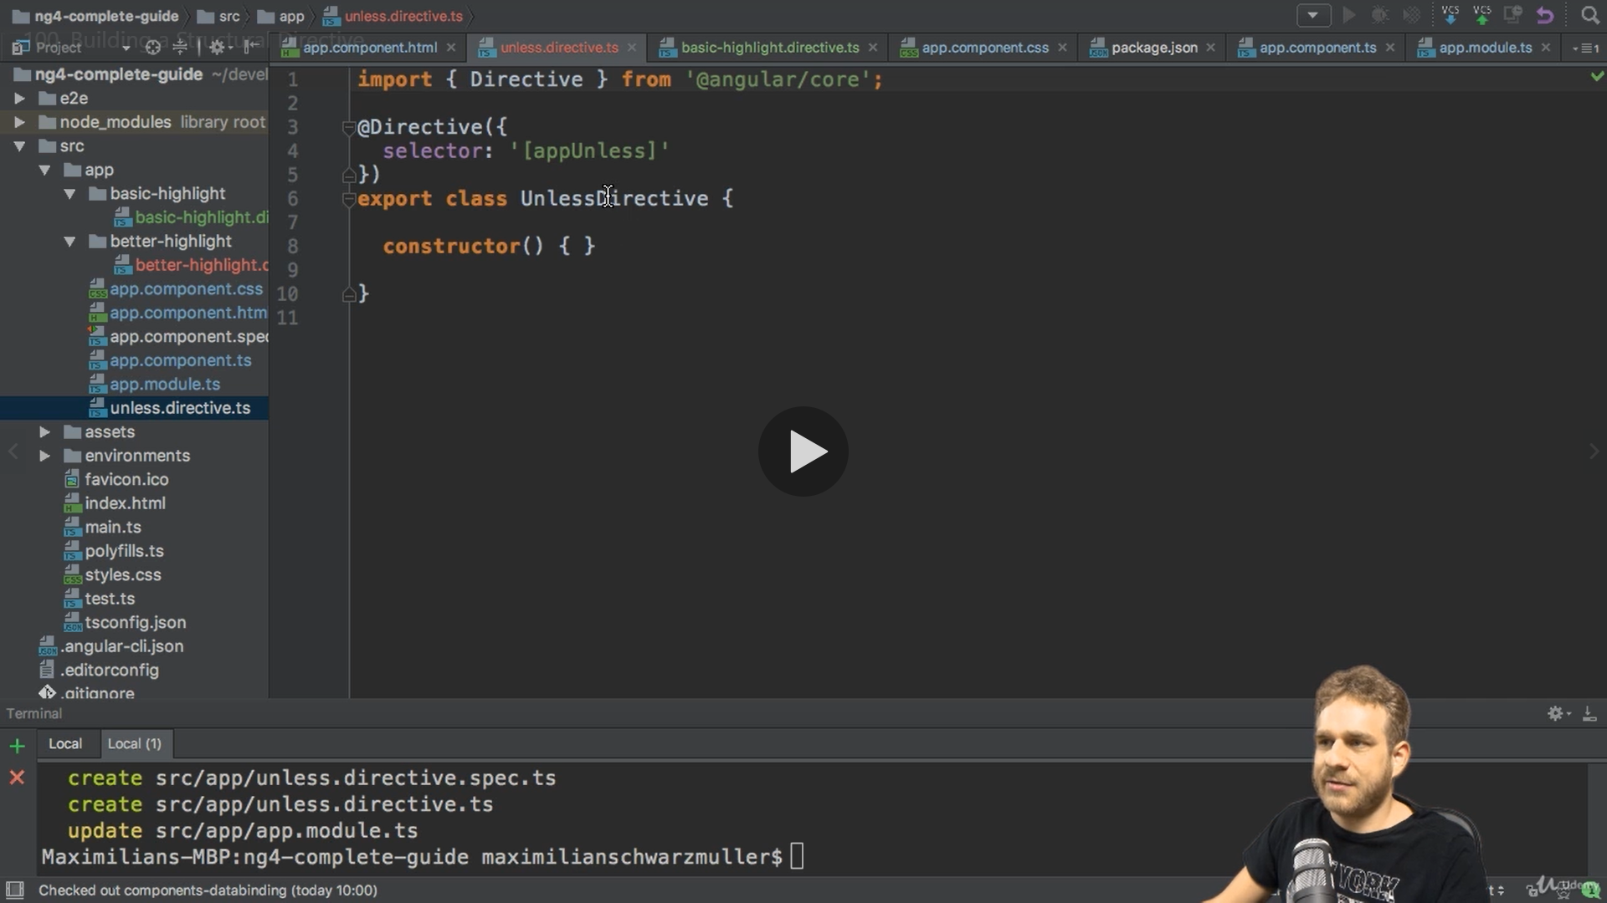

Here we need need to get the condition as input

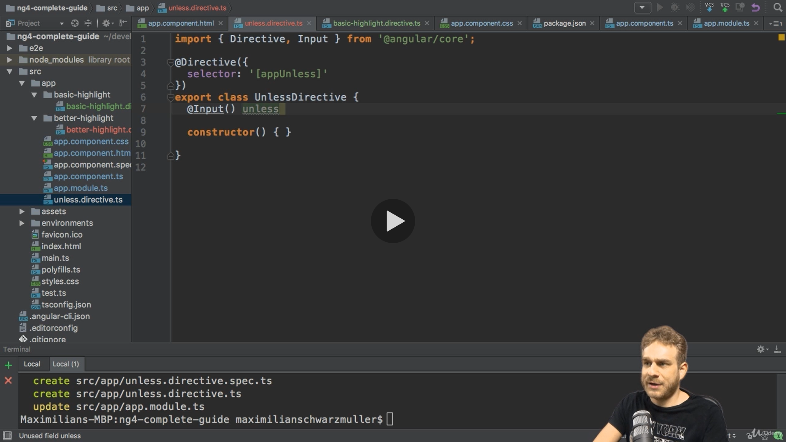

We create a property “unless”and whenever a condition and value of that property changes we need to execute a method

We use a Setter to set the value and not this converts the property into method

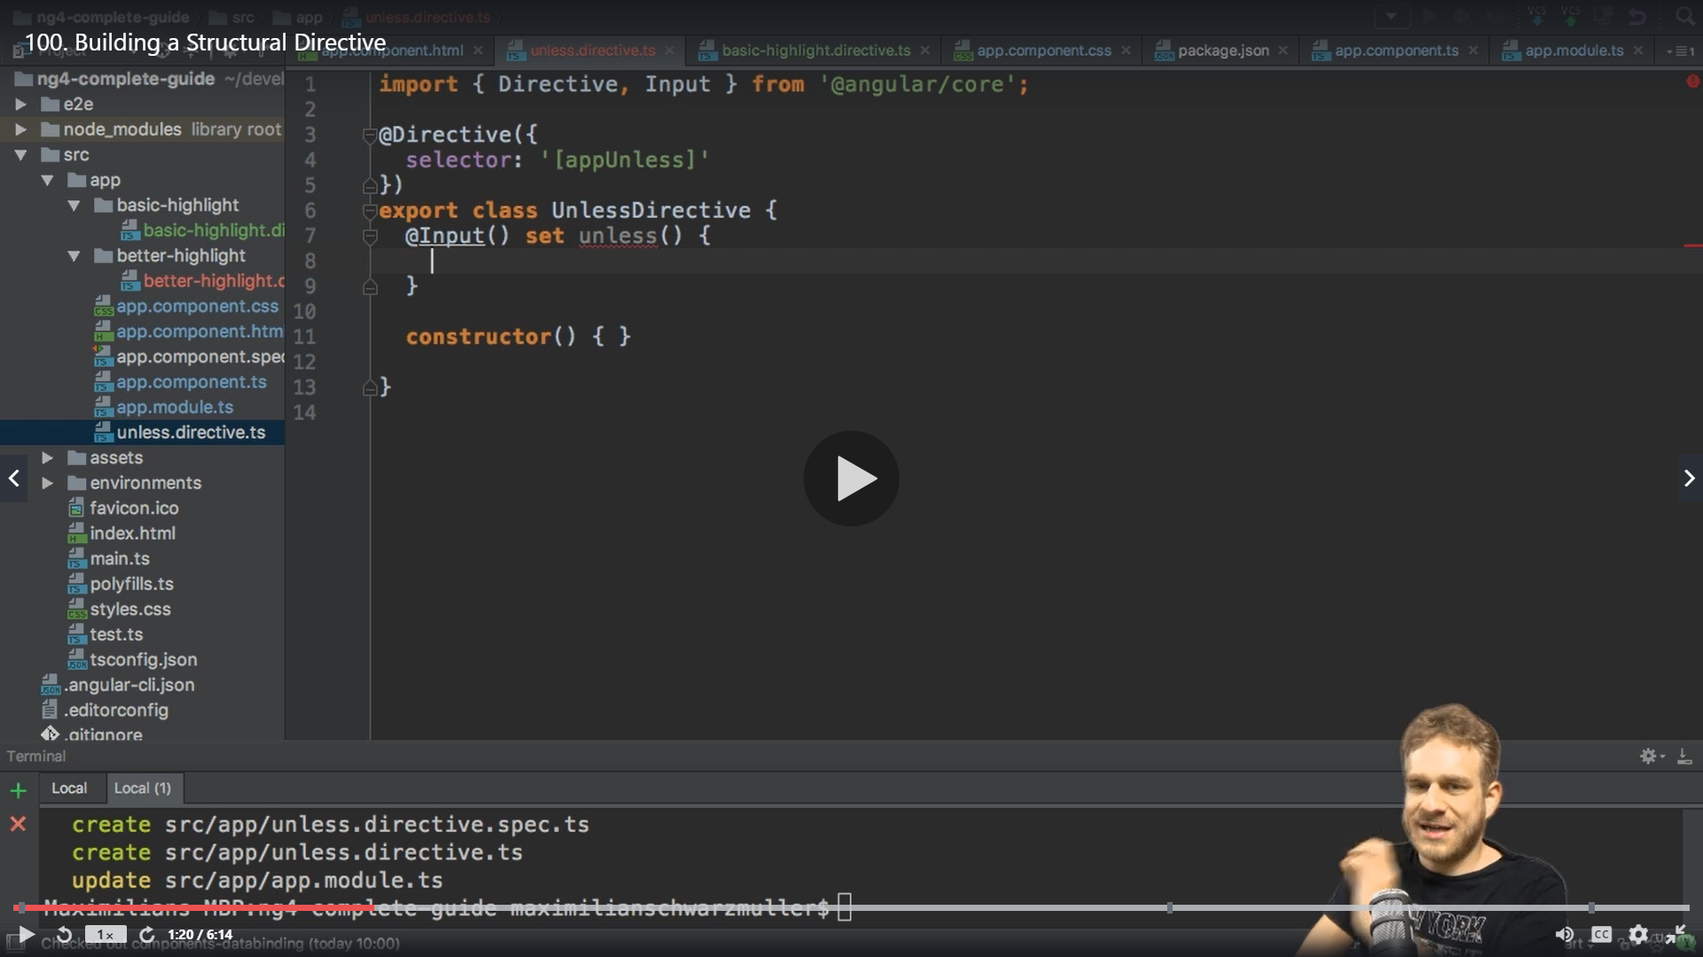

Its still a property it’s a setter of the property which is a method which is executed whenever the property changes outside the directive ie if the condition changes or parameter changes

We pass condition as parameter of type Boolean

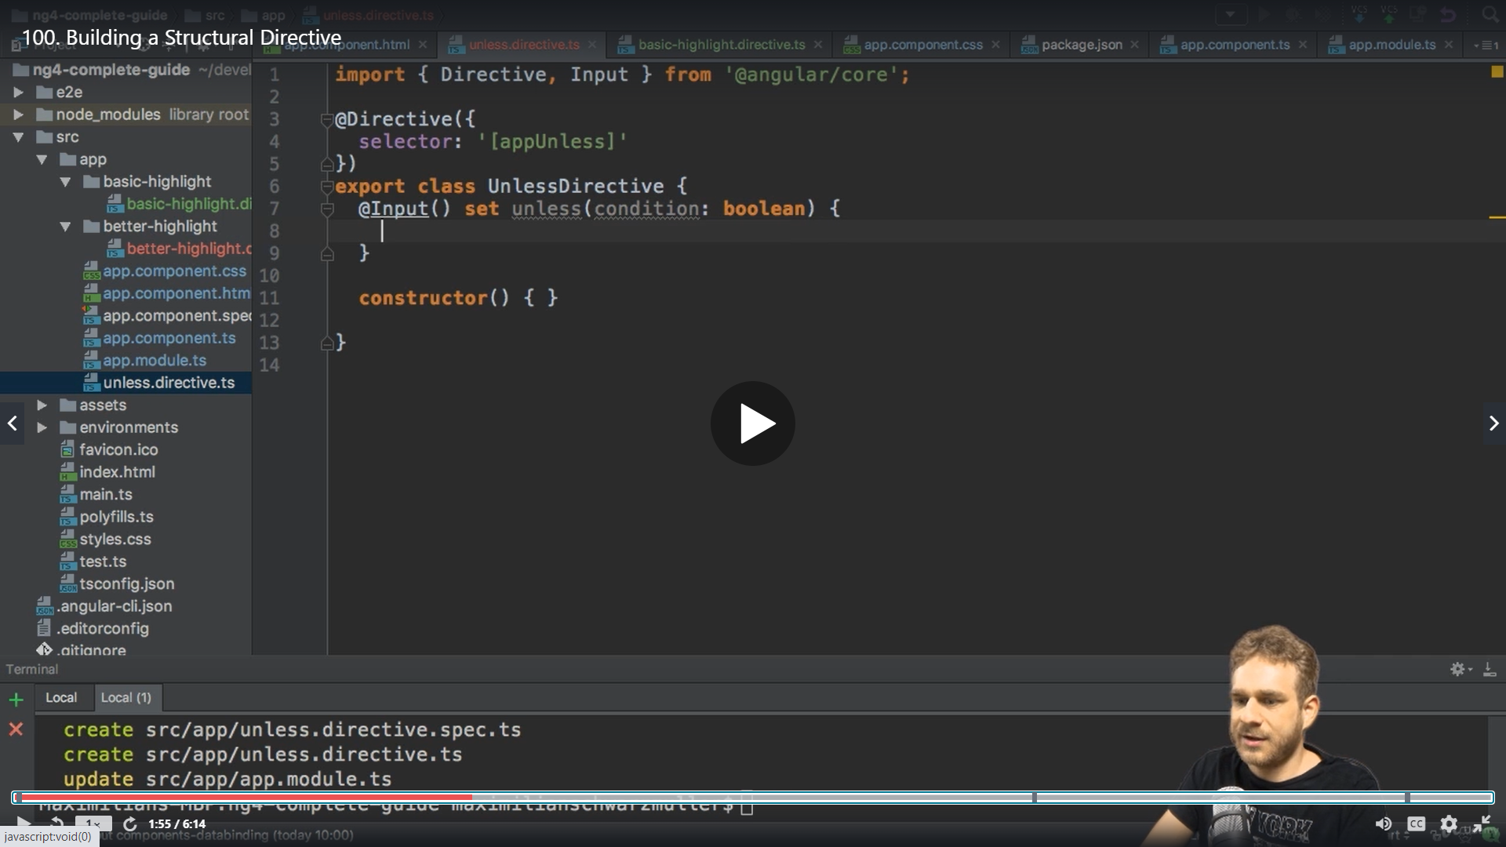

Here we get the condition like

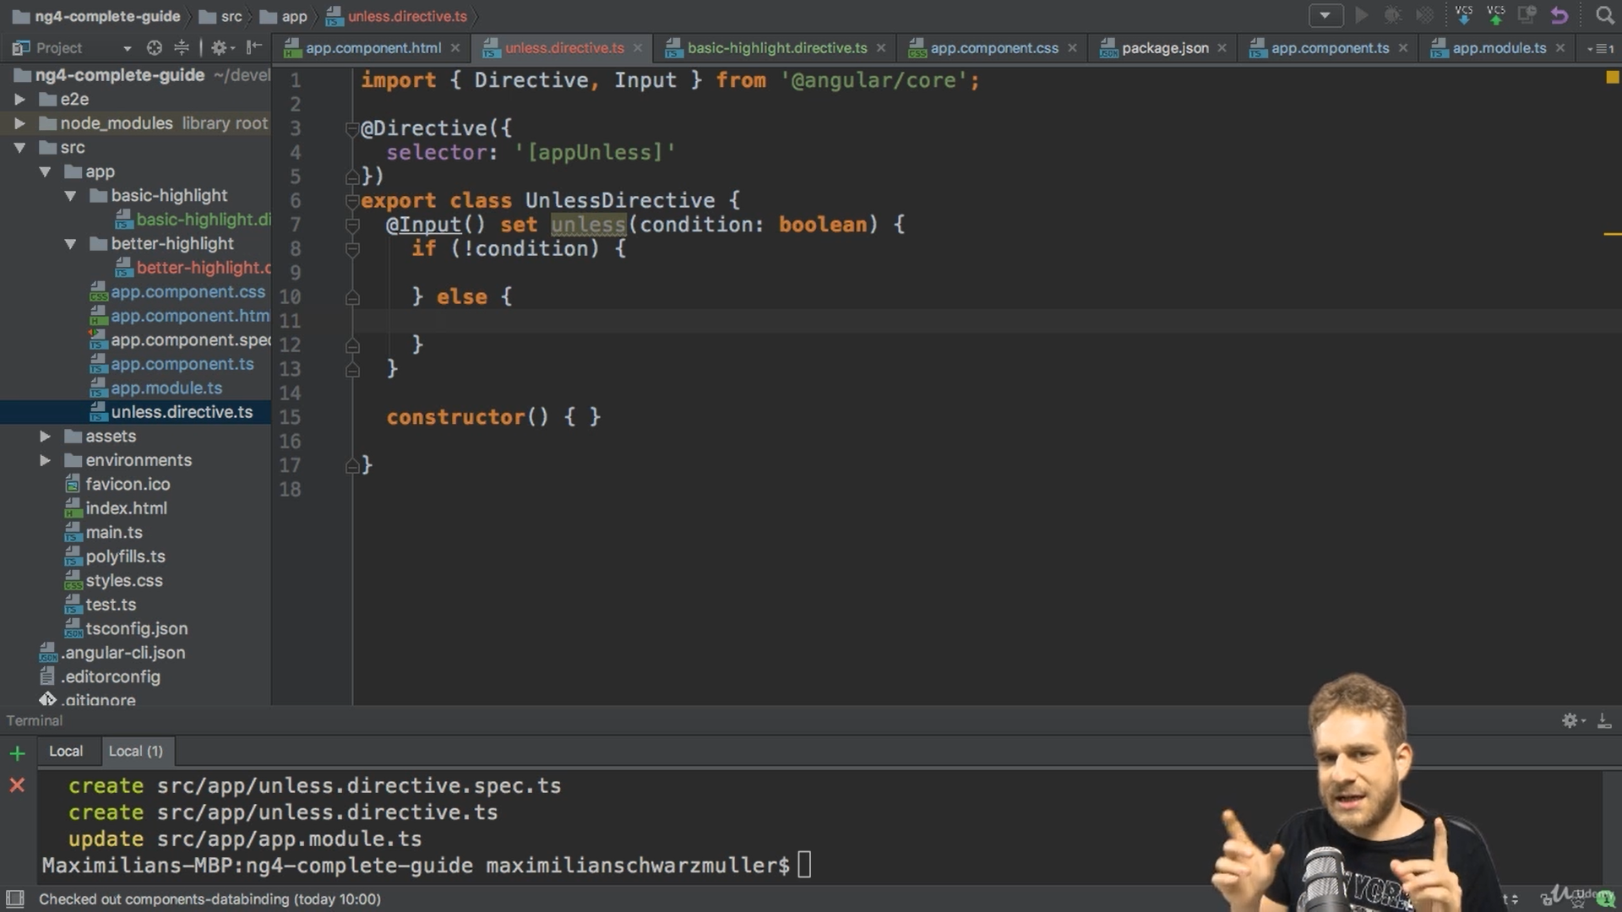

Keep in mind Our unless directive will sit on a template like ng-template

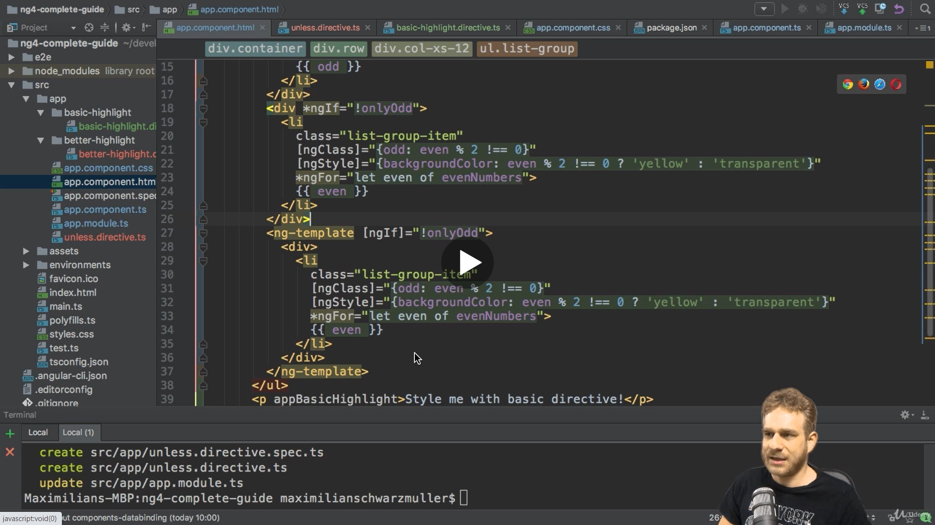

No now we need access to the template and the place in dom where we we will inject it

So in constructor we use TemplateRef .Just like ElementRef which gave us access to the evelemt we have TemplateRef which gives access to the Template

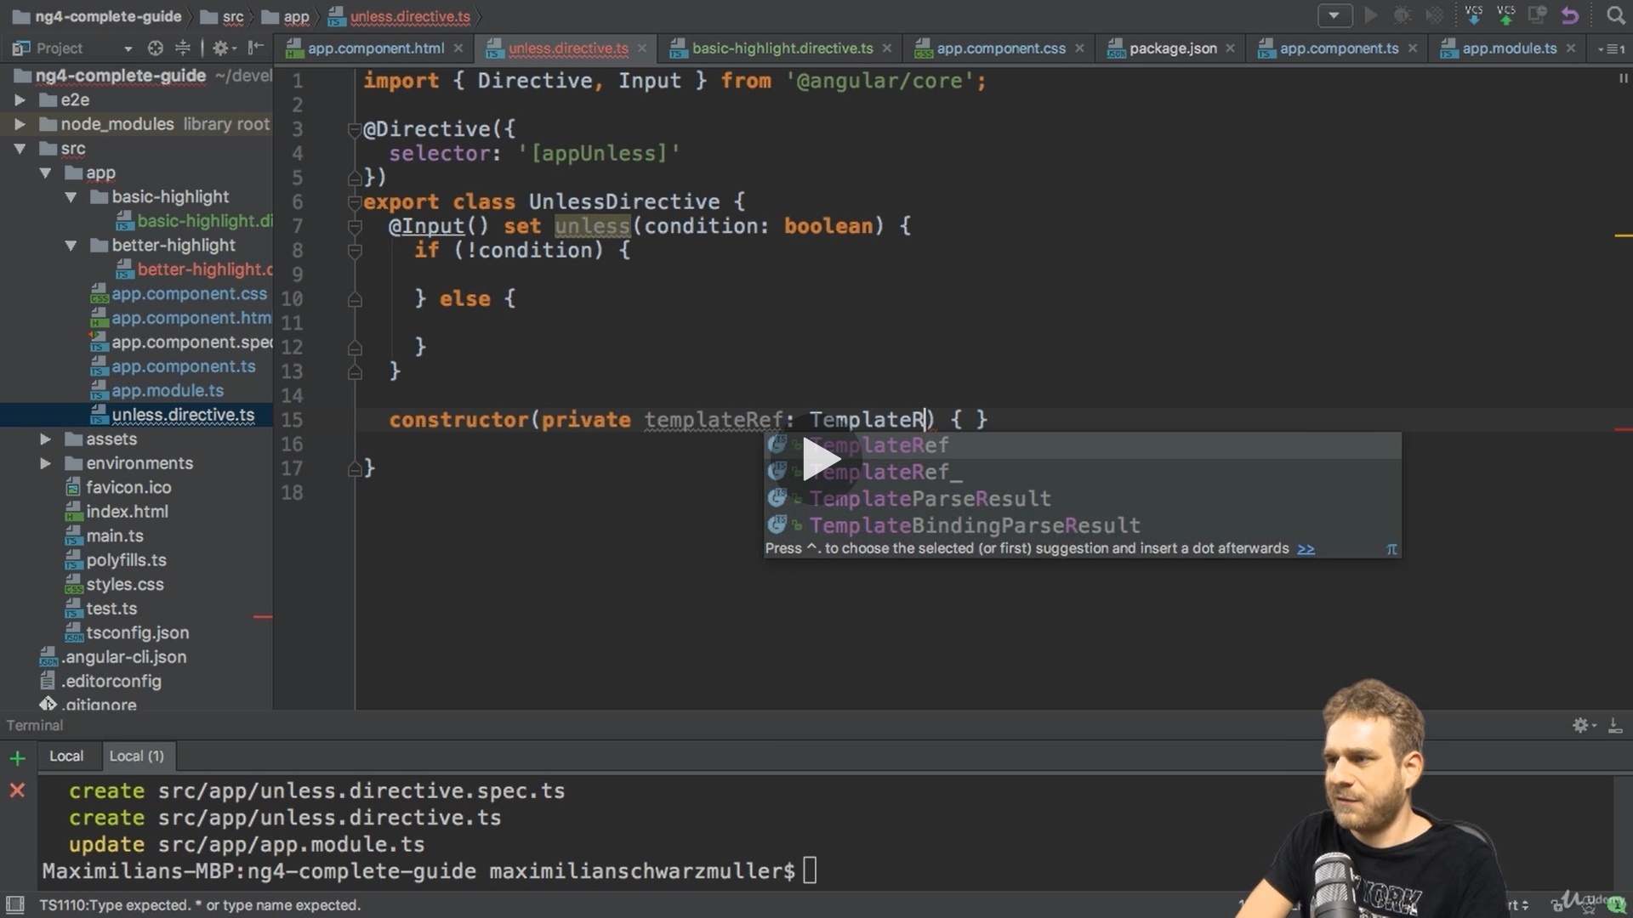

We pass generic type any

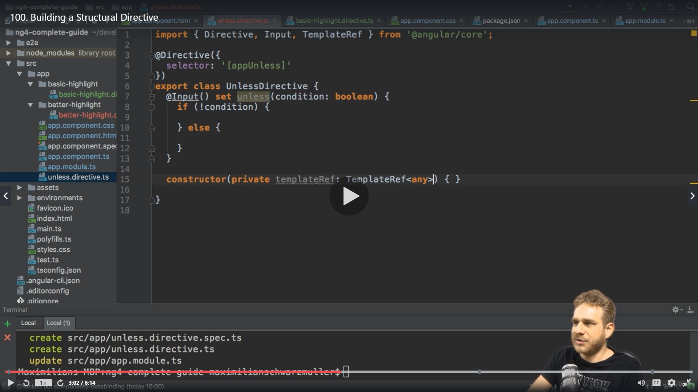

The second information is the view container where we will render it so it gives us (what ,where)

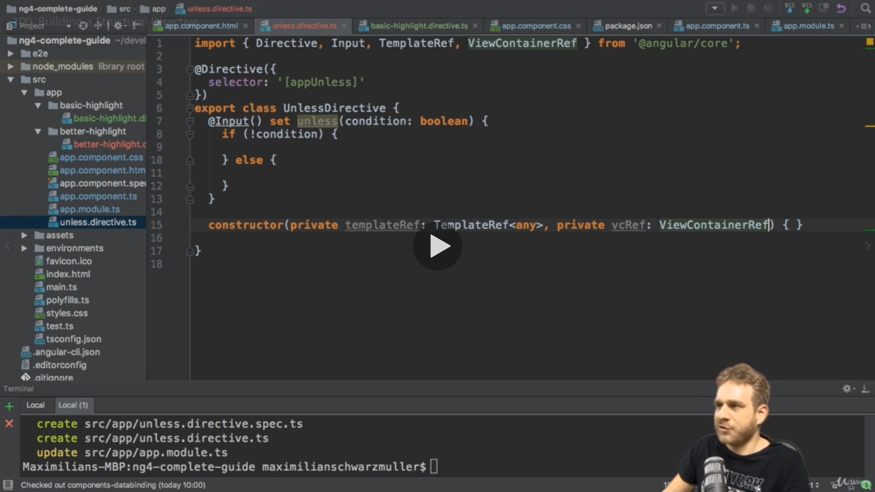

Angular marks this place and we can see it in inspect element ,now we can use them in condition checking

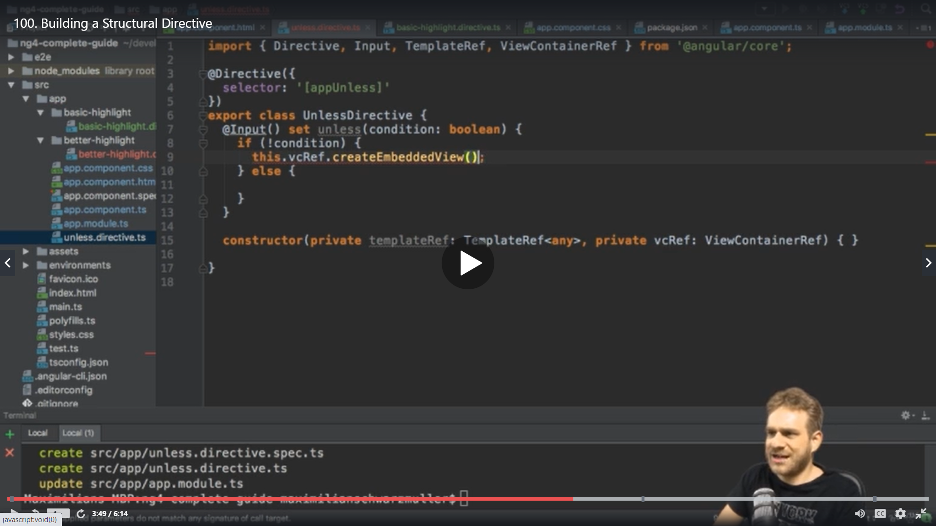

createEmbeddedView() creates a view in this container and the view is our template ref .

So that makes like template in a container

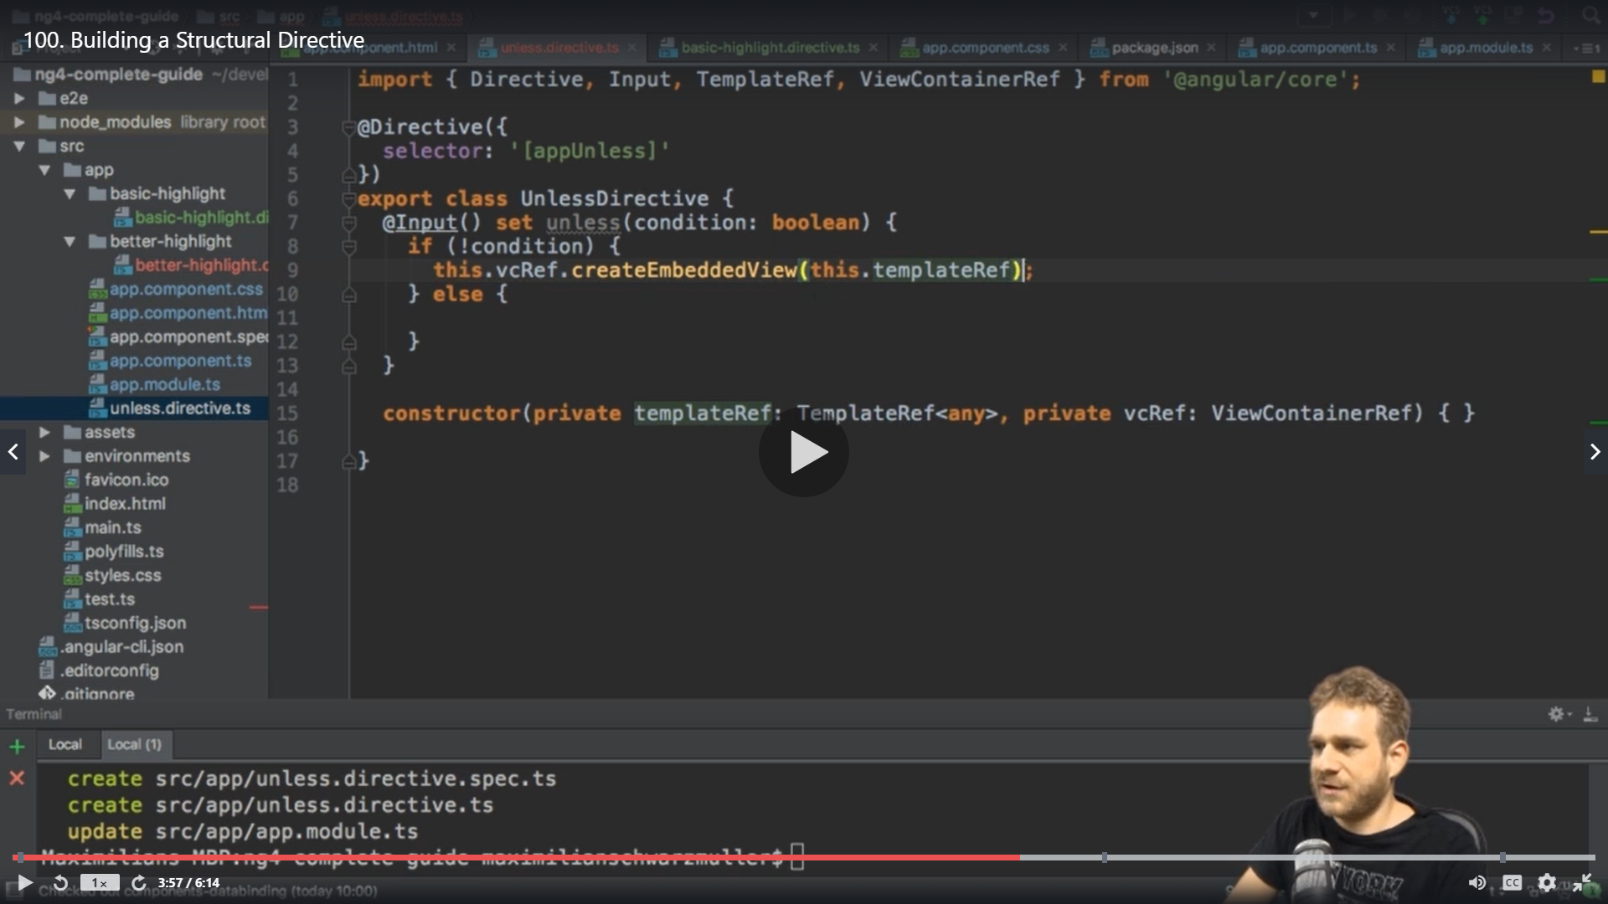

If condition is not satisfied we can remove everything from this place in Dom

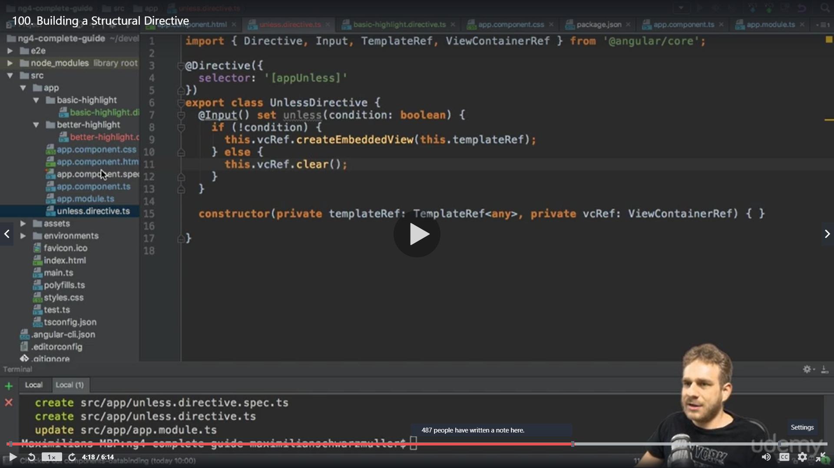

With this our own directive is setup and its added in appmodule

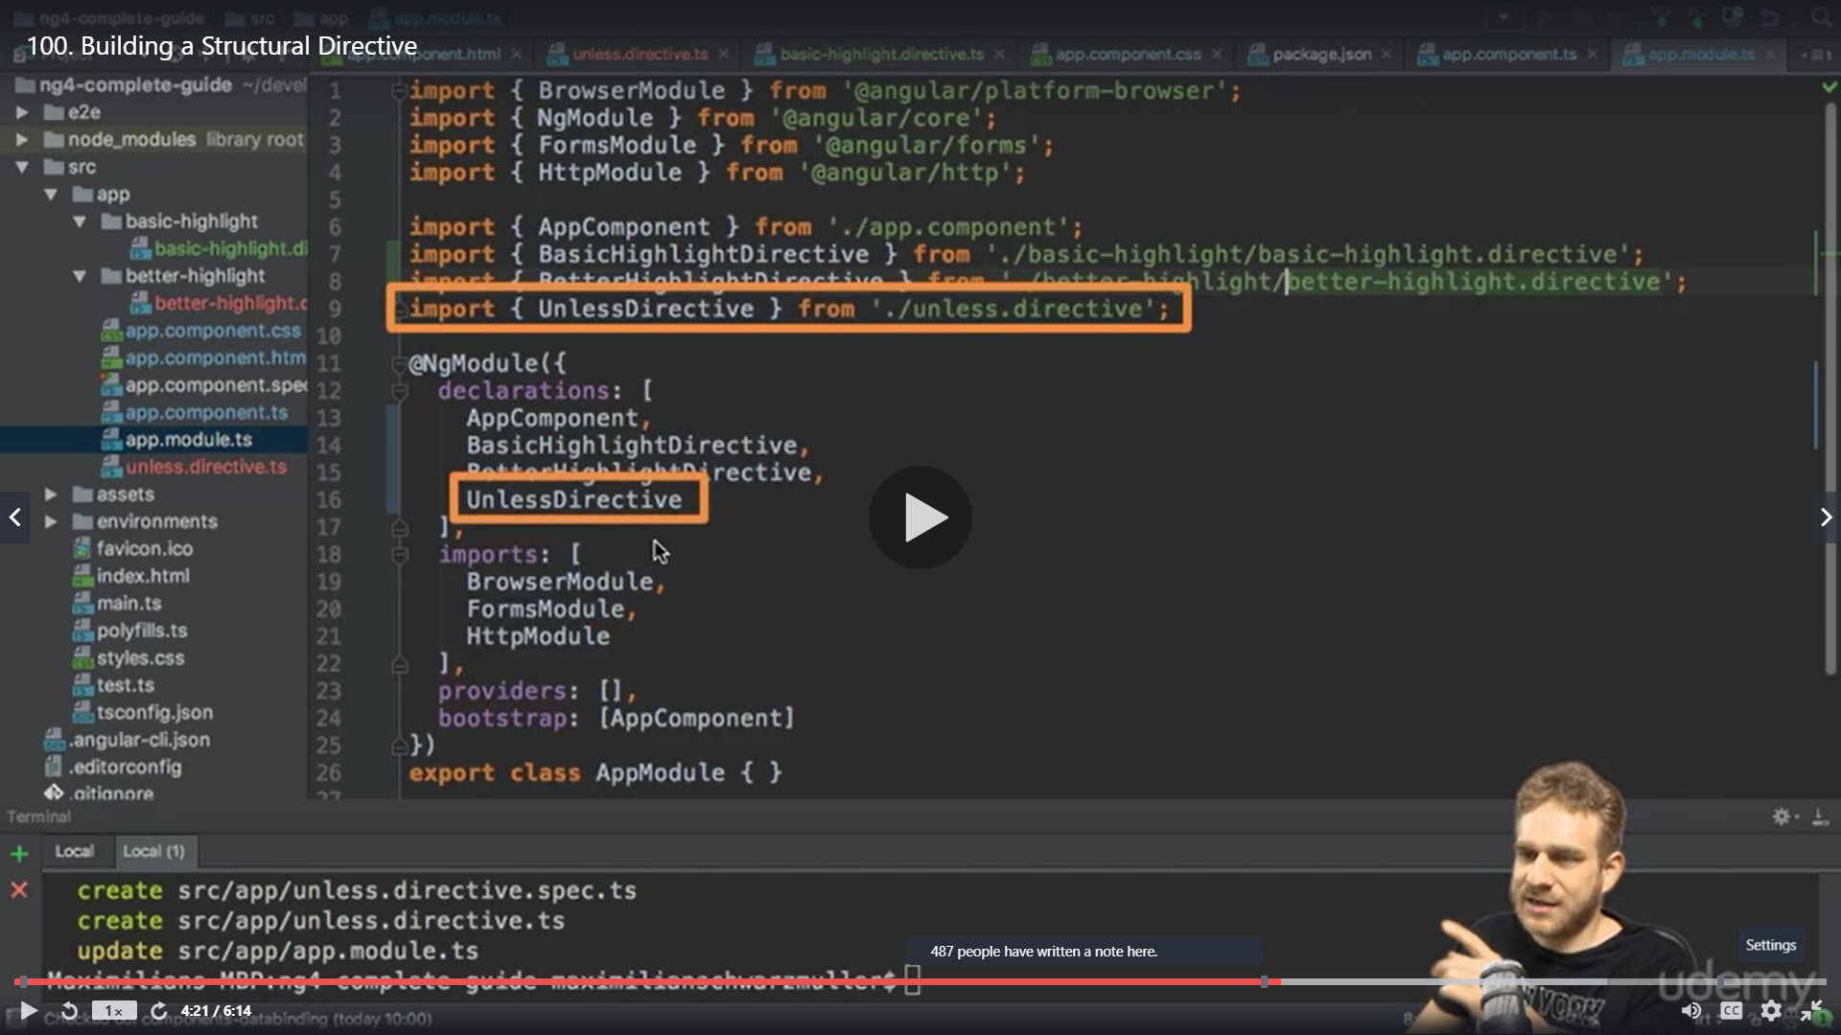

Now in the appcmponent we can use it ,our directive will replace the ngIf so we comment out all stuff of ngIf

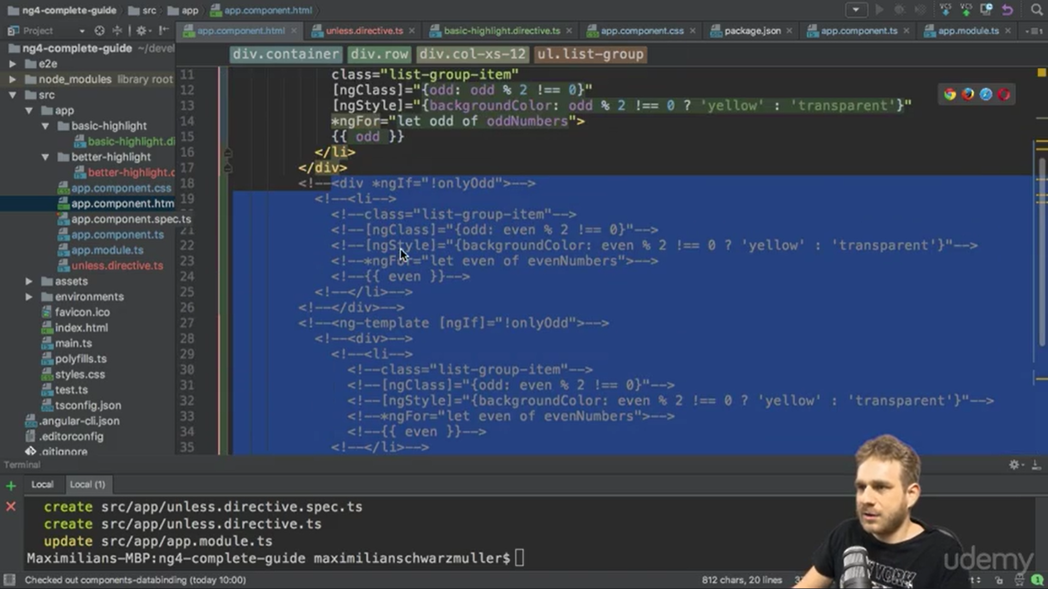

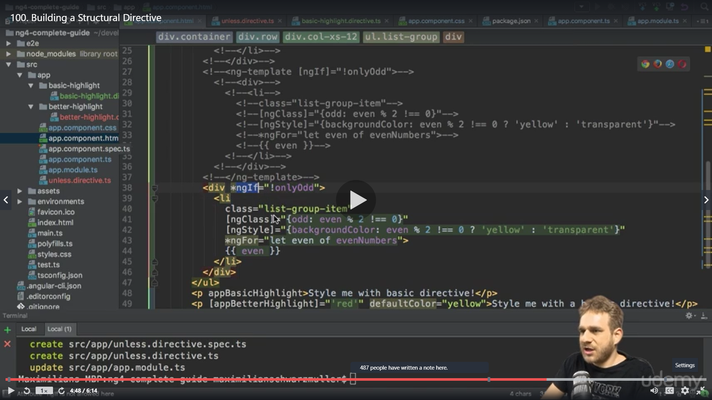

Here instead of ngIf we will use appunless which is our directive selector and * is imp because its still a structural directive

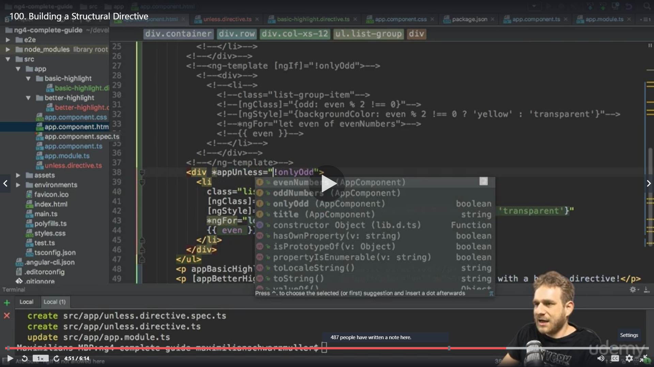

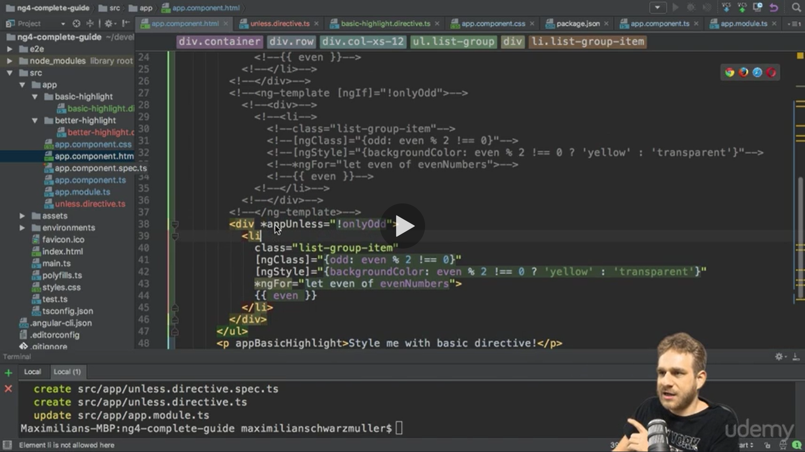

Otherwise we would manually have to write it with the ng-template like we learned in above previous example

Here we just check if its odd because the unless directive will check the not already

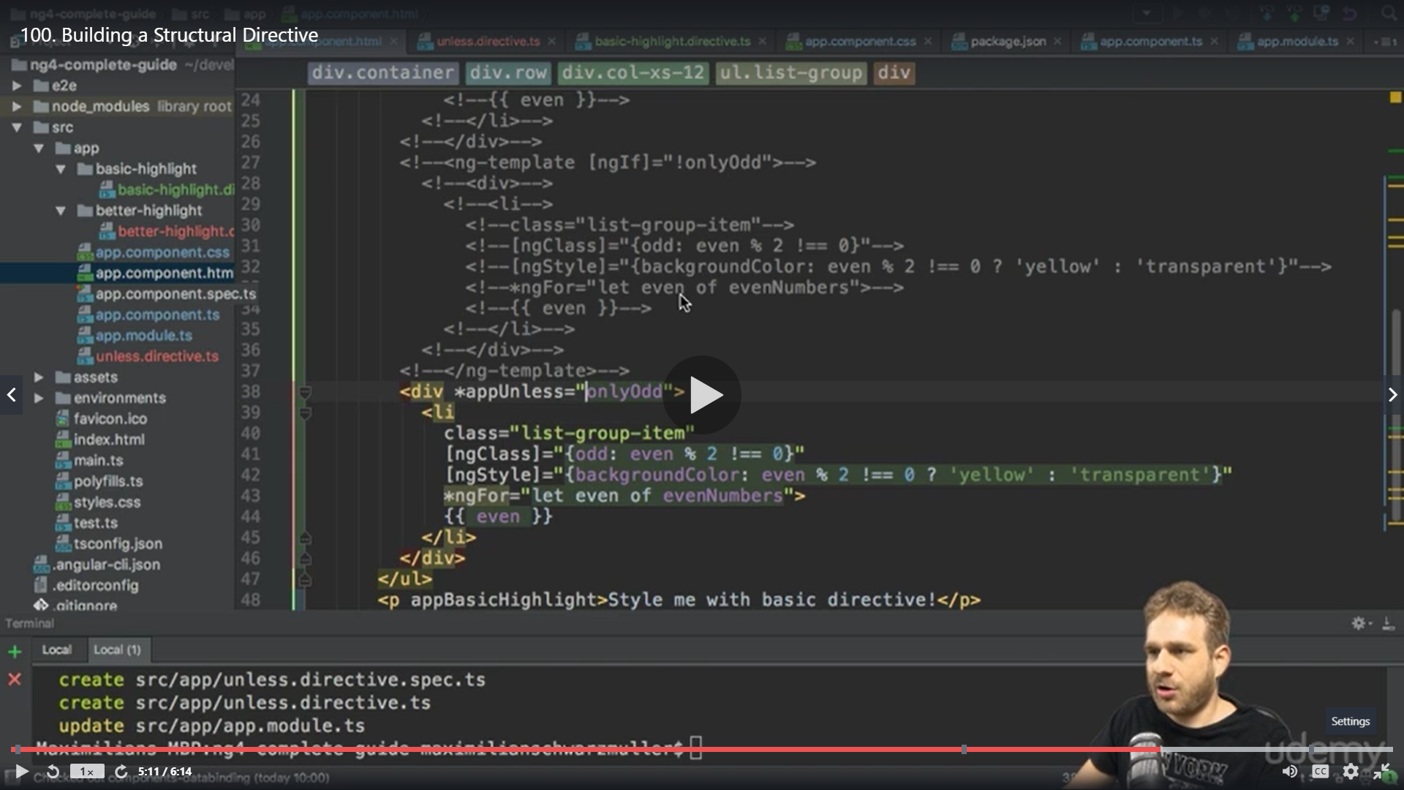

We get errro

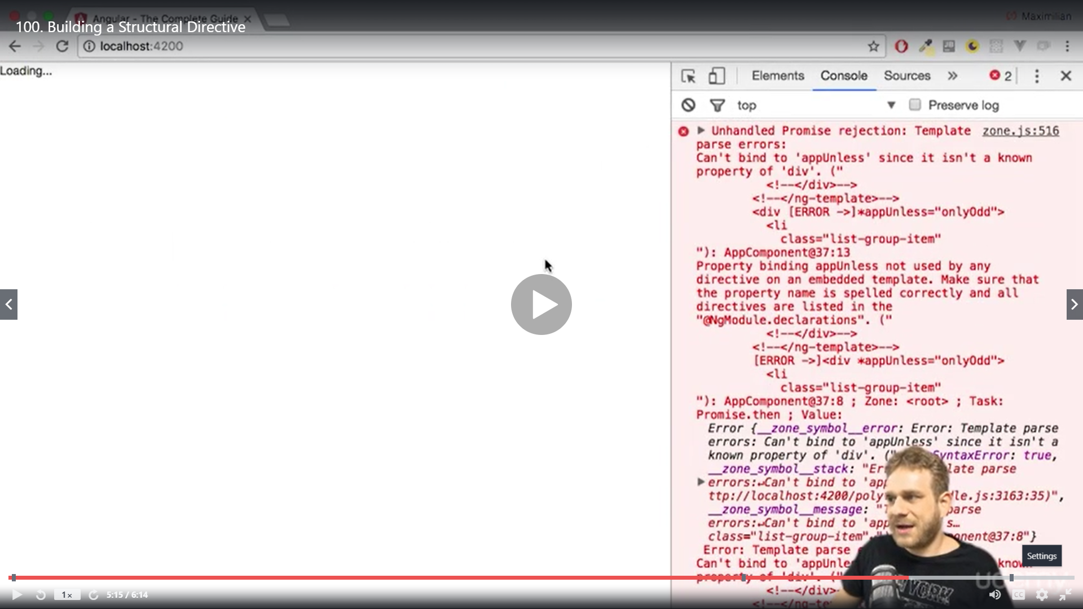

Cant bind unless since its not a known property

So weh have to make sure we have the directive name same

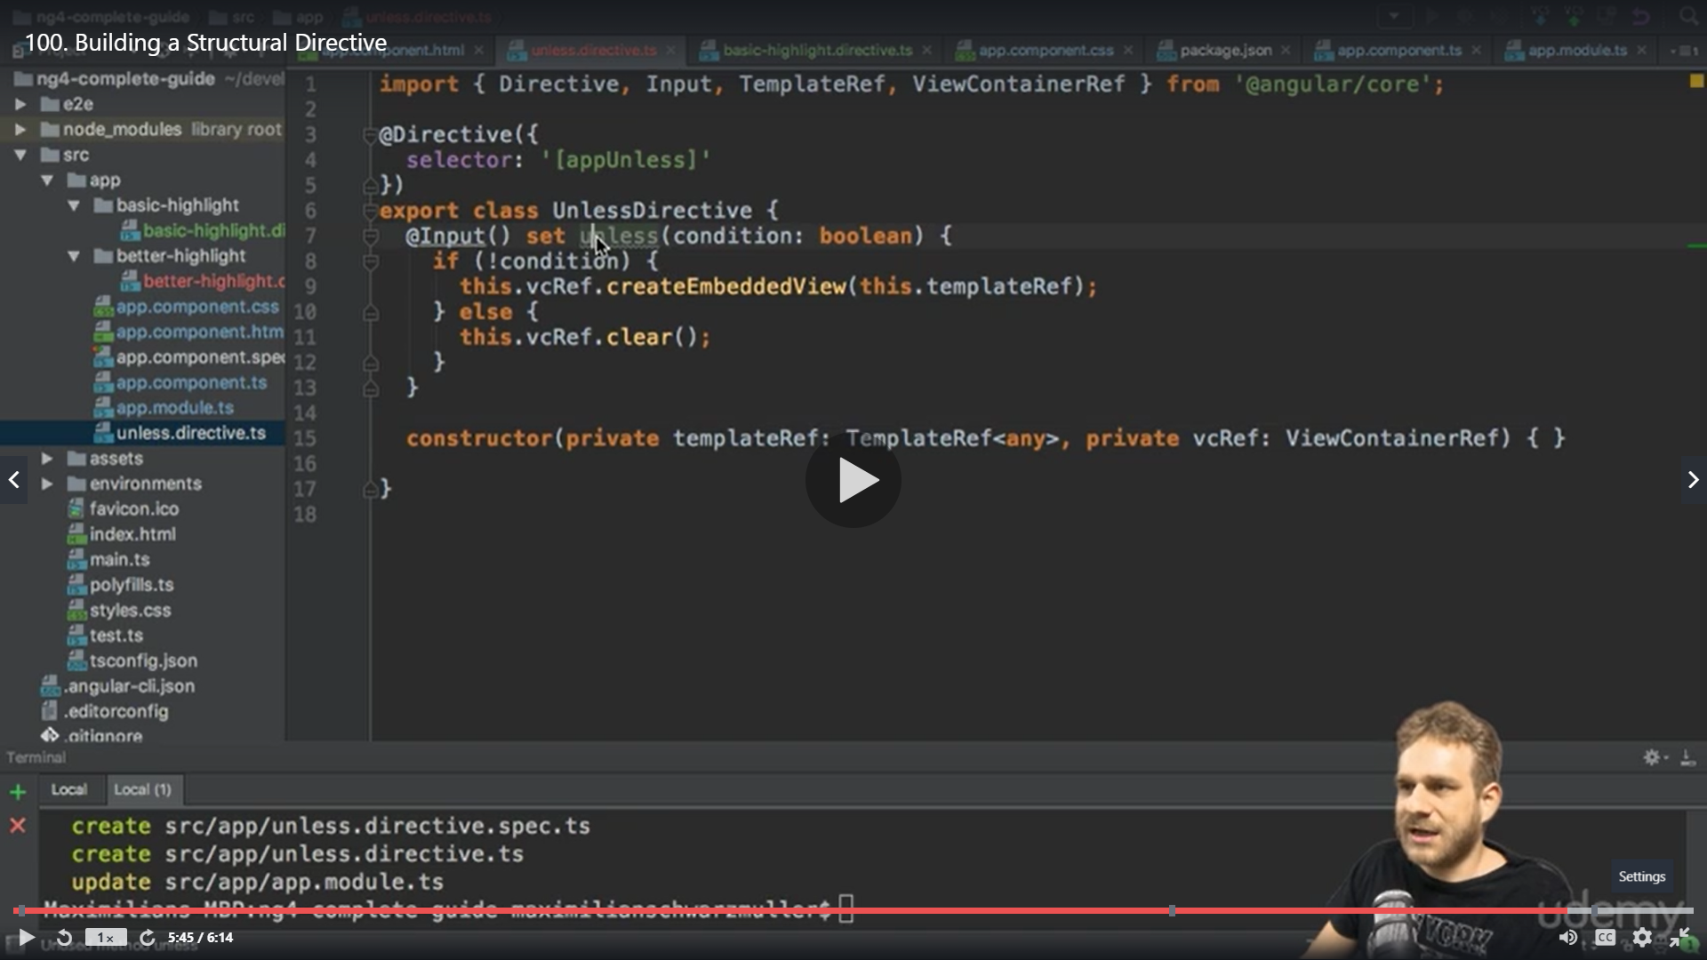

We change the property unless to the name of our directive appunless

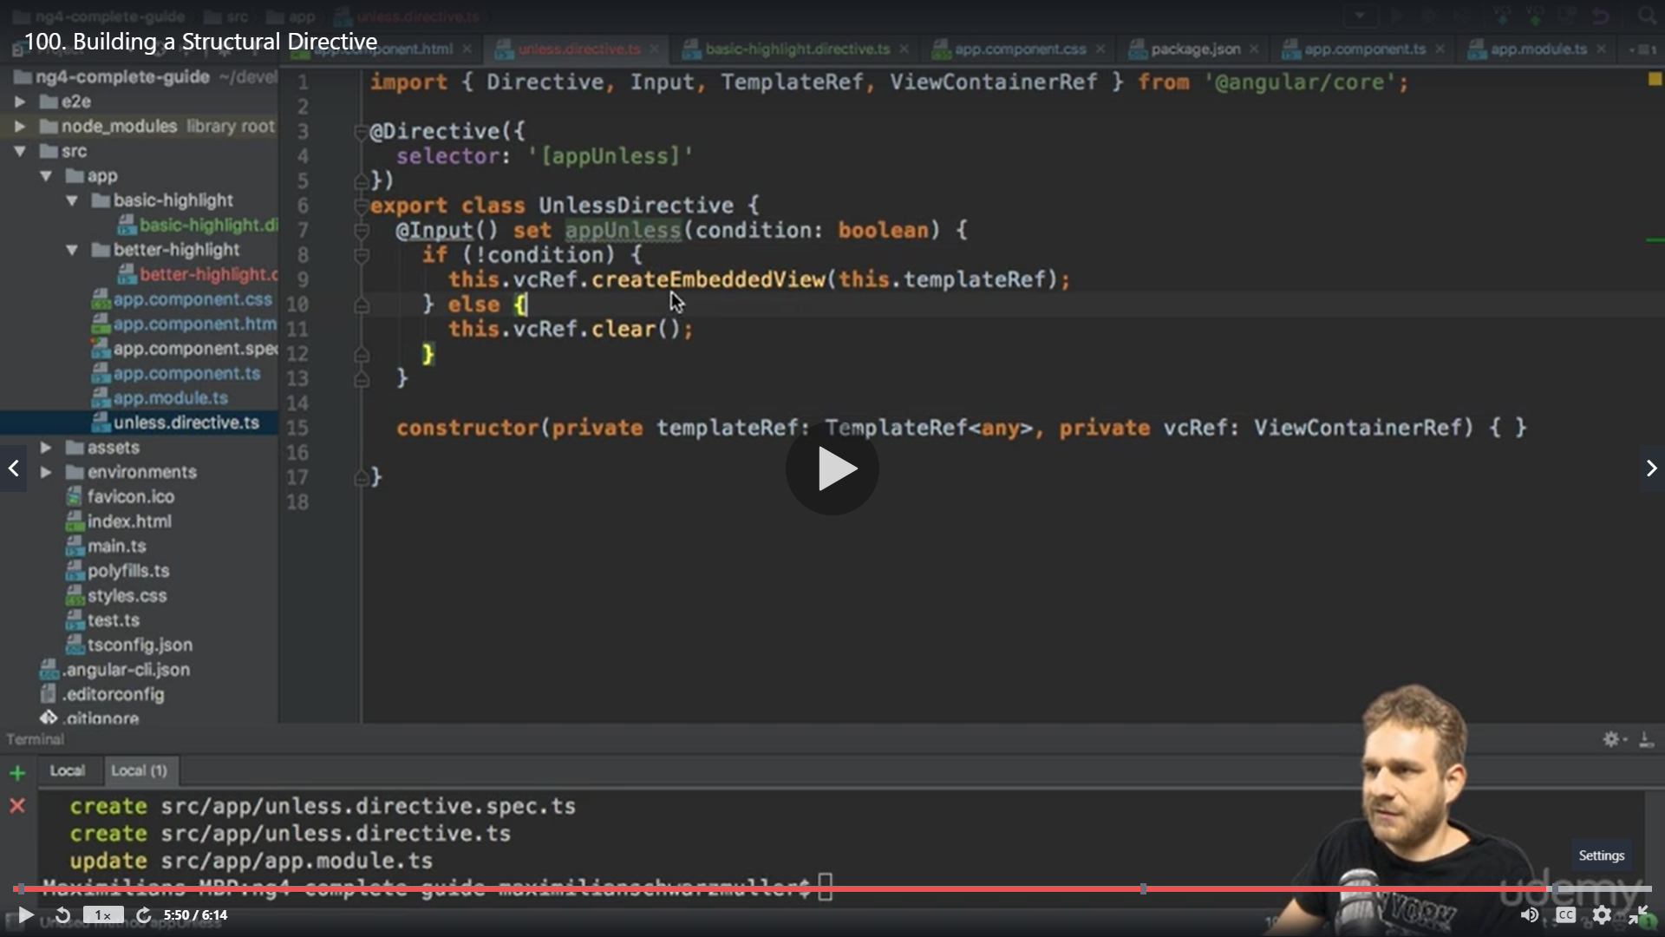

Result

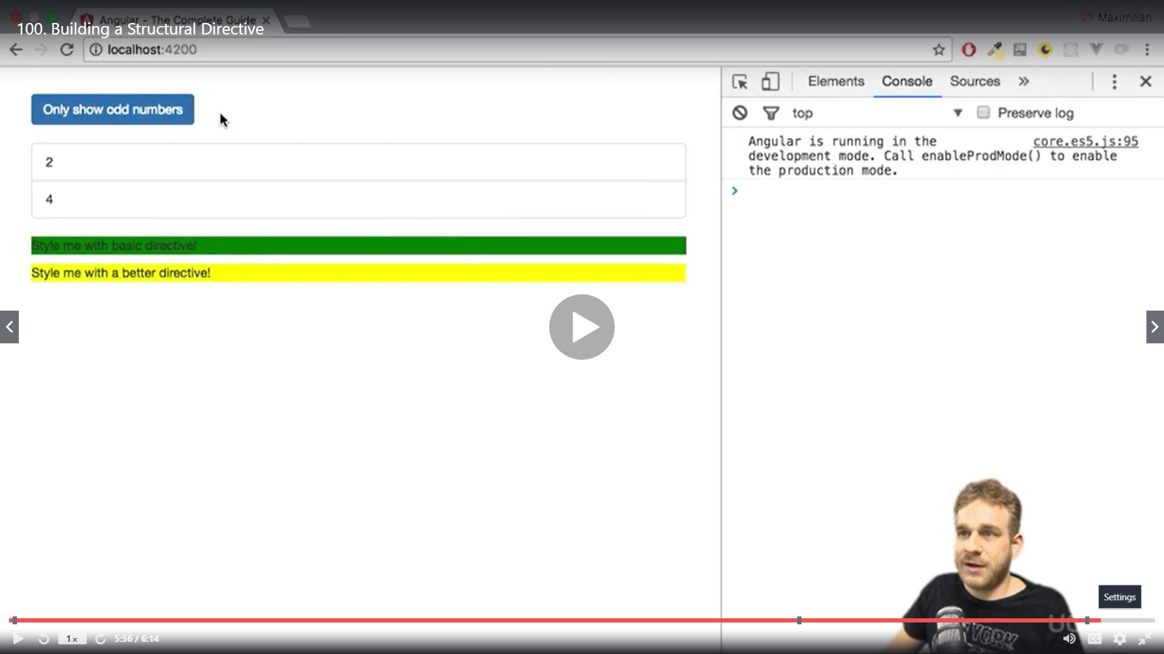

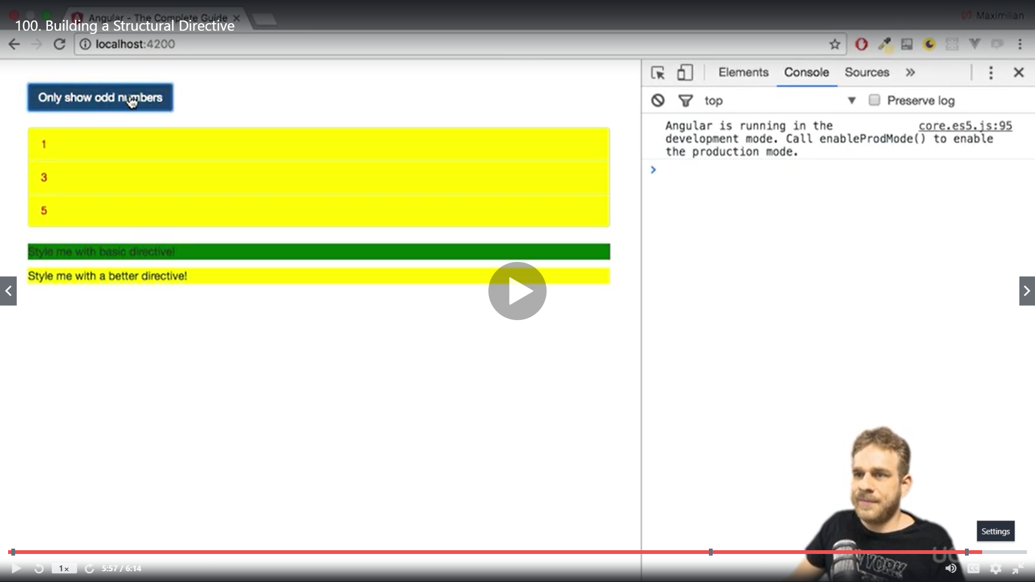

We get the same behaviour even though we are not using *ngif and using our own *appunless directive

Understanding ngSwitch another structural directive

We have a value 10

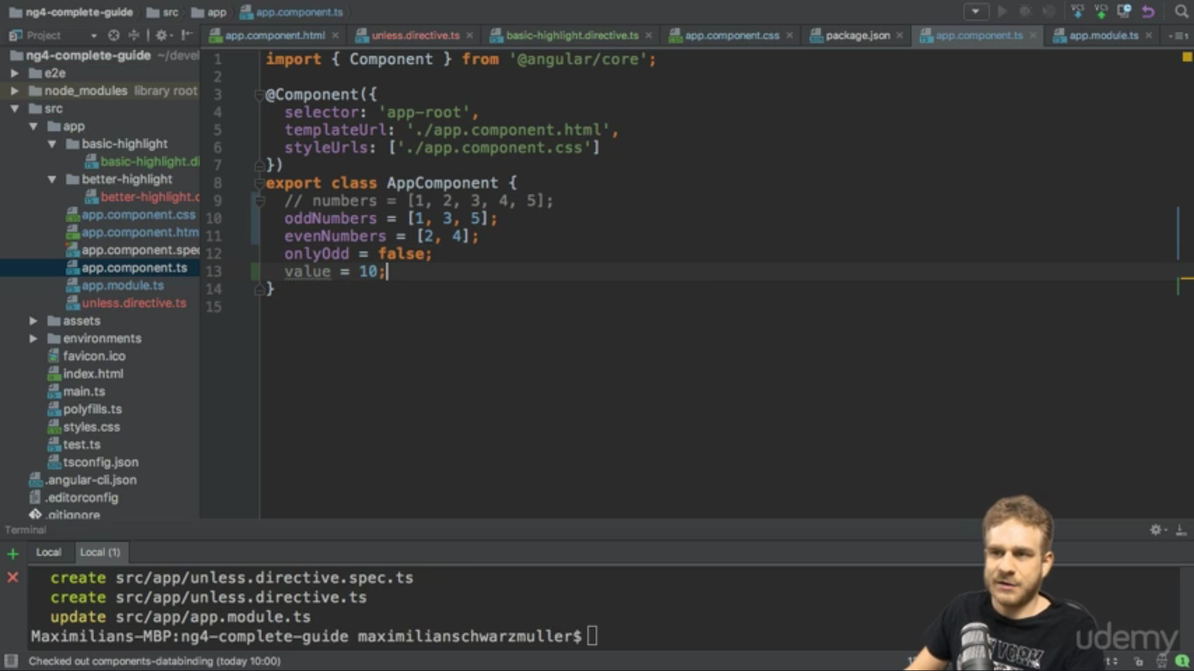

And

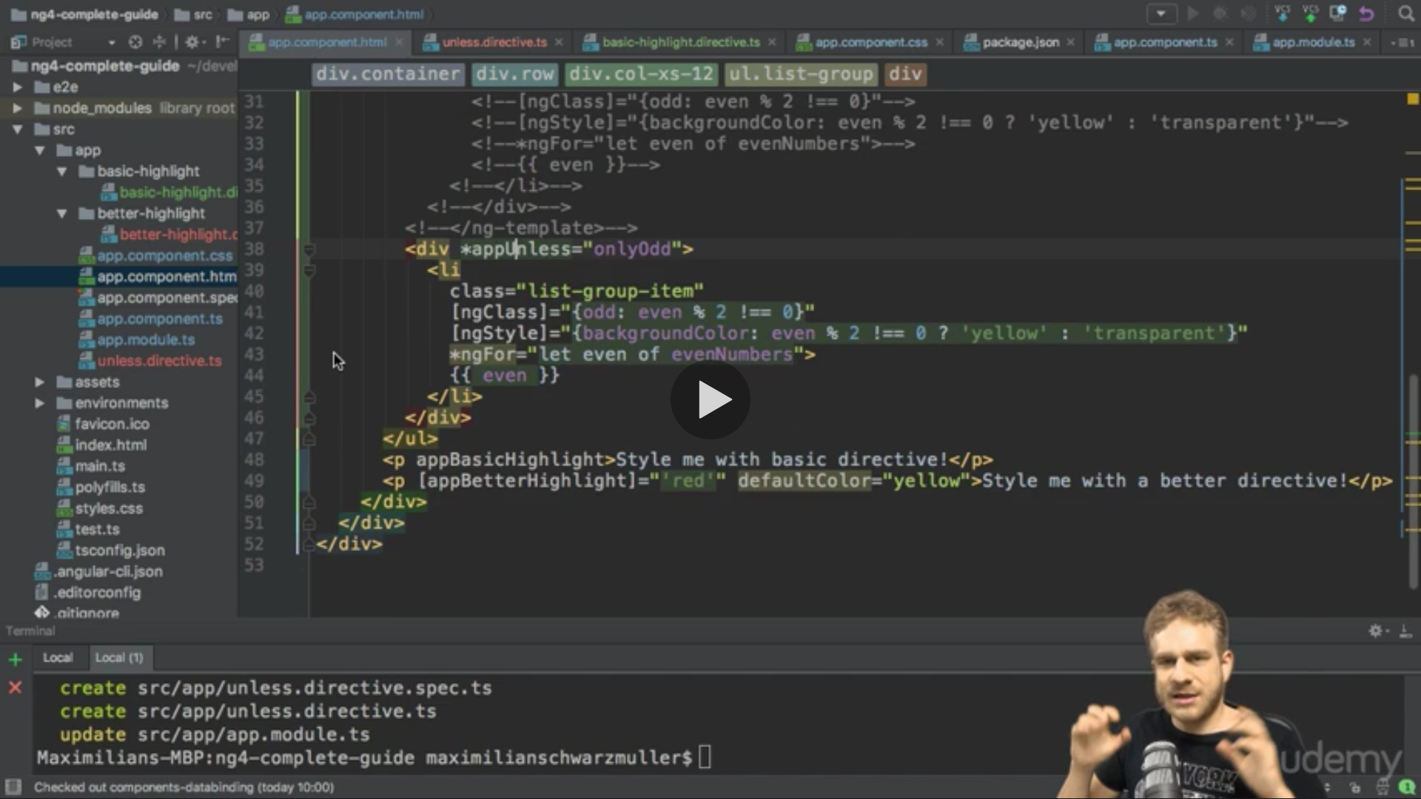

We want to display different messages for each of these values for this we use ngSwitch

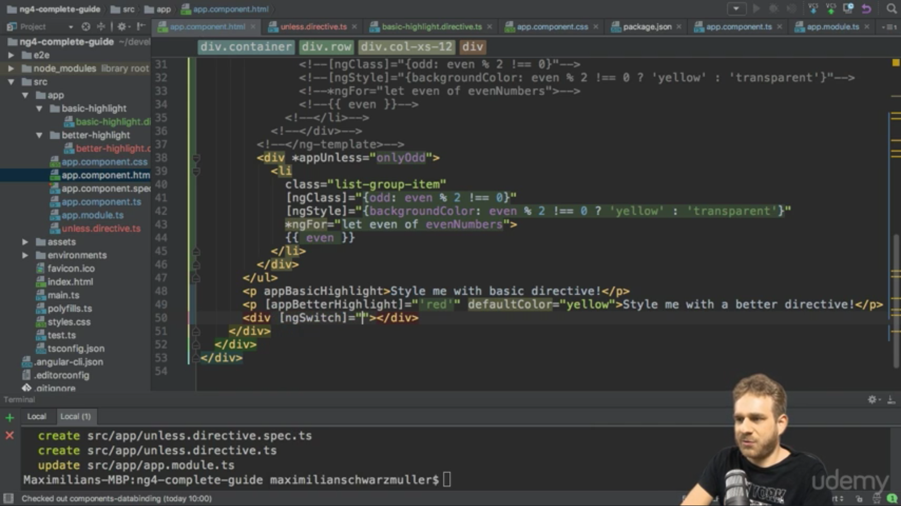

No * till here

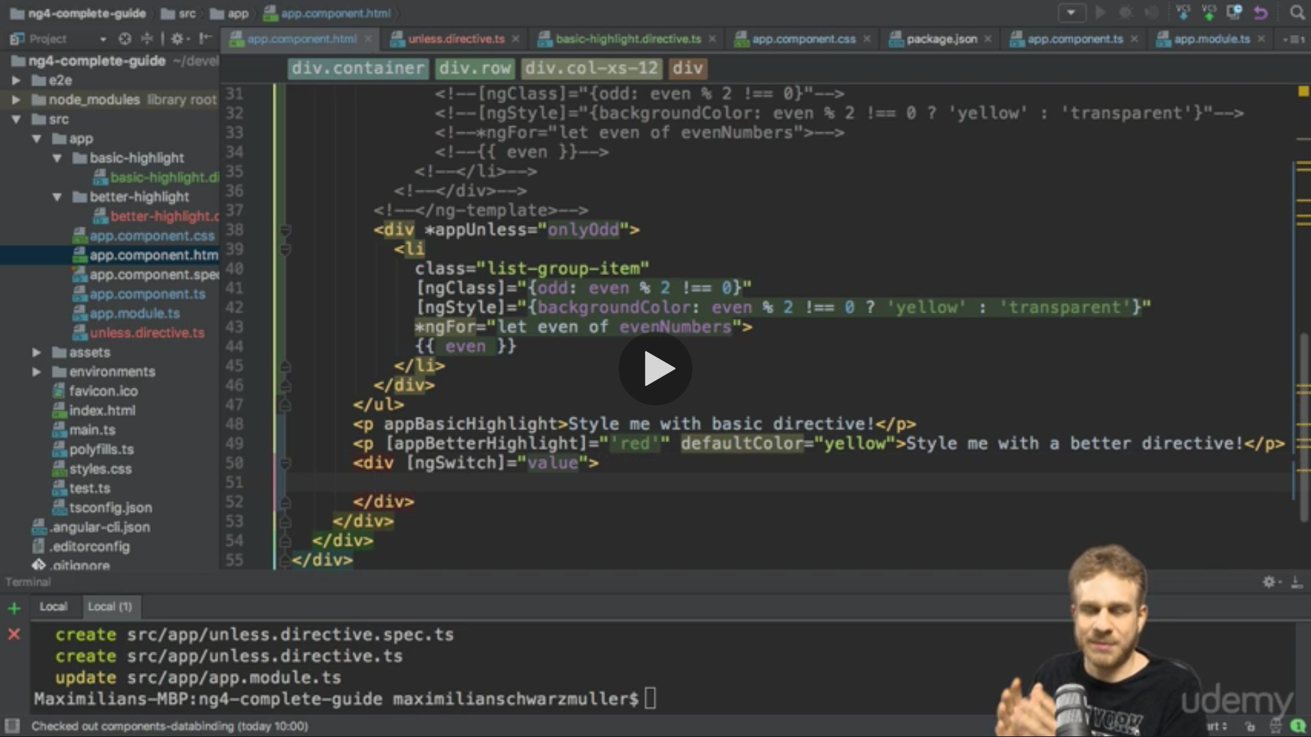

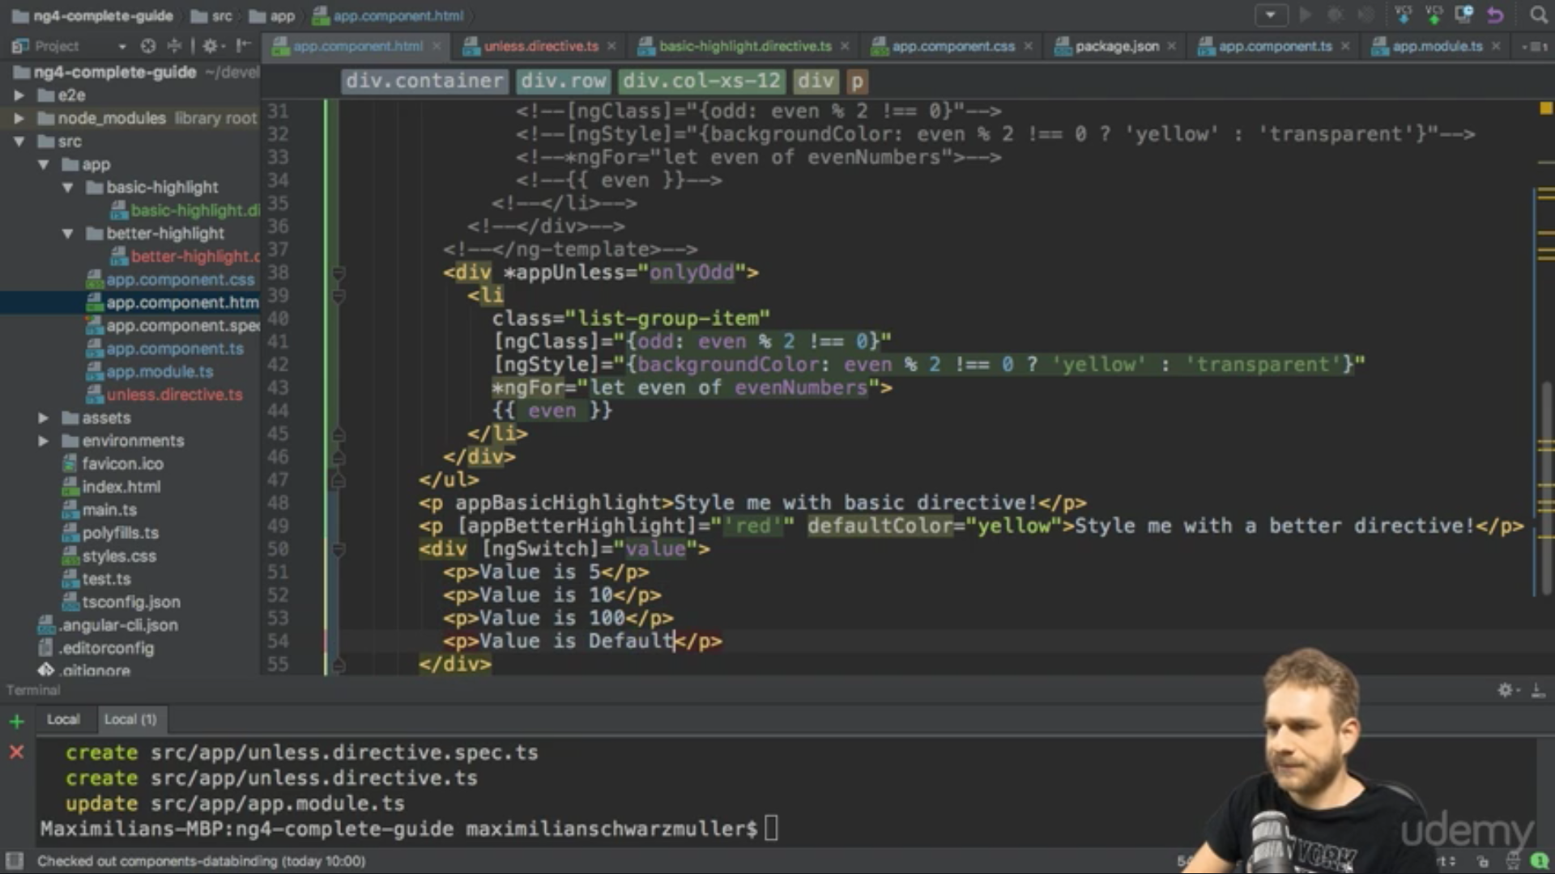

Now we want to display only one msg so we have ngswitchcase

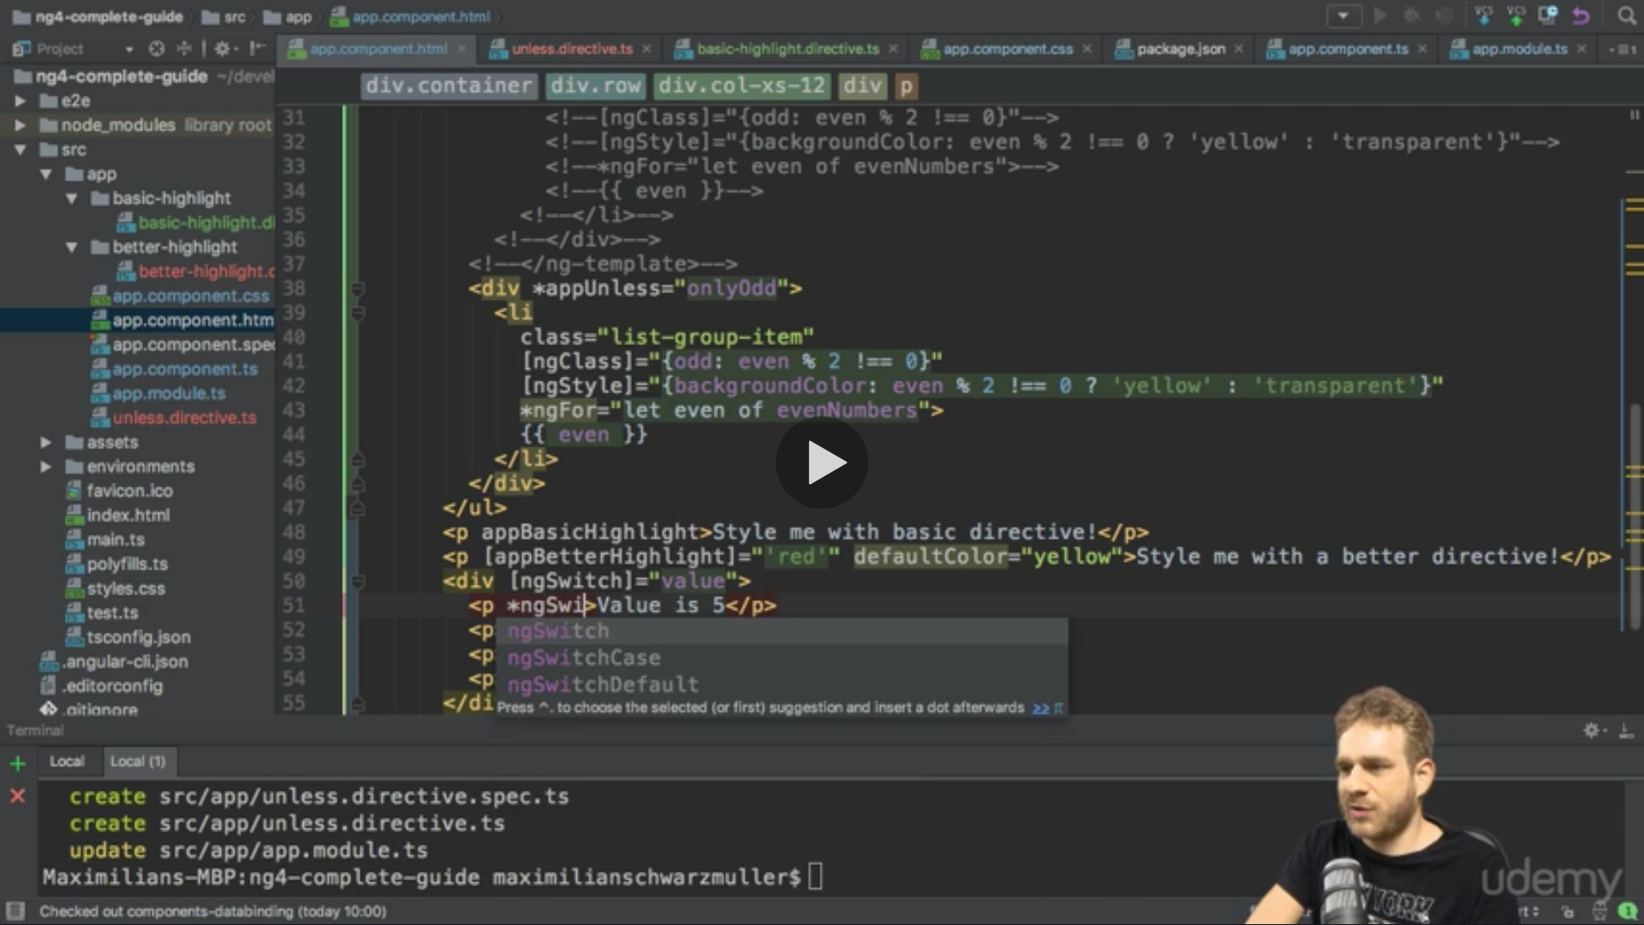

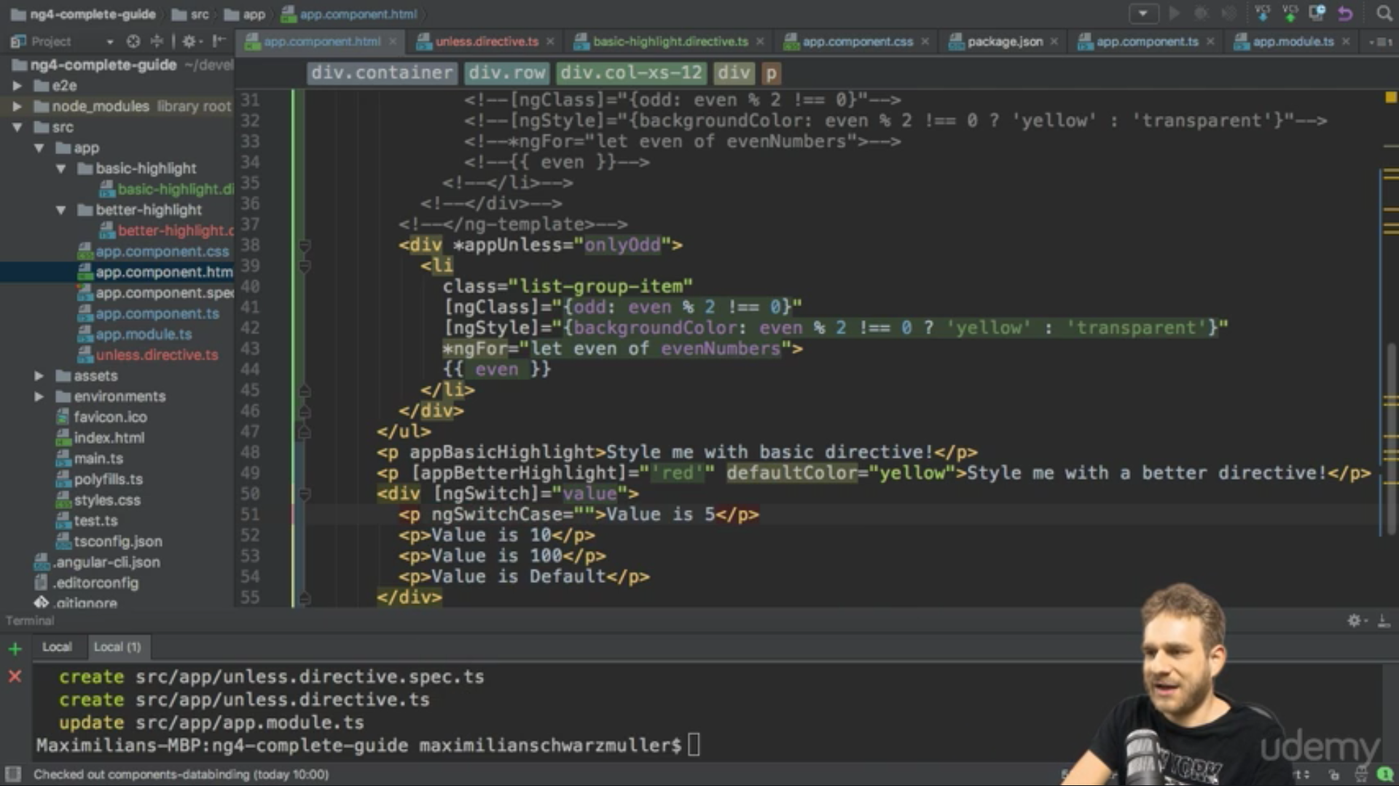

Now we add start * and value as 5

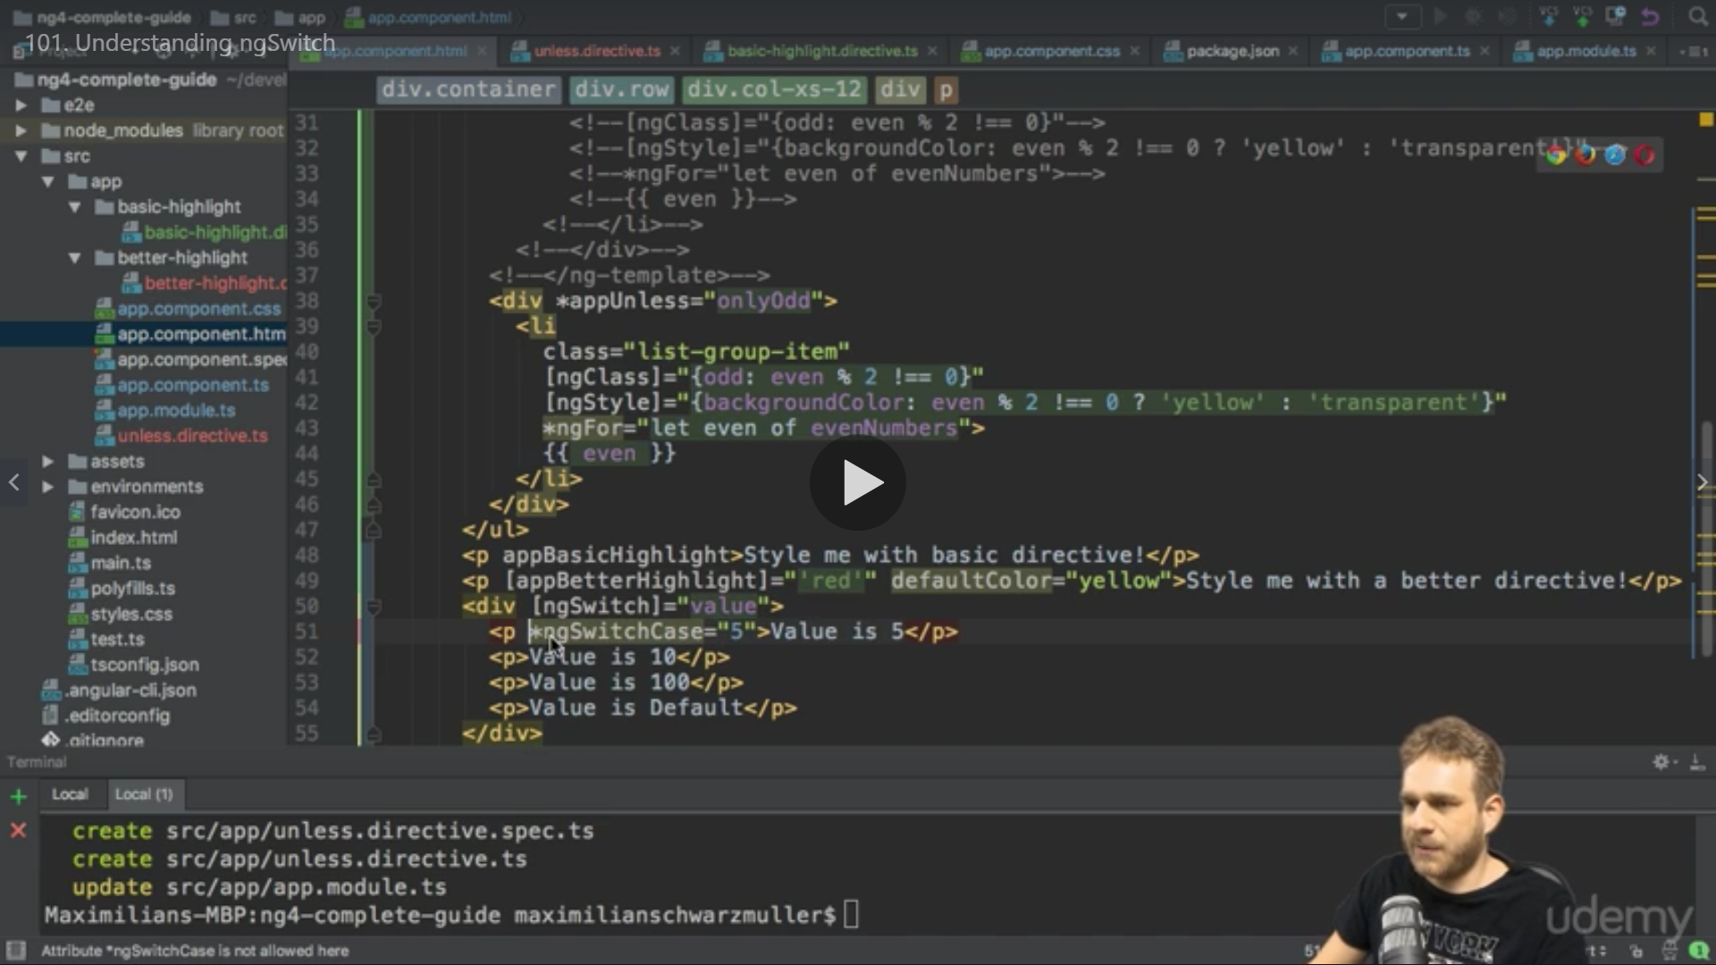

We do for other as well

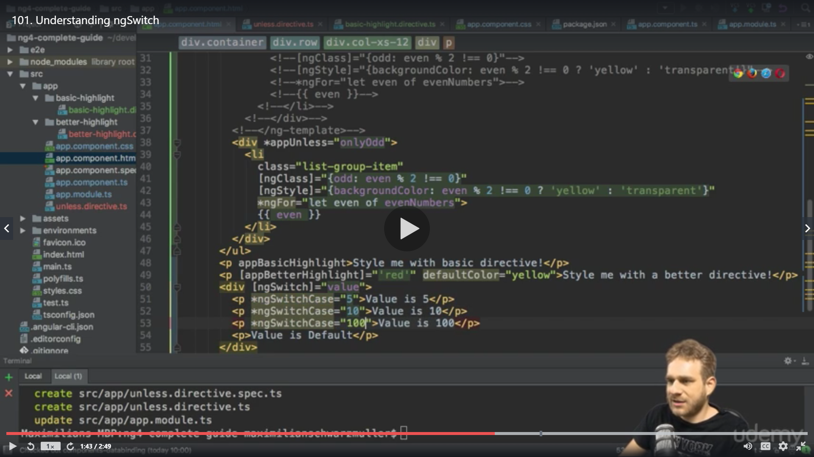

For default we have ngswitchdefault

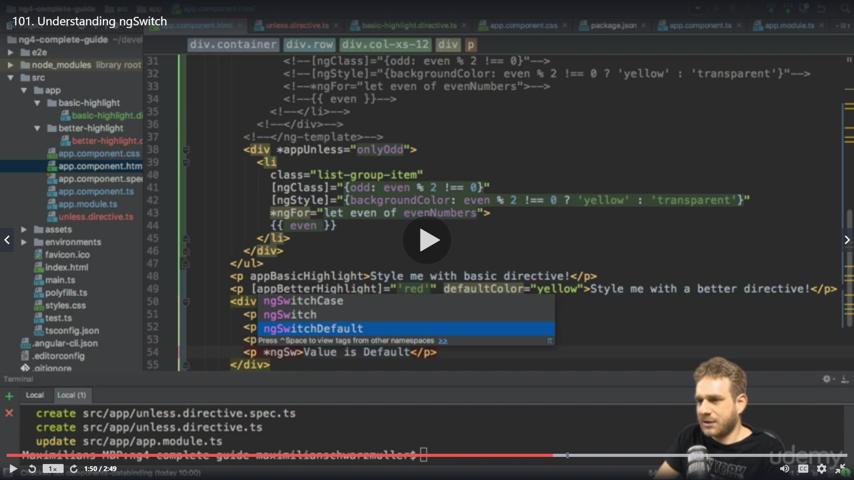

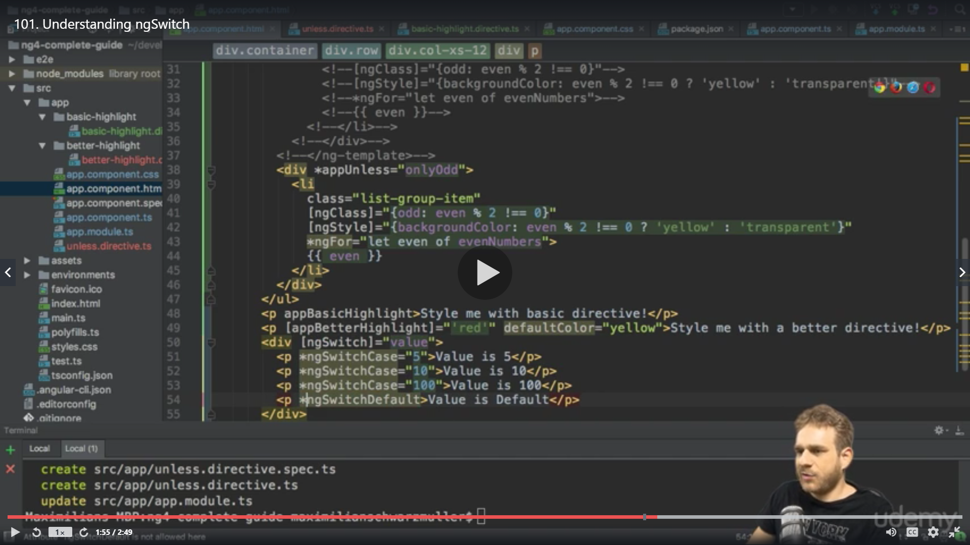

Reslt

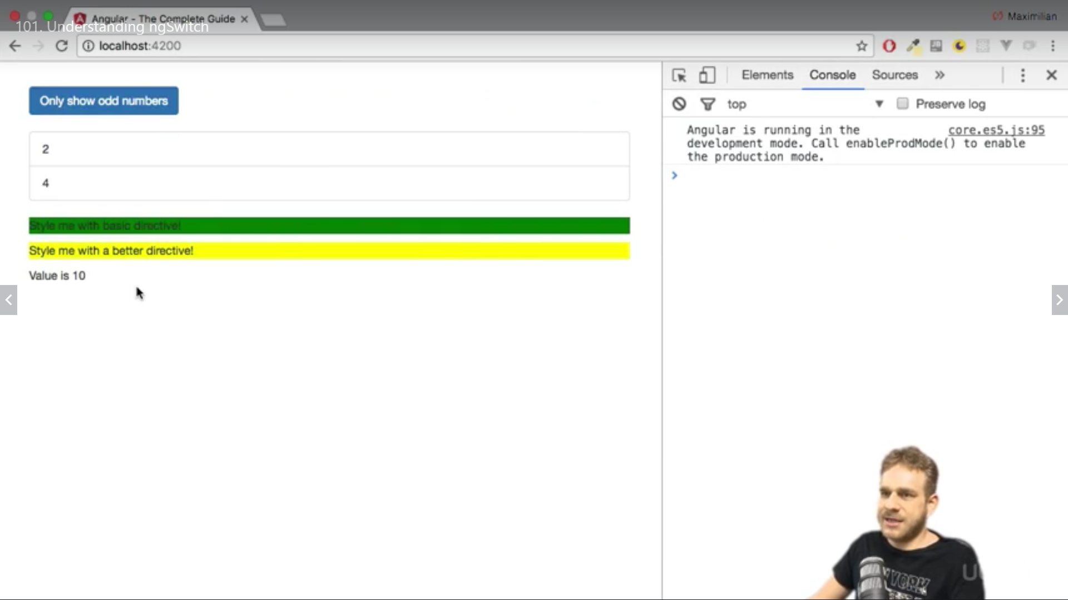

Now we change

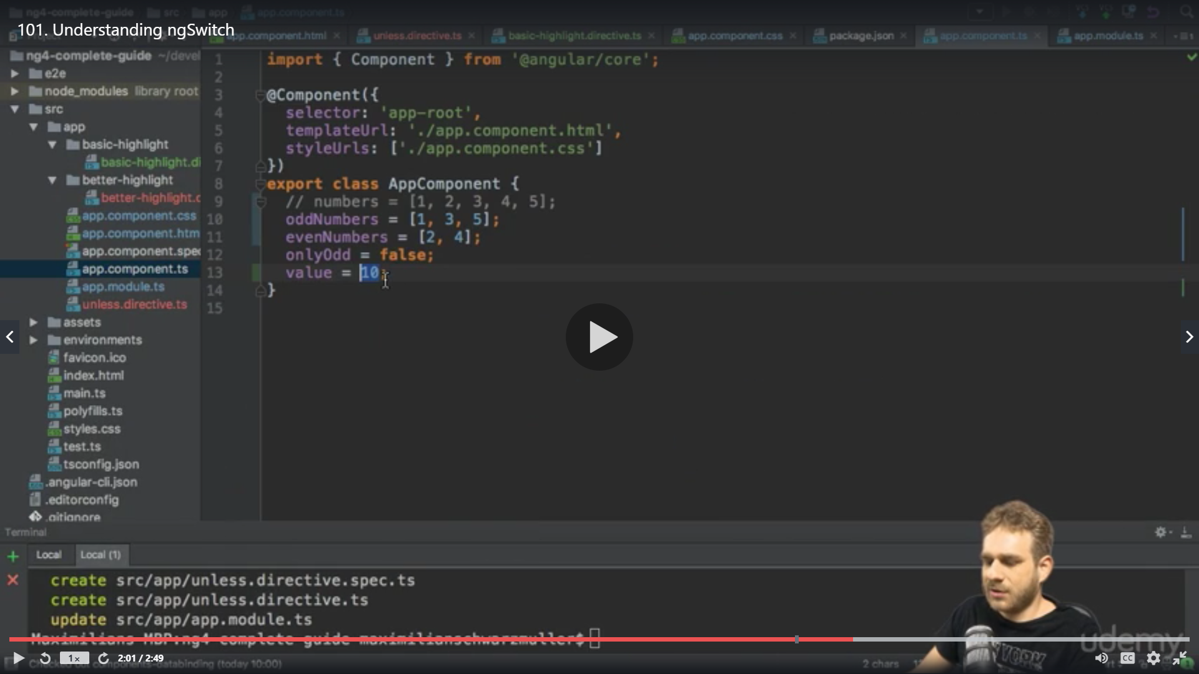

To 5

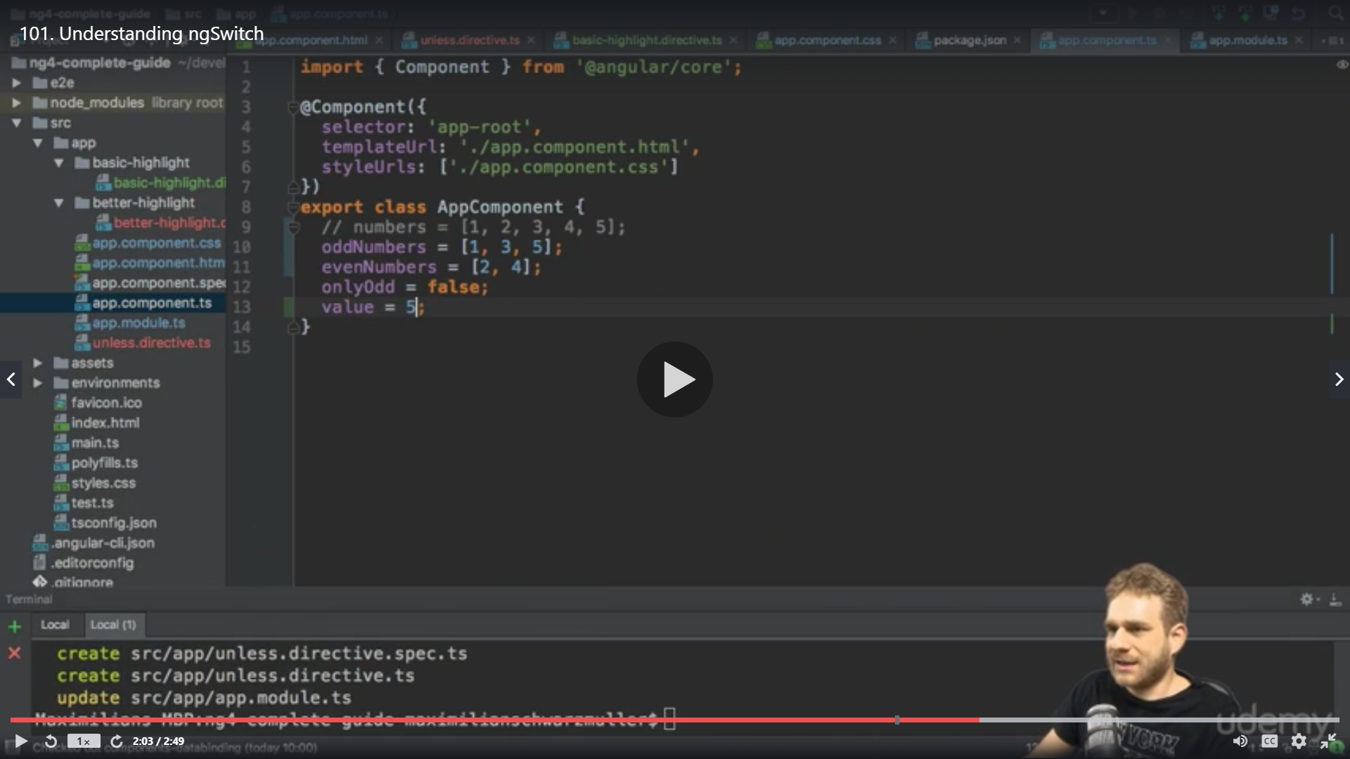

We get

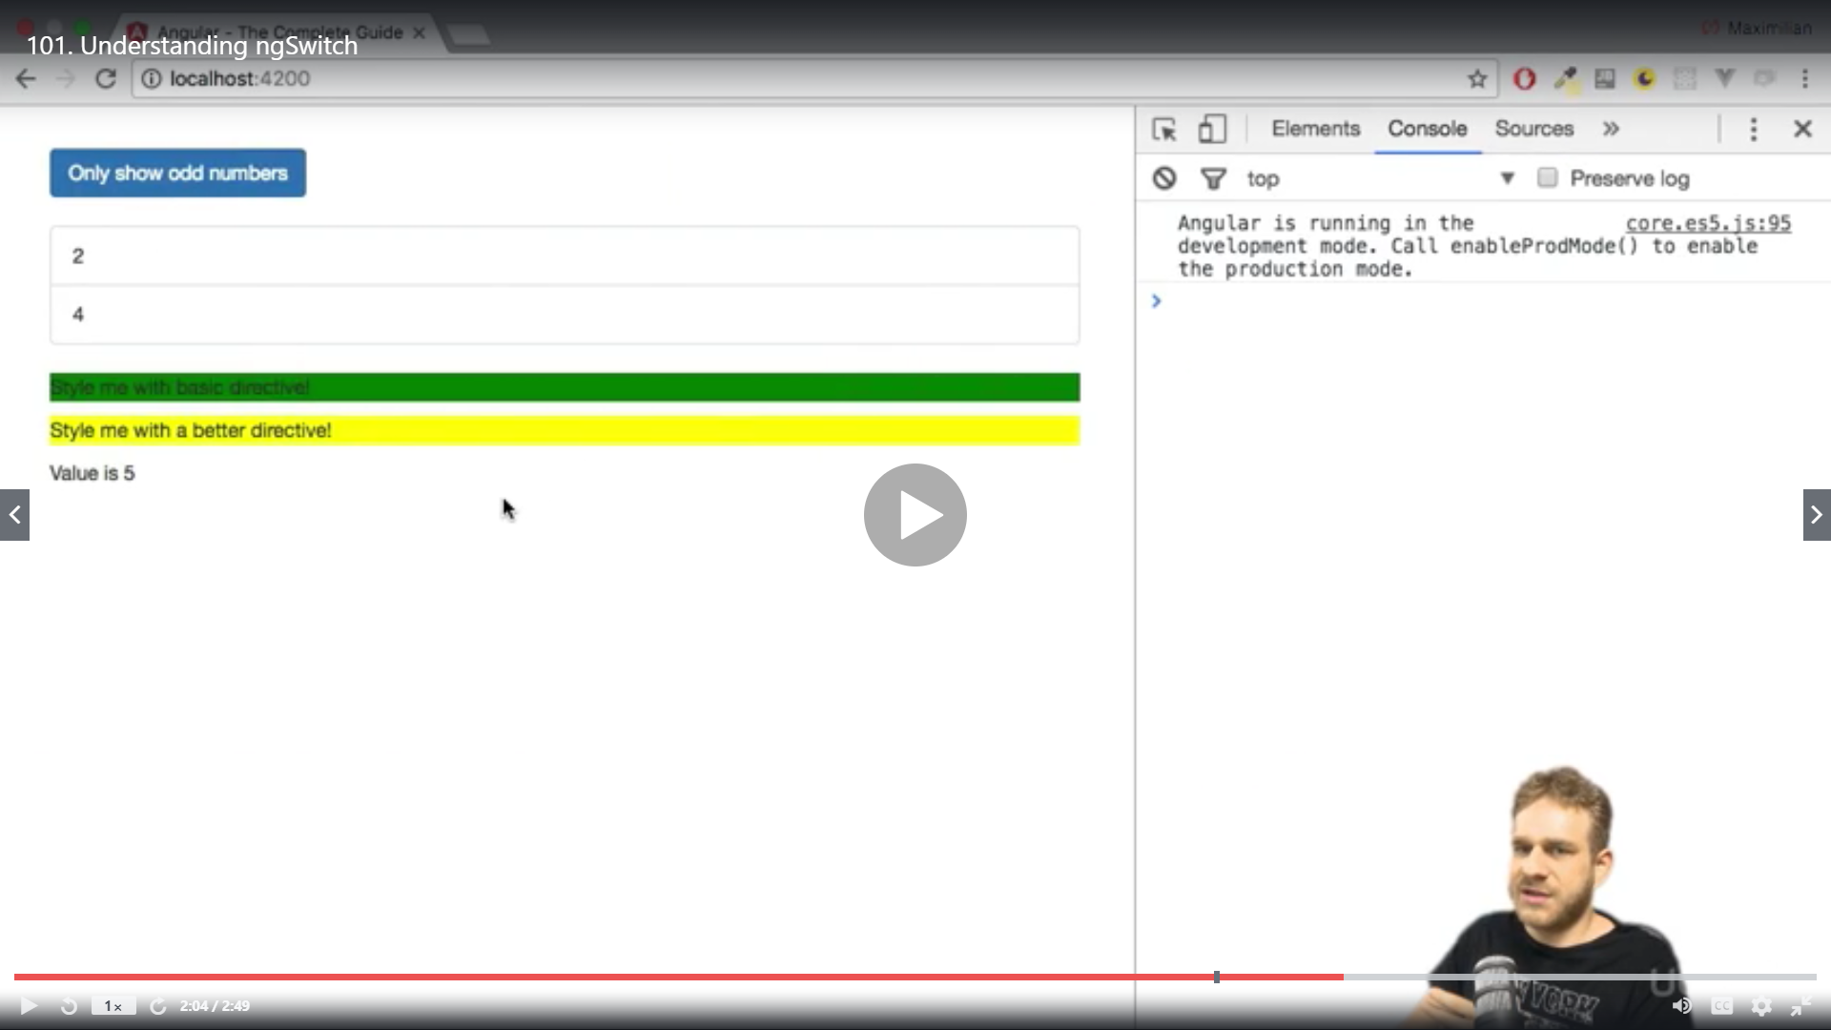

Ng switch is used where you want to create a lot on ngif cases ngswitch will be a better solution